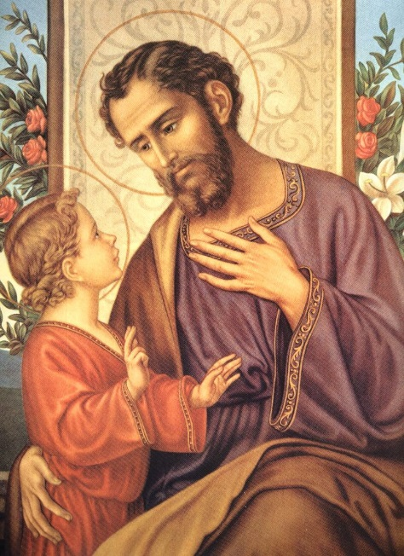

ST. JOSEPH, HEAD OF THE HOLY FAMILY

"The growth of Jesus 'in wisdom and in stature, and in favor with God and man' (Lk. 2:52) took place within the Holy Family under the eyes of St. Joseph, who had the important task of 'raising' Jesus, that is, feeding clothing, and educating him in the Law and in a trade, in keeping with duties of a father."
"Inspired by the Gospel, the Fathers of the church from the earliest centuries stressed that just as St. Joseph took loving care of Mary and gladly dedicated himself to Jesus Christ's upbringing, he likewise watches over and protects Christ's Mystical Body, that is the Church, of which the Virgin Mary is the exemplar and model."

"By virtue of this trust he completely fulfilled his mission entrusted to him by God for the sake of Mary and his son."

"May he always guard, protect and enlighten families." - Pope St. John Paul II

