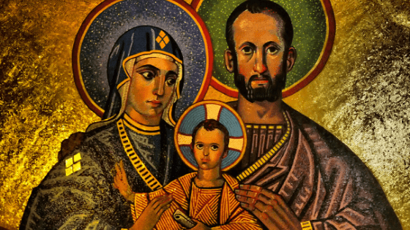

St. Joseph “Light of Patriarchs”

Amidst all the Patriarchs in salvation history, Joseph is the Light of Patriarchs. He serves as a light and model, the universal patron of the church, a man who lived in humble and dedicated service to God, willing to lay down his life for his family. Joseph took on the unique role as being the foster father of Jesus. His fatherhood plays a very important role in God’s wonderful plan. He is the perfect example of the Father of Lights, helping us to receive the light of Christ. Isn’t is comforting to know that St. Joseph offers his spiritual fatherhood to each of us? In this world filled with turmoil, he is an example of how to live your life as the center point and guide of your family. Stay close to St. Joseph and walk in the light!

