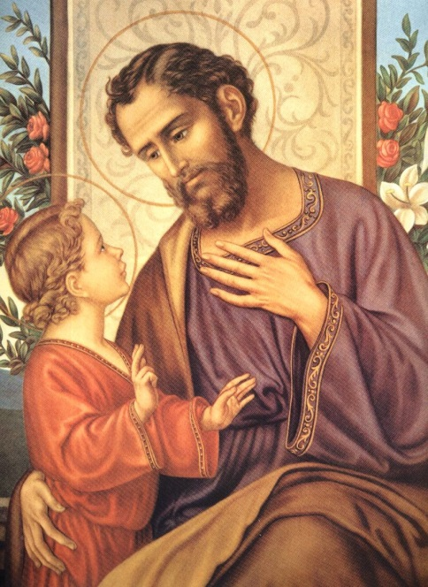

St. Joseph Mirror of Patience
Patience is truly a virtue, something not all of us find ourselves having a whole lot of! Finding time to have patience in our world today, especially in our hectic everyday routines is challenging. Traffic jams, long checkout lanes or drivethru lanes, dealing with your 2 year old, and being unable to have something instantly all can wear our patience quite thin. St. Joseph’s mission required a lot of patience. His life was a continual process of waiting on the Lord’s revelation to him. St. Joseph waited for the Lord to reveal what Mary’s pregnancy was all about, and what his role would be. When Jesus was an infant, St. Joseph had to uproot his family to Egypt, and then find them shelter, and work for himself. Imagine the anxiety he felt. Regardless, St. Joseph was patient, trusting in God’s care for him. We should all attempt to mirror St. Joseph’s ability to deal with the situations before him as he did. Having patience and trusting God, however, does not mean we will not continue to have daily challenges. Dealing with these challenges as St. Joseph did will truly strengthen our faith in God. Pray to St. Joseph and ask for his intercession to help be patient and merciful, trusting in God’s plan for us.

