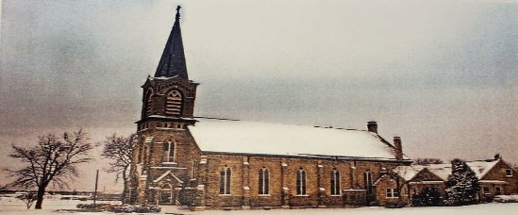
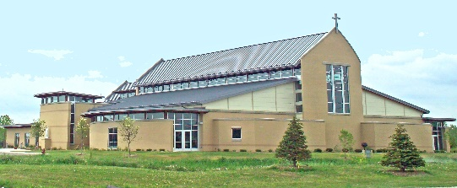

*** PRESS RELEASE ***
July 28th, 2021

SAINT STEPHEN, THE MARTYR, CATHOLIC CHURCH
“Building Our Faith Together for 175 Years” 1847-2022

Currently located at 1441 W. Oakwood Road in Oak Creek, WI, the parish will begin a year-long celebration recognizing 175 years of rich history and tradition. With little to nothing in possessions, those early German pioneers began to rebuild their lives in a new world. Many times, they faced almost-insurmountable-obstacles and difficulties in building their little home Church in what was then called New Coeln. Later, this town would become a part of the City of Milwaukee, with the parish being called the little airport Church.
Faith carried them through two disastrous fires, rebuilding their brick structure each time, always accepting the challenges and hardships of their circumstances. They were strong willed people who were committed to God, country, and family. They worshiped for decades at the airport site until a new Church was built in Oak Creek, WI, in 2009. Today’s Church is a wonderful edifice to God with an awe-inspiring blend of the Old St. Stephen’s wood carved interior furnishings, now blended into a new modern worship space, with air-conditioning for the first time ever.
With this momentous anniversary celebration, comes a great sense of gratitude. Wonderful memories of the family church, the school, the Priests and the religious Sisters who served the parish over the many years, are fondly remembered. A new generation, in the growing demographics of Oak Creek, now holds the church keys endowed to them by past generations.
A parish wide celebration will happen on Sunday, June 5th, 2022 at 10:30am with many dignitaries and local officials in attendance. The gift of faith and community continues for future generations. See you in the year 2047 for the 200th Anniversary!!!

Contact Information:
Church Office: 414-762-0552
Rev. Robert Kacalo: rkacalo@saintstephenmil.org
Lynda Trani (Director of Anniversary Planning): ltrani@saintstephenmil.org
Nick Ward: adminasst@saintstephenmil.org

