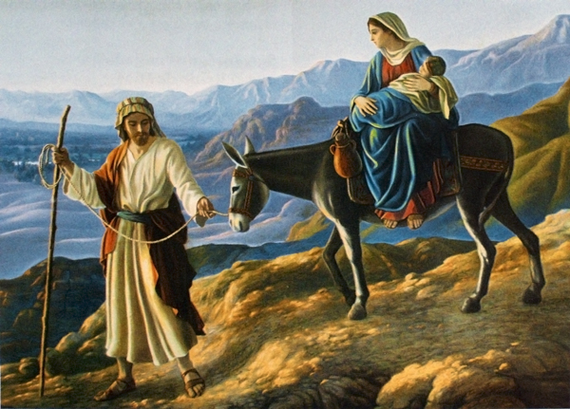
St. Joseph “Pillar of Families”
Our mental image of a pillar is that of a strong support between a foundation and something above. It is strong, unbending, dependable and necessary
St Joseph is all of the above. He took upon himself to take the family to Egypt until the threat of King Herod had passed. Think about this! He had to walk from Israel to Egypt and back with Mary and the baby Jesus. Can you image walking from Israel to Egypt? Taking care of a family by providing security, food and shelter. How could St Joseph do it? He disciplined himself to be open to God’s will. This is what a virtuous man does. While the world would enjoin a person to quit, or give up because it is too hard, St. Joseph pushed on doing what he was called to do.
The world offers us many temptations; drugs, alcohol, gluttony, pornography etc. we must be the pillars for our families and community for the fight. Prayer, meditation on God’s word, personal sacrifice all terrorizes the demons who prod us for our weaknesses. Follow the example of St Joseph – St. Joseph Pillar of Families pray for us!

