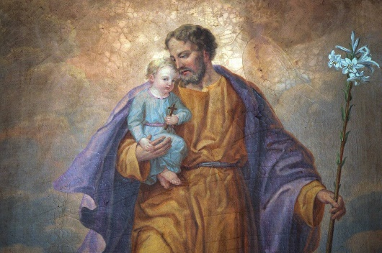

Prayer of the Holy Cloak
Glorious Patriarch St. Joseph, you who were chosen by God above all men to be the earthly head of the most holy of families, I beseech you to accept me within the folds of your holy cloak, that you may become the guardian and custodian of my soul.
From this moment on, I choose you as my father, my protector, my counselor, my patron, and I beseech you to place in your custody my body, my soul, all that I am, all that I possess, my life, and my death.
Look upon me as one of your children; defend me from the treachery of my enemies, invisible or otherwise, assist me at all times in all my necessities; console me in the bitterness of my life, and especially at the hour of my death. Say but one word for me to the Divine Redeemer who you were deemed worthy to hold in your arms, and to the Blessed Virgin Mary, your most chaste spouse. Request for me those blessing which will lead me to salvation. Include me amongst those who are most dear to you and I shall set forth to prove myself worthy of your special patronage. Amen

