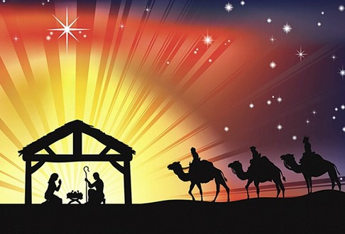

Holy Day Mass Times and St. Stephen Parish Schedule
Thanksgiving Day Mass, Wednesday, November 24th at 6:00 P.M.
Parish Office closed on Thursday, November 25th and Friday, November 26th
Immaculate Conception Mass, December 8th at 8:00 A.M. and 6:00 P.M.
Communal Reconciliation, December 15th 5:30 P.M.
Parish Office closed on Thursday, December 23rd and Friday, December 24th
No daily Mass at 8:00 A.M. on December 24th
CHRISTMAS EVE Friday, December 24th
Christmas Pageant at 4:00 P.M.
Christmas Family Mass at 4:30 P.M.
Christmas Eve Piano Concert at 6:30 P.M.
Christmas Eve Mass at 7:00 P.M.
Christmas Eve Choir Concert at 9:30 P.M.
Christmas Eve Mass at 10:00 P.M.

CHRISTMAS DAY Saturday, December 25th
Mass at 9:00 A.M. ONLY
No Saturday 4:30 Vigil Mass Today

Feast of the Holy Family, Sunday, December 26th 9:00 A.M. Mass ONLY

Parish Office closed on Thursday, December 30th and Friday, December 31st
No daily Mass at 8:00 A.M. on Friday, December 31st
Solemnity of Mary, Holy Mother of God
Mass on December 31st at 4:30 P.M.
Mass on January 1st, 2022 9:00 A.M. ONLY
No Saturday 4:30 P.M. Vigil on January 1st

Solemnity of the Epiphany
Mass on January 2nd, 2022 at 9:00 A.M. ONLY

