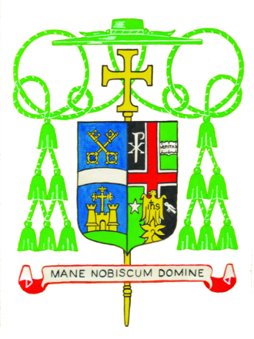
_______________________
Diocese of Belleville
Office of the Bishop
April 24, 2020
St. Fidelis of Sigmaringen, Priest and Martyr

Dear Priests, Deacons, Seminarians, Religious, and Diocesan Staff:

Peace be with you!

I am sending you the most recent directive from the Office of the Governor of Illinois, Jay Robert “JB” Pritzker. As you can see, while the new directive makes certain modifications concerning “essential businesses,” it does not significantly change the original stay at home and shelter in place orders of the original directive. The new directive stresses the importance of wearing a face mask if someone has to go out and cannot maintain a distance between themselves and the nearest person. This new directive extends the stay at home order for another month, until the end of May (unfortunately, this may require selecting a new date for Ordination to the Priesthood now scheduled for May 30th.)

The new directive from the Governor does NOT lead to a change to the norms that were sent to you earlier concerning liturgical celebrations, our Catholic schools, and Diocesan gatherings and meetings. Please refer to these norms and continue to follow them carefully during the weeks ahead, since the indications are that our efforts to comply with these norms have helped to prevent an alarming and dangerous increase in the number of people who get infected with the novel coronavirus which causes Covid-19 disease.

I am very aware that these restrictions in our activities have disrupted our lives in many ways. Most significantly, they have made it impossible for us to gather in our communities of faith for the celebration of the Sunday Eucharist where we receive the Body and Blood of Christ and experience the support, affection and fellowship of our sisters and brothers in Christ. This separation dampens the spirits of us all.

I commend, in a special way, the priests who are live-streaming the celebration of the Eucharist and other devotions and making them available to so many parishioners who, in turn, have shared with me how much they appreciate these efforts. At the same time, I am encouraged by the creative efforts that our priests, deacons, religious, and the Christian Faithful have made to ensure that, even though we must be separated from one another, we are not alone.
Please continue to share your homilies, reflections, and other spiritual resources with your parishioners.

It is a great paradox that, during this time in the Church’s Year of Grace when we are called to meditate on that great mystery of Christ’s triumph over suffering and death in the Resurrection, we are confined to our homes by a pandemic that randomly brings suffering and death to so many. May our faith remain strong through this current ordeal and may our appreciation of the Sacramental Life of the Church be deepened. Know that you have the constant support of my prayers and concern.

Sincerely yours in Christ,
The Most Reverend Edward K. Braxton, Ph.D., S.T.D.
Bishop of Belleville

