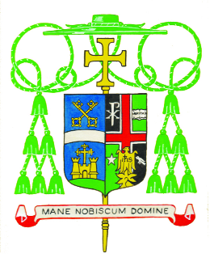

Bishop Edward K. Braxton
Invites you to view the

Liturgy of Ordination of

The Reverend Mr. Nicholas T. Fleming
St. Clare of Assisi Parish in O’Fallon

The Reverend Mr. Carl E. Schrage
St. Lawrence Parish in Sandoval

The Reverend Mr. Joel L. Seipp
St. Clare of Assisi Parish in O’Fallon

To the Order of Priesthood

on

Saturday, the Eleventh of July
in the Year of Our Lord, 2020

At 10:30 o’clock in the morning

In the Cathedral of St. Peter

During this Liturgy, our Priest Jubilarians will be honored.
The Oil of Catechumens and the Oil of the Sick will be blessed.
The Sacred Chrism will be consecrated.

In order to provide for the health and safety of everyone during this pandemic, we regret that the number of people that can participate in the Cathedral must be limited.

Therefore, the Mass will be livestreamed at: www.cathedralbelle.org
Please join me in praying for our candidates for Priesthood
and our Jubilarians.

