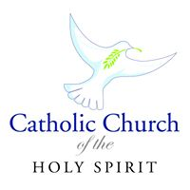

300 N. Pine Street, Carterville, IL 62918
618-985-2900 Email: HolySpiritParish300@gmail.com

May 29, 2020
Dear Members of Holy Spirit Parish,

When you listened to the video we sent out from the diocese regarding the opening of our parish, you probably noticed that we are to set up three Volunteer teams: A set up team, a Greeting team, and a cleaning team. Our directives state clearly that team members would include no one over 65 and no one with an underlying medical condition. So, it is our younger members, including high school students, that we call upon as we prepare to open our parish again.

The plan is to go slowly…for the protection of the priest, the people, and all involved. During Phase 1 ten or fewer worshipers may gather. During this Phase we may celebrate Baptism, Reconciliation, Weddings and Funerals.

Not until Phase II can we reopen for weekday or weekend masses. We will be in touch as we move from Phase I to Phase II.

For now, we are in need of team members to help open our parish. We are asking eligible Ushers to serve on the Greeting team. We need volunteers for the setup team and the cleaning team. Tomorrow morning at 7:30 a.m. a couple of parishioners will begin setting up the church. If anyone could join us, we would welcome that. We are also in need of a clean-up team. Please notify the Parish Office of your availability. Thanks so much for helping us open Holy Spirit Parish.

Gratefully,
Sr. Phyllis Schenk, O.P.

