November 03, 2019
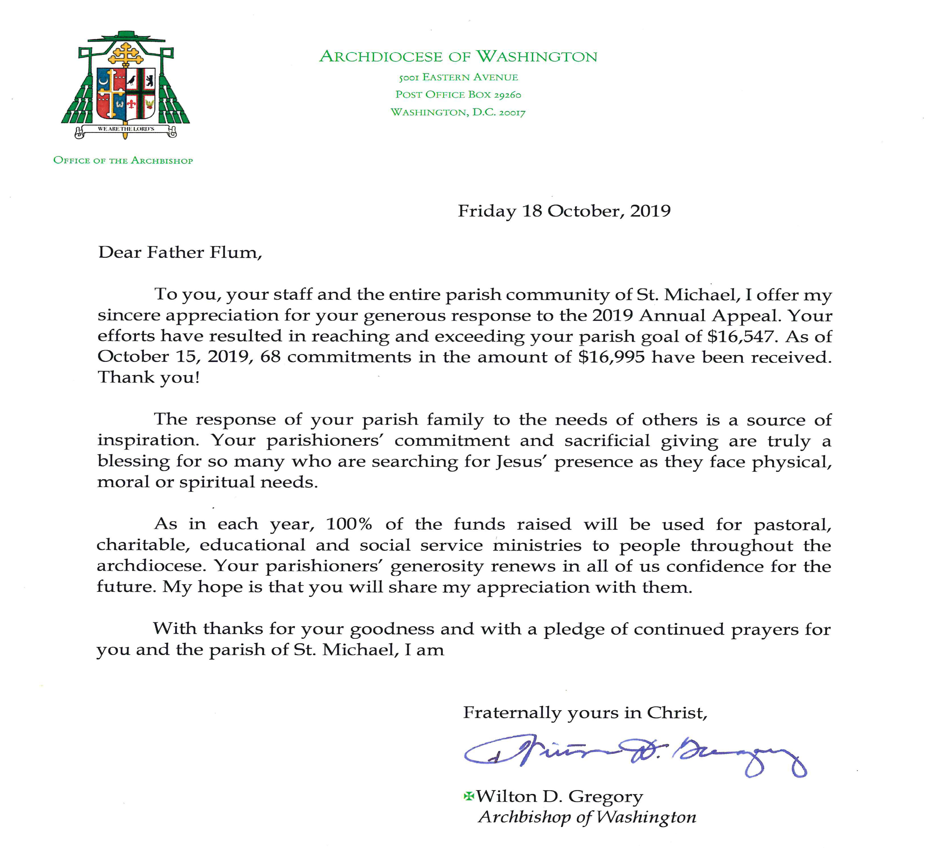
Thirty-first Sunday in Ordinary Time

Dear brothers and sisters in Christ,

A few weeks ago, the parish and mission were consecrated to the Holy Family. That formal act was a sign of our desire to live together with the Holy Family in our day to day life. It was a special invitation to the Holy Family to guide and bless our local Catholic Church. It was also an acknowledgement of the fact that God had already entrusted us to their patronage. Our response indicates a sincere willingness to receive the graces and help that we need to participate fully in the life of the family of God.
Now we are preparing to make a personal consecration to Jesus through Mary according to the method of St. Louis de Montfort. Beginning November 5th, there is a 33-day period of personal preparation for the solemn consecration that will occur on December 8th.
To assist us in the personal preparation, a series of Friday night talks are being offered that will explain how St. Louis de Montfort recommends that we proceed. His methodology was highly recommended by Pope St. John Paull II who took his papal motto “Totus Tuus,” meaning “totally yours,” from St. Louis’s treatise “True Devotion to Mary.”
The talks will continue consecutive Fridays at St. Michael’s Church at 7:30 pm with the following topics:

- on November 8 The spirit of the World
- on November 15 Knowledge of Self
- on November 22 The Blessed Virgin Mary
- on November 29 Jesus Christ, Divine Wisdom

We will complete our 33-day preparation by publicly praying together the prayer of Total Consecration to Jesus through Mary on the Solemnity of the Immaculate Conception, Sunday, December 8, during a holy hour at 4 pm. Don't miss this opportunity to learn more about Church teaching on how we can grow in holiness under the guidance of the Blessed Virgin Mary, the angels and saints.
All of that being said, the preparation for total consecration can be done without attending the talks or the Dec. 8th consummation. This series is an opportunity to deepen our understanding of consecration and to link our spiritual journeys together in Christ thru Mary.
You can obtain the preparation book at the talks or at Heavenly Presents Catholic store in Leonardtown for a half price discount or download the App or a pdf file of the preparation materials. To get more information, contact Fr. Flum 240-681-3551 or www.connectstmarys.com. Your registration is free.
Holy Family, Jesus, Mary and Joseph, save souls!
Fr. Martin Flum
READINGS FOR THE WEEK OF NOVEMBER 3, 2019
Monday: Rom 11: 29-36/ Ps 69/ Lk 14: 12-14
Tuesday: Rom 12: 5-16ab/ Ps 131/ Lk 14: 15-24
Wednesday: Rom 13: 8-10/ Ps 112/ Lk 14: 25-33
Thursday: Rom 14: 7-12/ Ps 27/ Lk 15: 1-10
Friday: Rom 15: 14-21/ Ps 98/ Lk 16: 1-8
Saturday: Ez 47: 1-2, 8-9, 12/ Ps 46/ Cor 3: 9c-11, 16-17/ Jn 2: 13-22
Next Sunday: 2 Mc 7: 1-2, 9-14/ Ps 17/ 2 Thes 2: 16-3: 5/
Lk 20: 27-38

ST. MICHAEL’S MINISTRY SCHEDULE FOR NEXT WEEK
Saturday, 11/9/19 5pm
Rosary Leader: Alice Williams Lector: Arlene Bloom
Server: James Aviles EMHC: Irene Goldsmith
Sunday 11/10/19 8am
Rosary Leader: Ron Smith Lector: TBD
Server: TBD EMHC: Joe Sobnosky
Sunday, 11/10/19 11:30am
Rosary Leader: Kevin Mondorff Lector: Maureen Ingle
Server: Kayla Aure EMHC: TBD

OUR SACRIFICIAL OFFERINGS
St. Michael’s
Offertory Collection for Oct. 27th $ 3,656
St. Dominic’s
Offertory Collection for Oct. 27th $ 892

SECOND COLLECTION
The second collection for November 2 and 3, 2019 is for the Retired Priests of the Archdiocese of Washington. This helps to provide care and housing for our retired priests.

PLEASE PRAY FOR THE SICK
For those who suffer from chronic illness, especially Martha Adams, Joe Aviles, Madison Brady, Ann Canter, Charlene Cardwell, Tom Cardwell, Joyce Chambers, Thomas Chambers, Jackie Chapman, Brianna Daniels, Dorothy Dunston, Kathy Fisher, Mabel Hamilton, Florence Henderson, Bernice Kirby, Marie Knobel, Wanda Langley, Betty Lindsay, Kenny Lindsay, Adam Lumpkins, Rachel Makle, Mike Mohun, Ralph and Regina Nasatka, Fannie Newman, Joyce Pickeral, Rev. Robert Pittman, Ann Proctor, Betty Proctor, Doris Riess, Dawn Russo, Lucille Shanks, Dee Smith, Geraldine Stewart, Willie Stewart, George Thomas, Terry Wilson and Belinda Windsor, may their crosses be joined to the Cross of Jesus.

MASS INTENTIONS
Saturday, 11/02/19 8am Krista Wells
Saturday, 11/02/19 5pm Yvette Parker
Sunday, 11/03/19 8am All Souls Intentions
Sunday, 11/03/19 10am Our Parishioners
Sunday, 11/03/19 11:30am Doris Riess +
Monday, 11/04/19 8am All Souls Intentions
Tuesday, 11/05/19 8am Doris Riess +
Wednesday, 11/06/19 8am Doris Riess +
Thursday, 11/07/19 8am Doris Riess +
Friday, 11/08/19 8am Doris Riess +

Entering Canaan - Days of Prayer and Healing
Project Rachel Ministry is offering two upcoming Entering Canaan Days of Prayer and Healing for women seeking healing from abortion. The event in English will take place on Saturday, November 23 from 9:00 am - 5:00 pm, and the event in Spanish will take place on Saturday, December 7 from 8:30 am - 5:00 pm. If you or someone working with you would like more information, please call the helpline at 301-982-2008.

Live the Gospel - Challenge of the Week
The International Week of Prayer and Fasting is from Saturday, November 2nd to Sunday, November 10, 2019. Our challenge this week is to take part in this time of prayer and fasting for the conversion of America and the salvation of the world. Do you remember the part in the gospel when the apostles are unable to cast out a demon from a young boy? Jesus comes and casts it out, and afterwards the apostles ask why they were not able to do it themselves. Jesus responds that "this kind cannot be driven out by anything but prayer and fasting."(Mark 9:29) How often we forget that although hard work for good causes is necessary, it must always be built on the foundation of prayer and fasting. See the handout in the back of the Church on the International Week of Prayer and Fasting for ideas on how to take part.
COURAGE TO SPEAK – Men’s Pre-Advent Retreat
On Saturday, November 23rd, Holy Redeemer Catholic Church in Kensington, Maryland will be hosting a Men’s Pre-Advent Retreat. Fr. Dan Leary, Pastor of St. Andrew The Apostle Catholic Church, Silver Spring and Kevin Wells Catholic author of “The Priests We Need to Save the Church” will be the speakers.
The retreat will take place from 7:30 a.m. – 11:00 a.m. It will begin with Mass, followed by a light breakfast then the speakers. Adoration and Confession will be available immediately after the retreat. Cost is $10 and all proceeds benefit Fr. Bill Ryan and the Togo Mission. Advance registration is required. To register visit:
https://membership.faithdirect.net/events/details/3528

Heavenly Presents Prayer Breakfast -- will be held at 8:30 am on Saturday, November 16 at St. Aloysius’s new Parish Hall at 22800 Washington St., Leonardtown, MD (Mass at 7:30 am). The morning will begin with music followed by recitation of the Rosary, breakfast, testimony and closing prayer. We are so blessed to have Rose Folsom who will be sharing with us "How to Harvest the Garden of your Soul!" Rose Folsom founded Virtue Connection in 2014; she has curated a Smithsonian exhibit, showed her artwork around the globe, wrote a dictionary, and served a stint in the White House. To register, call the Bread of Life Center for Peace at (301) 475-7139 or stop by Heavenly Presents in Leonardtown. You can also go online at: www.breadoflifecenterforpeace.org. If you register by Tuesday, November 12, the cost is $15, price increases to $17 after the 12th. You do not want to miss this opportunity! All are welcome - men and women!

MASSES FOR THE HOLY SOULS IN PURGATORY
During November we will be offering Masses for the repose of the souls of our beloved dead whose names were submitted to us with the “All Souls Day” envelopes. In accord with Archdiocesan policy, these “collective intentions” will be offered twice each week.

At Our Lady Help of Christians in Waldorf!
