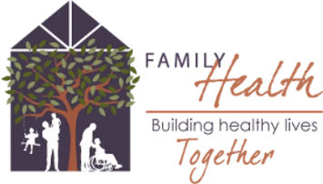
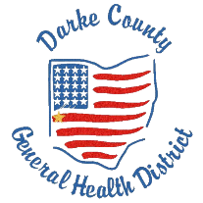
Darke County Guidelines for Quarantine After Exposure in K-12 Setting

While great strides have been made in controlling the spread of COVID-19, the virus remains a threat and the ongoing health and safety of K-12 students, staff and volunteers remain paramount. Darke County’s goal is to keep K-12 students in school, in person five days a week. Students benefit cognitively, emotionally, and developmentally from in-person learning.
This guidance can help guide quarantine decisions after a student or adult contact is exposed to someone with COVID-19 in the school setting. This guidance is not applicable to exposure in the community or household. All Darke County Schools have the option to follow this guidance document or guidance provided by Ohio Department of Health.
Prevention strategies for controlling COVID-19 during the 2021-22 school year include recommending vaccination for those eligible; recommending the use of facemasks in K-12 settings; socially distancing individuals at least 3 feet apart; prompt identification and providing appropriate care for people exhibiting symptoms of COVID-19; practicing good hygiene; and routine environmental cleaning disinfection.
The K-12 school environment is a settting in which layered public health strategies have been shown to be effective at reducing spread of COVID-19. With these strategies in place, more students will be able to remain in the classroom and continue participating in sports and extracurricular activities.
A “contact” of a positive COVID-19 case is someone who is unmasked and within 3 feet of a positive COVID-19 case for more than 15 cumulative minutes in a 24-hour time period.
How to determine quarantine for contacts of a positive COVID-19 case:
If the contact has either been fully vaccinated OR has documentation to show they have previously tested positive for COVID-19 OR has documentation to show they have COVID-19 antibodies:
-They will be able to stay at school and participate in all extracurricular activities. They will wear a mask at school for 7 days. If they remain symptom free, then no testing is needed. If the contact has any symptoms during the 7 day mask period, then a PCR or antigen test will be needed. Parents can test at day 5 if concerned with possible COVID-19. If the contact tests positive, then they will be quarantined for 10 days from the date of the positive test or onset of symptoms, whichever is earlier. The contact will be required to bring proof of vaccination, positive COVID-19 test, or positive antibody result to be placed into this group. If unable to produce proper paperwork, then the student/staff will be required to follow the requirements below.
If the contact has NOT been fully vaccinated, does NOT have documentation to show they have previously tested positive for COVID-19, and does NOT have documentation to show they have COVID-19 antibodies:
They will have two options-
1. They will have the option to quarantine at home for 10 days.
2. They can continue to attend school but will be required to wear a mask while at school. They will eat in an area away from other classmates. They will be tested (PCR or antigen) at day 5. If negative, they can stop wearing their mask after day 7 if they are not having symptoms. They can continue extracurricular activities if they wear a mask at all times until they receive a negative test result (on or after day 5). If the student tests positive, they should isolate at home for 10 days from date of the positive test of onset of symptoms, whichever is earlier.
If any contact refuses to test at day 5-7, they must wear a mask for the full ten days.
No home tests will be accepted to return to school. If using BinaxNOW kits from school, it needs to be done in the presence of the school nurse to ensure accuracy.
For more information, visit coronavirus.ohio.gov.

