Volunteer Registration & Emergency Contact Information
ST. MARY VACATION BIBLE SCHOOL
August 6th – August 10th 9am until Noon

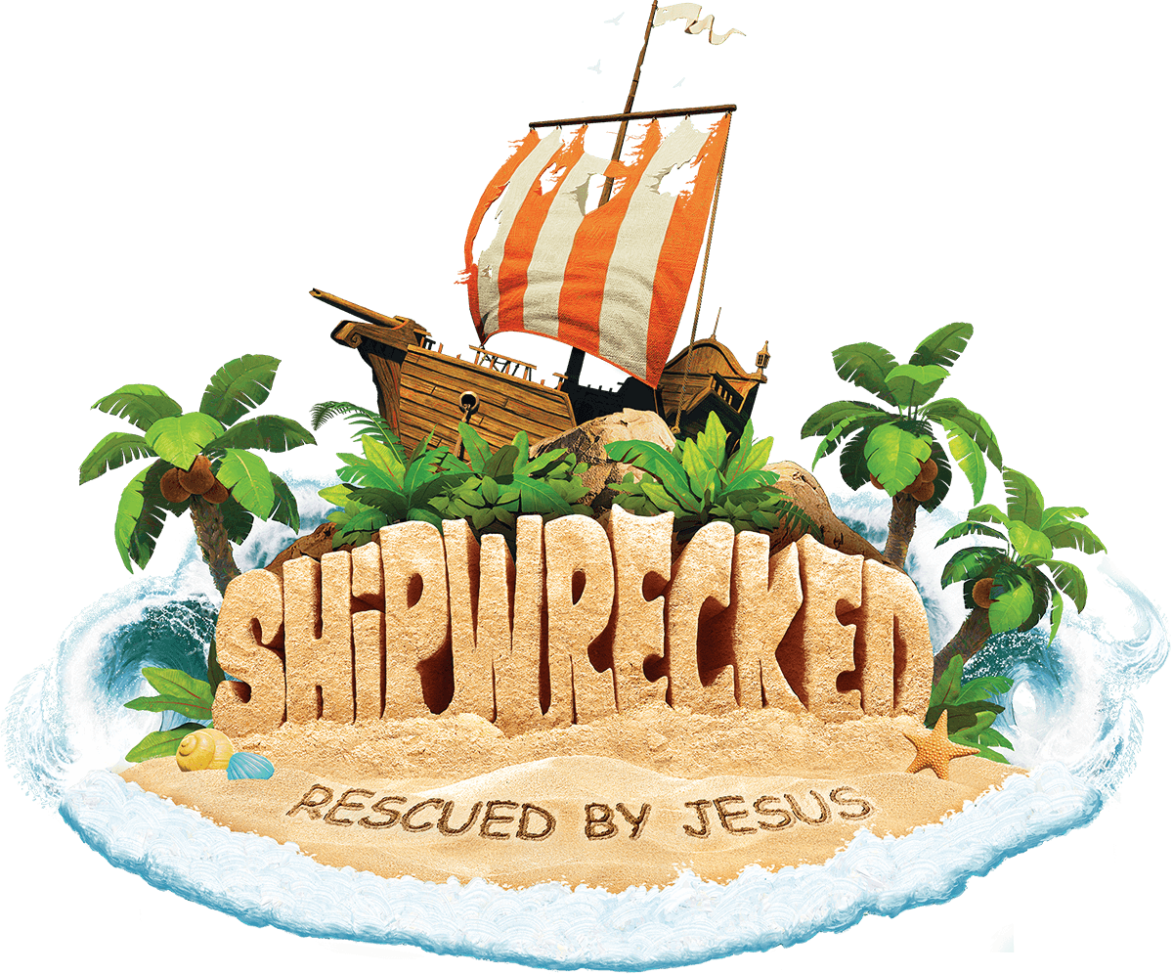

Name_____________________________________________________________

Cell #_____________________________Home Phone#____________________

Circle LAST school grade completed: 7th 8th 9th 10th 11th 12th
or are you in college adult

Are you over 18? Yes No If yes have you taken Virtus? Yes No

Is this your first year helping at VBS? Yes No
T-shirt size? S M L XL XXL

Emergency Contact Person & Phone Number

Allergies or Other Medical Conditions

The following jobs are available for VBS, please pick your top two choices:

Small group leader _____
Art room helper _____ Bible story helper _____
Snack helper _____ Games helper _____ Preschool helper _____ Help with set up_______

Will you be bringing someone for the breakfast club? Yes____No____ If Yes, how many?_____

Crew Assignment (For Parish Use Only)

For all those over 18, you MUST be certified in Virtus, protecting children from abuse. Please call the parish office to learn how to become certified.
Office # 734.475.7561 or Email smcch@aol.com

