Volunteer Registration & Emergency Contact Information
ST. MARY VACATION BIBLE SCHOOL
August 1st – August 6th 8am until Noon Saturday 4:30-6:30 Mass/Picnic

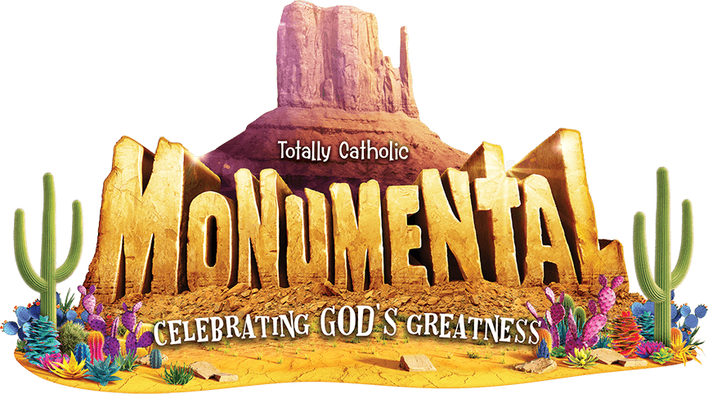

Name_____________________________________________________________

Cell #_____________________________Home Phone#____________________

Circle LAST school grade completed: 6th 7th 8th 9th 10th 11th 12th
or are you in college / adult

Are you over 18? Yes No If yes have you taken Virtus? Yes No

Is this your first year helping at VBS? Yes No
T-shirt size? S M L XL XXL

Emergency Contact Person & Phone Number
Allergies or Other Medical Conditions

The following jobs are available for VBS, please pick your top two choices:
Color leader _____ Small group leader _____
Art room helper _____ Bible story helper _____
Snack helper _____ Games helper _____
Help with set up_______
Will you be bringing someone for the breakfast club? (your child/sibling attending VBS) Yes_______ No______ If Yes, how many?_________

ChChecking this box gives St. Mary Parish permission to use your photo in all media releases (bulletin/website/social media).
Crew Assignment (For Parish Use Only)
For all those over 18, you MUST be certified in Virtus, protecting children from abuse. Please call the parish office to learn how to become certified.
Office # 734.475.7561 or Email smcch@aol.com

