Saint Mary Our Lady of Grace
Faith Formation

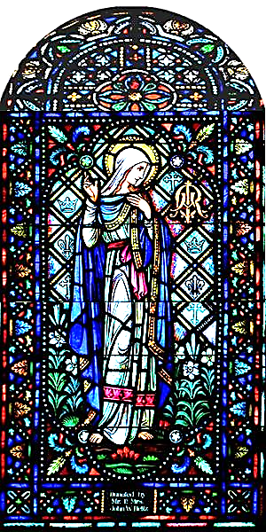
Parent/Student Handbook
2022 - 2023

Saint Mary Our Lady of Grace Parish Faith Formation Staff
Pastor: Fr. Damian Amantia, TOR
Director of Faith Formation: Mrs. Claudia McIvor
TEL: (727) 896-2191 extension 207
E-mail: cmcivor@stmaryolg.org

The Mission of Catechesis
Faith Formation or “Catechesis” is derived from a Greek term meaning “to echo” or “to resound.” Catechesis invites (each one of) us to make our own the “attitudes of Christ” as we promote knowledge of the faith, engage in the Church’s liturgical life, embrace moral living, promote a life of prayer, focus on belonging to community, and enable our missionary spirit to come alive through Christian witness. As John Paul II indicates, “The definitive aim of catechesis is to put people not only in touch but also in communion, in intimacy, with Jesus Christ.” Catechesi Trendenae, I,5

Parents and guardians “have the unique responsibility for the education of their children; they are the first educators, or catechists. They catechize primarily by the witness of their Christian lives…Parents or guardians are catechists for their children precisely because they are parents or guardians, not because they have developed any specialized skills… When children are baptized, parents accept the responsibility to bring up their children in the practice of the faith…the church promises to help parents foster their children’s faith and assist them specifically in their role as catechist of the children.”
National Directory for Catechesis

Table of Contents

Table of Contents 2
Welcome Letter from the Director of Faith Formation 3
Curriculum 4
Parish Faith Formation Guidelines 4
Admissions 4
Online Classes 4
Attendance 4
Behavior 4
Student Information 5
Program Policies 6
Non-Custodial Parents 6
Harassment Policy for the Diocese of Saint Petersburg 6
Purpose of the Policy 6
Explanation of Harassment 6
Confidentiality 7
Communication 7
Use of Parish Grounds and Facilities 7
Arrival and Dismissal Procedure 7
Absences from Intergenerational Sessions 7
Dismissal 8
Hurricane Plan for Program Cancellation 8
Right to Amend 8
Parent/Guardian and Student Agreement 8
Sacramental Preparation 9
Baptism Preparation Program 9
Sacraments of First Reconciliation, Eucharist and Confirmation 9
First Reconciliation/First Eucharist Preparation Program 9
Confirmation Preparation Program 9
Safe Environment Acknowledgement Form 11
PROMOTIONAL MEDIA RELEASE FORM - STUDENT 12
PROMOTIONAL MEDIA RELEASE FORM – PARENTS 13
Emergency Medical Release Form 14
Faith Formation Registration Form 2022-2023 15

Welcome Letter from the Director of Faith Formation

Dear Parent/Guardian,
Welcome to the Saint Mary Our Lady of Grace Faith Formation Program for children. We thank you for allowing us to be partners with you in the faith formation of your children. Faith Formation is both catechesis (education) and formation (spiritual nurturing). Our children’s program meets the basic level of religious instruction for children in elementary through middle school.
Our role at Saint Mary's is to support, assist, and encourage you as you model a Catholic Christian lifestyle for your family by your love and example. We have adopted an intergenerational model of Faith Formation that is based on all the basic teachings of the Catholic faith
In this handbook you will find additional information that will facilitate your involvement in your child’s faith journey at Saint Mary's. Please feel free to call the Faith Formation Office with questions or for further information.
I ask you to carefully read the material in this handbook. Please keep this handbook, but be sure to return the registration paperwork to me by August 20, 2022. These pages include:
Safe Environment Acknowledgement Page
Student Promotional Media Release Form
Parent Promotional Media Release Form
Emergency Medical Release Form – PLEASE SIGN IN PRESENCE OF A NOTARY
Faith Formation Registration Form (2 pages)
COVID form
Yours in Christ Jesus,
Mrs. Claudia McIvor
Director, Faith Formation
Saint Mary Our Lady of Grace Catholic Church

Curriculum
This year we will use religious education materials published by Sophia Institute Publishers. All texts follow the curriculum guidelines for the Diocese of Saint Petersburg.
Each grade level will be learning from the same Catechetical Themes (categories) at the same time. For example a second grader will be learning about The Trinity at the same time a fifth grader is learning about The Trinity. The development of the topic will be different but siblings will be learning the same overall topic.

Parish Faith Formation Guidelines

Admissions
- Saint Mary Faith Formation Program for children has an open registration policy for regular program participation from 1st through 8th grade. This means that parents may register at any time during the academic year (for example, if they have just moved to town).
- All children are welcome, regardless of race, ethnicity or creed. However, be aware that this is a Catholic faith formation program and the tenets of the Catholic Church will be taught!
- Families who wish to enroll children in Faith Formation classes must be registered parishioners.
- Children being brought to Faith Formation by someone other than the custodial parent must have a written statement of permission from the parent to participate in our program.
- Parish Registration forms should be on file at the time of program registration.
- We offer a schedule designed to accommodate the needs and flexibility of the modern family. Parents and children (and any other family members who wish to, as appropriate) should plan to attend these scheduled sessions.

Online Classes
In the event we are not able to meet in person due to the pandemic, classes will be conducted online.

Attendance
- Faithful attendance to all scheduled sessions is expected. An email (cmcivor@stmaryolg.org) or phone call (727-896-2191, ext. 207) to the Faith Formation Office is appreciated if you anticipate an absence for one of the gathered sessions.
- Some of our students do rotate their weekends with different households. If this is true for your child please make us aware of that so we can assist you in making up any missed lessons.
- Please arrive on time for our sessions. Arriving after a program has begun makes it difficult for everyone. Class sessions run 9:30 – 10:45 unless otherwise indicated on the schedule.
- Families are expected to attend Sunday Mass every week. Attending Mass is a key practice of Catholics and the Eucharist is the center or our community, individual spirituality, and nourishment for the faith journey.

Behavior
- In the event students have a special session without parents, students may enter the classrooms only if the adult aide or Catechist is in their classroom. Otherwise, students are to wait outside their classroom door for catechists to arrive.
- Students are expected to model their behavior after Jesus Christ who instituted two Great Commandments: "You shall love the Lord Your God with all your heart, and with all your soul, and with all your strength, and with all your mind; and you shall love your neighbor as yourself." (Luke 11:27).
- The following are some guidelines for behavior based upon these simple principles:
- Students properly respect and obey adults in authority.
- Students properly respect the personal space and personal property of others.
- Behavior or language that intimidates, belittles, harasses (including harassment of a sexual nature), makes inappropriate references or physically harms oneself or others will result in disciplinary action (see special Diocesan Harassment Policy page)

- In the event a student engages in inappropriate behavior any or all of the following may occur:
- Parental notification of infraction.
- Meeting between parents, Catechist and Director of Faith Formation.
- Temporary removal of student from Faith Formation program.
- Permanent removal of student from Faith Formation program.
- The Director of Faith Formation is responsible for ensuring that all sanctions against students are implemented in a fair and consistent manner by the Catechists and other volunteer staff.
- Because children will only be present on the church grounds for gathered, inter-generational sessions, and parents will be present for these, catechists and parents will be expected to work together if there are any behavioral issues
- Please do not drop off your children for faith formation. A parent/adult family member must be present at all times.

Student Information
- The Faith Formation Office keeps records of a confidential nature: Attendance, discipline, last grade completed, address, phone number, date of birth, place of birth, sacraments received, marital status of parents, disabilities, allergies, emergency contact information.
- Saint Mary Faith Formation program abides by the Privacy Act and will not disclose personal information to third parties without written permission from the persons involved. (Note: Catechists will have student’s phone numbers to contact families in case of emergency.) Parents and/or guardians have a right to review any records kept by the Formation Office pertaining to their child for any reason.
- Catechists are provided limited access to personal information as is necessary for them to perform their job. Such information would include: last grade completed, disciplinary records, address, phone number, emergency contacts, disability, allergies, and other family information when it is appropriate.
- Please make known to us any special learning needs of your child so that he or she may be better served in the program. All information is confidential.
- Health concerns should be brought to the attention of the religious education office during registration. If a child is diagnosed with a medical condition that we should know about, please inform the office and catechist as soon as possible. No medication will be administered to any student. Please contact the office if special accommodations need to be made.

Program Policies

Non-Custodial Parents
The Faith Formation program abides by the provisions of the Buckley Amendment with respect to the rights of non-custodial parents. In the absence of a court order to the contrary, we will provide the non-custodial parent with unofficial copies of records when such records are requested. If there is a court order specifying that there is to be no information given, it is the responsibility of the parent to provide us with an official copy of the court order. This is to be done at the time of program registration or as soon as a court order would become effective during the course of the school year.

Harassment Policy for the Diocese of Saint Petersburg
The Diocese of Saint Petersburg requires that each parish, Catholic school or early childhood center establish and adopt this policy that prohibits any form of harassment by any individual. The Diocese of Saint Petersburg strives for the establishment of a Christian, professional and supportive educational environment for all persons engaged in or involved with religious education programs, schools and early childhood centers, and parish youth ministry programs in non-employment situations. No parish, school, or early childhood center will be responsible for off campus harassment, unless it occurs at a parish, school, or early childhood center-sponsored event.

Purpose of the Policy
This policy intends
- that each individual is free from physical, psychological or verbal intimidation and harassment in the schools, early childhood centers, religious education and youth ministry settings;
- that each individual involved in schools, early childhood centers, religious education and youth ministry programs maintain and further develop attitudes and behaviors which express respect for others and are reflective of each person’s God-given dignity;
- to encourage a heightened sensitivity toward behaviors that others may find offensive and intimidating, whether these behaviors refer to race, religion, color, gender, sexual orientation, national origin, age, marital status, familial status, and veteran status or disability.
This policy is not intended to otherwise limit the expectation of staff, children, students, and volunteers to engage fully in the traditions of teaching, celebrating, participating in and being formed by the Catholic faith, including but not limited to curriculum, catechesis, the Sacraments, other liturgies, worship services and ministries.

Explanation of Harassment
Harassment can result from a single incident or from a pattern of behavior involving verbal, written or physical conduct or communication. Harassment encompasses a broad range of behaviors, which could include, but are not limited to:
- Physical, mental or verbal abuse
- Insults, jokes, or derogatory slurs based on one or more of an individual’s protected status(es)
- Unwelcome sexual advances or touching
- Implicit or explicit requests for sexual favors
- Unwanted sexual comments (serious or humorous)
- Unwanted sexually suggestive telephone calls, texting, letters, e-mail, etc.
- Comments or jokes based on issues of modesty and developing social awareness
- Unwanted forced involvement in activities (e.g., physical, religious, etc.)
- Coercion of religious styles or personal beliefs upon a participant
- Intimidation in front of a group or forced personal sharing in groups
- Inappropriate media or music use which would violate this policy

Confidentiality
The right to confidentiality, both of the complainant and of the accused, will be respected to the extent possible, but will be consistent with legal obligations and with the necessity to investigate allegations of misconduct and to take corrective action when this conduct has occurred.
(Citation taken from Harassment Policy for Non-Employment Situations in Schools/Centers, Parish Religious Education and Parish Youth Ministry Programs of the Diocese of Saint Petersburg, Florida).

Communication
Saint Mary Faith Formation Office, along with the Church Universal, strives to maintain open communication with all who participate in Faith Formation. We also encourage catechists and parents to keep each other informed of student progress. This will be done via an online setting, telephone calls and emails between the Catechists, Administration and parents
From time to time it may be necessary for parents to discuss issues of concern with the catechist or the Director of Faith Formation. In keeping with Church teaching and the Biblical tradition of subsidiarity, issues of concern should be resolved at the lowest possible level. Parents/guardians should attempt to resolve any issues with a Catechist by first contacting the Catechist and discussing the issue.
If satisfactory progress is not made, then the parents/guardians may contact the Director of Faith Formation to discuss the issue and request that action be taken. If the parent is not satisfied with the Director of Faith Formation’s action, only then, should the matter be taken to the Pastor.

Use of Parish Grounds and Facilities
The classrooms, facilities and grounds of our parish are used by numerous ministries and organizations. It is essential that all who participate in Children’s Faith Formation exercise the greatest amount of respect for the facilities that we share, so that all may be good stewards and enjoy the gifts God has bestowed.

Arrival and Dismissal Procedure
Children will only be released to those persons, other than parents/guardians, whose names are listed as emergency contacts or on the Registration Form. Photo identification may be required. Please notify the office if there is someone to whom your child should NOT be released.

Absences from Intergenerational Sessions
While early dismissals are discouraged, sometimes it is necessary for parents or guardians to excuse themselves and their child early from a session. Please support your child in attending all the gathered sessions as much as possible. If you must miss a gathered session due to illness or travel, please notify the Director and we will make arrangements for you to make up the work so that it will count as an “excused absence.”

Dismissal
Safety from both injury and from abduction is our top concern during arrival and dismissal. We also want to ensure a smooth and quick transition from class to home for our students. Please abide by our dismissal policy.
Parents and children attend the gathered sessions together. If a parent is unable to attend, another ADULT may accompany the child with a written note from the parent giving permission for that adult to supervise the child and remove him/her after the session. Please do not drop off your children alone.

Hurricane Plan for Program Cancellation
Should a tropical storm or hurricane be forecast to hit our area or if flooding due to a storm should affect our area, it may be necessary for Faith Formation to be cancelled. The decision to cancel children’s Faith Formation sessions will be based on local (Saint Petersburg) conditions.
If you wish to confirm the decision to cancel classes, you may contact the Director of Faith Formation at her email: cmcivor@stmaryolg.org, or call or text her cell phone at 727-492-4446. Because the decision to cancel classes may have to be made several days prior to Sunday classes, it is important to remember that the decision to close will stand firm, regardless of how beautiful the weather may be on Sunday morning. We may have had to perform extensive preparation to protect against the storm and it may take time to reopen sandbagged buildings, or to “clean-up” and prepare the property again after a storm.
Please realize loss of electricity or standing water, among other conditions may make it difficult to reach us by phone or by car. It is better to keep your family members home and safe rather than to risk adverse weather conditions to bring a student in. Our catechists and volunteer staff have family and safety obligations as well.

Right to Amend
The Pastor and Director of Faith Formation reserve the right to amend these guidelines at any time for any appropriate reason. Prompt notification of any changes made to this Handbook or any guidelines will be made in writing to all that are registered in the religious education and sacramental programs.

Parent/Guardian and Student Agreement
By signing the registration forms, the parent/guardians and students are agreeing to be governed by this Faith Formation Handbook and the rules and policies contained in it. The registration forms are kept on file for the course of the school year. Parents/guardians and students will be asked to reaffirm their agreement with a new signature sheet each year.

Sacramental Preparation

Baptism Preparation Program
- Parents of children that are infants to 6 years old are to contact the Director of Faith Formation to register for Baptism class. Parents requesting baptism must be active members of the parish for at least six months prior to the baptism.
- Parents of children and youth (7 years or older), are to contact the Director of Faith Formation for more information regarding the Children’s Catechumenate.

Sacraments of First Reconciliation, Eucharist and Confirmation

Sacramental preparation for Reconciliation, Eucharist and Confirmation is done outside of regular faith formation classes. Please read the requirements below.

First Reconciliation/First Eucharist Preparation Program
- Families of students in the second grade or older who have not received First Reconciliation/First Eucharist are eligible to register for Sacrament Preparation.
- Families of candidates must be registered in Saint Mary OLG Parish and actively participating in Sunday Mass.
- A copy of the child’s Baptismal information must be provided at the time of registration.
- The student must have completed one full year of faithful participation in a Catholic parish Faith Formation, Catholic Parochial School, or an approved Catholic home schooling religion program the school year immediately prior to registration for the sacramental preparation year.
- The student’s religious education continues in Catholic Parochial School, Parish Faith Formation, or approved home schooling while the student and parent(s) participate in the freestanding sacramental preparation process. This process may be completed at another parish if it is not offered at Saint Mary’s.
- Faithful attendance is expected for scheduled sessions. Being dropped from the program may occur if attendance is poor. A courtesy call or email to the office explaining the absence is to be made.
- Parents may be required to attend scheduled preparation meetings with their children. Please see the Sacramental Preparation Schedule provided by the Director for full details.

Confirmation Preparation Program
- The invitation to prepare for Confirmation usually takes place in the eighth or ninth grade.
- Families of Confirmation candidates must be registered in Saint Mary OLG parish and actively participating in Sunday Mass.
- A copy of the student’s Baptismal information must be provided at the time of registration for the Confirmation Preparation classes.
- The student must have completed one full year of faithful participation in religious education or Catholic Parochial School immediately prior to enrollment.
- Saint Mary’s does not offer a Confirmation Preparation class for children at this time. Eligible students can register for Confirmation at any neighboring parish. We will assist you in finding a program that works for your schedule.
- During the year that Confirmation preparation is taking place, the student will still attend monthly Faith Formation classes at Saint Mary’s.
- Faithful attendance at confirmation class is expected. Being dropped from the program may occur if attendance is poor.
- Parents are required to attend scheduled meetings and designated sessions with their child, according to the parish doing the Confirmation preparation.
- Candidates are required to select a Sponsor that can participate in the candidate's formation. Sponsors are to complete eligibility forms and attach a Sponsor Certificate from the Catholic parish where they worship weekly.

Safe Environment Acknowledgement Form

A completed copy of all forms must be on file in the parish office before your child attends class.

Parent/Student Acknowledgement Form 2022-2023

Please note that the date of the live Safe Environment presentations are listed below. You may discuss this class content with the Director of Faith Formation in advance if you wish.

Grade | Date and time of presentation
Grade 1 - 8 | Sunday, Sept. 18 from 9:30 – 10:30 AM
Parents | ONLINE Presentation offered on Sept. 18 at 2 PM

Please check all that apply and sign/print/date as appropriate in the spaces provided.
___My child(ren) will attend the Student Safe Environment Education program sessions as scheduled
___ I, the parent or guardian, would like to attend the ONLINE Safe Environment Presentation for Parents this year.
___I cannot attend the Parent Safe Environment Education Program, but I wish to receive all additional (beyond handbook policies) materials related to the Safe Environment Parent/Student Education Program.
___I cannot attend the Parent Safe Environment Education Program, and I do not wish to receive the materials (beyond handbook policies) related to the Safe Environment Parent/Student Education Program.

Parent/Guardian: ________________________________________________________________________________________________________________
Signature Print Name Date

Parent/Guardian: ________________________________________________________________________________________________________________
Signature Print Name Date

___________________________ _______________________________ Child 1 Name Printed Child 3 Name Printed
___________________________ _______________________________ Child 2 Name Printed Child 4 Name Printed

PROMOTIONAL MEDIA RELEASE FORM - STUDENT

STUDENT Promotional Media Release Form
2022-2023

During the Faith Formation Program Year 2020 - 2021, Saint Mary Our Lady of Grace may participate in videotape, motion picture, audio recording or still photograph productions that involve the use of students’ names, likenesses or voices. Such productions may be used for educational or exhibition purposes by Saint Mary Our Lady of Grace in perpetuity and may be copied, copyrighted, edited and distributed by Saint Mary Our Lady of Grace in perpetuity unless said consent is revoked in writing.

News media, including representatives of television, radio, newspapers and magazines, also often are permitted on parish property and may take notes, still, photos, sound recordings and/or videos that may include your child. These items may appear or be used in news or feature stories by print, television or radio media.

You have the right to object to the use of your child’s name, picture or voice in these productions and may do so by completing the form below and returning it to the Parish Director of Faith Formation for Saint Mary Our Lady of Grace.

If you have any questions, please contact the Faith formation office at:
727-896-2191, extension 207. Please return this form by August 20, 2022.

I/We, the undersigned DO – DO NOT hereby consent that:
(Circle One)
Saint Mary Our Lady of Grace may use the name, portrait, or other likeness of my child for Saint Mary Our Lady of Grace bulletin boards, Website, news releases, videos, media, and promotional activities. This consent is renewed at the beginning of each Faith Formation Program Year.

(complete one form for each child)

Student’s Name Date of Birth

__________________________________ _________________

________________________________ ______________________________

Father or Legal Guardian’s Name (print) Father or Legal Guardian’s Signature

_____________________________________ ____________________________________
Mother or Legal Guardian’s Name (print) Mother or Legal Guardian’s Signature

Today’s Date __________________________

PROMOTIONAL MEDIA RELEASE FORM – PARENTS

PARENT Promotional Media Release
2022-2023

During the Faith Formation Program Year 2020-2021, Saint Mary Our Lady of Grace may participate in videotape, motion picture, audio recording or still photograph productions that involve the use of your name, likeness or voice. Such productions may be used for educational or exhibition purposes by Saint Mary Our Lady of Grace in perpetuity and may be copied, copyrighted, edited and distributed by Saint Mary Our Lady of Grace in perpetuity unless said consent is revoked in writing.

News media, including representatives of television, radio, newspapers and magazines, also often are permitted on parish property and may take notes, still, photos, sound recordings and/or moving pictures that may include your child. These items may appear or be used in news or feature stories by print, television or radio media.

You have the right to object to the use of YOUR name, picture or voice in these productions and may do so by completing the form below and returning it to the Parish Director of Faith Formation for Saint Mary Our Lady of Grace.

If you have any questions, please contact the Faith formation office at:
727-896-2191, extension 207. Please return this form by August 20, 2022.

I/We, the undersigned, DO – DO NOT hereby consent that:
(Circle One)
Saint Mary Our Lady of Grace may use MY name, portrait, or other likeness for Saint Mary Our Lady of Grace bulletin boards, website, news releases, media and promotional activities. This consent is renewed at the beginning of each Faith Formation Program Year.

PARENT/ GRANDPARENT FORM

________________________________ ______________________________
Name (print) Signature

_____________________________________ ____________________________________
Name (print) Signature

Date ___________________________________

Emergency Medical Release Form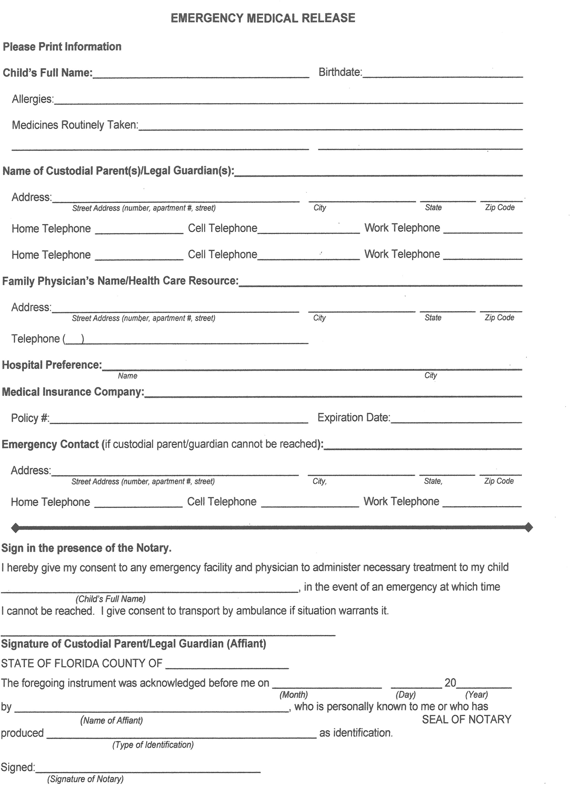

Faith Formation Registration Form 2022-2023
Please return this two-page form to the parish office before August 20, 2022
 | Mother | Father | Child 1 | Child 2
Last Name

First Name

Title (Dr., Mr. Ms., Mrs., etc.)

Grade Entering
In 2020

Gender M/F

Allergies
(Please describe)
Primary Language

Date of Birth

Baptized – Y/N and Faith

First Reconciliation
Y/N

First Communion
Y/N

Confirmation
Y/N
Form continues on the next page.

2022-2023 Faith Formation Registration Form, page 2
Family Name

Mailing Address - Street

City, State and ZIP Code

Home Telephone

Father’s Cell Phone

Mother’s Cell Phone

Primary email address

LOCAL Emergency Contact (in case we can’t get in touch with the parents – for emergency only.)

Name and phone number

Payment Information
The cost of materials is $40 for each child. This fee allows us to purchase the Pflaum Gospel Weekly materials printed and digital access and helps provide other needed materials throughout the year.
Several of our families are unable to pay this enrollment fee through no fault of their own. If you are able to contribute additional funds to help cover another child, we thank you very much. We will never turn a family away because they are unable to pay.
Amount Enclosed __________________________
Please make out checks to “Saint Mary OLG” and put “Faith Formation” in the memo line.
Thank you for allowing us to partner with you in the faith formation of your child!

