Saint Mary Our Lady of Grace Presents a Three-Session Program
Spiritual First Aid: Helping People Cope with COVID-19

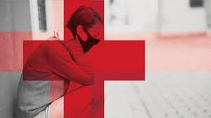
Saturday Mornings on Zoom
August 15, 22 and 29, 2020
9:30 – 11:00 AM
Register in advance for this meeting:
https://us02web.zoom.us/meeting/register/tZAtcO-orTsiGtQhA3gSYtyYaIUIN2OGTx9j
You will then receive a confirmation email containing information about joining the meeting.
For more information, contact Jim Messina at jamesjmessina@gmail.com

During the COVID-19 pandemic, mandated shutdowns have often abruptly disconnected a person’s usual access to their sources of community. People cope better when they can seek and receive support during a time of uncertainty. Learn how to “be there” for people who are seeking help. This series is free, and you will learn helpful skills, including the following:

- How to address the spiritual needs of others who are impacted in these times of COVID-19, and of social and economic distress.
- How to assist those who are impacted by physically distancing, sheltering in-place, and dealing with their life needs remotely.
- How to use a step-by-step approach to provide spiritual and emotional care for others through Spiritual First Aid.
- How to listen with care and concern to those who are suffering from job layoffs, workplace shutdowns, physical distancing, and financial hardship.
- How to identify safety concerns.
- How to use the three basic steps of Spiritual First Aid with people: ATTEND, ASK, and ACT.
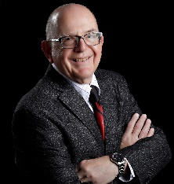
This series of presentations and discussions will be led by James Messina, Ph.D., CCMHC, NCC, DCMHS-T. Jim is a Licensed Psychologist and teaches in the Graduate Clinical Mental Health Counseling Program at Troy University Tampa Bay Site. He has been a member of Saint Mary for four years. He and his wife Connie lead the Little Rock Bible Study for the parish. His Coping with COVID-19 Tip Sheet is located on his website at: http://www.coping.us/covid19copingtips.html

