Schedule for 7th & 8th Grade
September 2018 to July 2019

Parent Meeting
- Sept 6^{h} – 6:30 to 7:30pm

Classes:
Sunday from 5:30-7:00
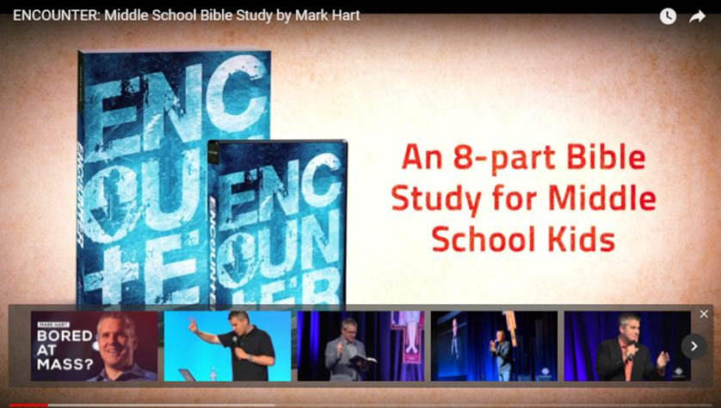
- Sept 9th
- Oct 21st
- Nov 4th
- Dec 9th
- Jan 6th
- Feb 10th - Winter Rally from 4-8
- Mar 10th
- Apr 7th

Service Projects:
- Sept 23rd
- Nov 17th & 18th - Thanksgiving Dinner for Seniors
- Dec 16th
- Jan 20th
- Feb 10th - Setup and take down of Winter Rally
- Tentative Date: June 29th - July 1st - Vermont Catholic Youth Serve - 8th Grade Only
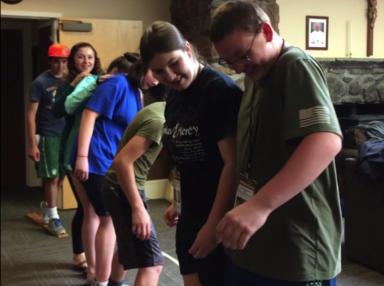

Class/Family Trips:
- Rally’s: (7th to 12th grades, includes a parent track.)
  - Oct 7th Fall Youth Rally – Chris the King in Burlington 12:30 to 7:00
  - Feb 10th - Winter Rally – St. Monica’s in Barre from 4 – 8pm
  - Mar 15th - Concert at St. Michael’s School in Brattleboro
Providing a Catholic Community for our Students and their Families
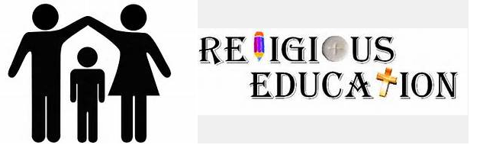

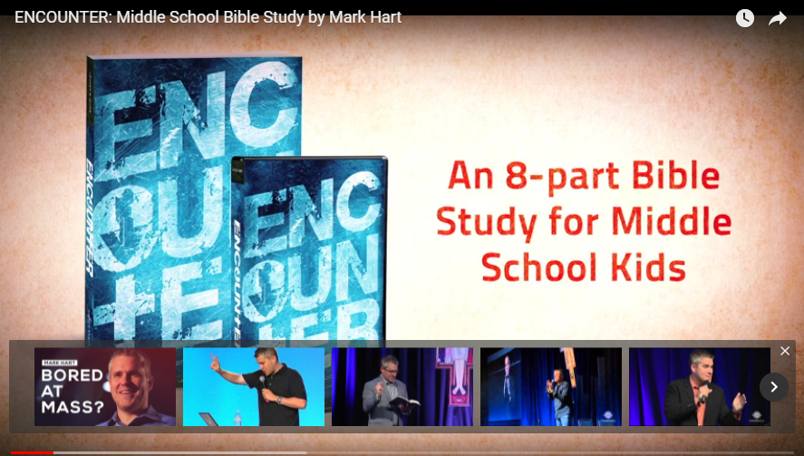
  - Learning about their faith – Encounter with Mark Hart
- Students will be provided with an Encounter Workbook and will need to bring their 5th grade bible to class

  - Serving Others as Pope Francis’ Mission of Service
The signs to understand what we are moving toward, the Pope said, “are in your heart: if you love and are attached to money, to vanity and pride, you are on that bad path; if you seek to love God, to serve others, if you are gentle, if you are humble, if you serve others, you are on the good path”. And thus, “your identity card is good: it’s from Heaven”. Friday, 7 November 2014

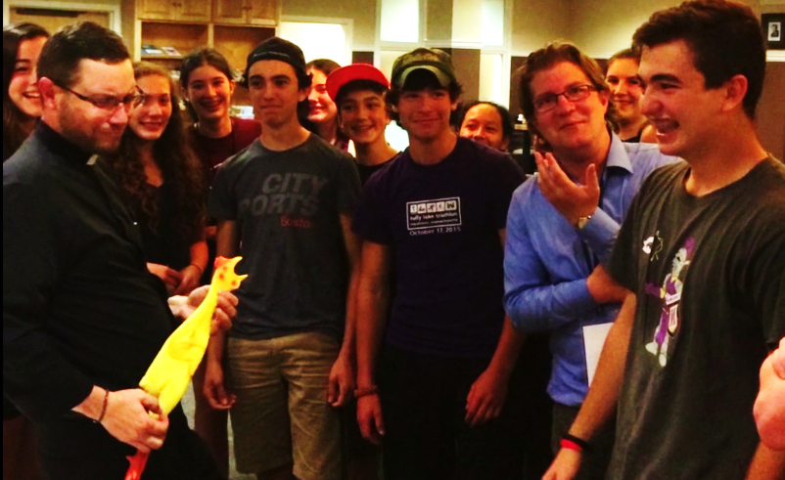
  - Engaging our Students by attending Events - where they can participate in activities and meet other teens with the same beliefs.

All Volunteers/Chaperones (Parents and Grandparents included)
Will need to complete Safe and Sacred

Safe and Sacred
Safe and Sacred is an online training program designed to streamline the important child safety elements for the attendees and the leaders responsible for a school, parish, or other organization.
Safe and Sacred can be found on vermontcatholic.org – under Child Safety
By participating online in the Safe and Sacred program, volunteers/employees will:
• Receive their safe environment training (annually for those who directly serve minors, and for those who are in positions of trust and authority)
• Complete their background screening form (every five years)
• Read the Diocesan Policies on Ethics and Integrity in Ministry (every five years)
• Sign the Code of Conduct (annually)
• If driving – will complete the Driver Information and return to the Religious Ed Office

Drivers:
The following guidelines should be strictly observed when Church personnel are involved in the transportation of minors:
- Ordinarily, except in an emergency, minors should never be transported without written permission.
- Minors should be transported directly to their destination. No unauthorized stops should be made.
- Church personnel should avoid unnecessary and/or inappropriate physical contact with minors while in vehicles.
- Drivers who are assigned to transport minors must be at least 25 years old.
- Ordinarily, except in an emergency, minors should not be transported by one adult alone.
- Non-trained parent drive ONLY their kids, and not someone else’s children.

The Diocesan Policy on Ethics and Integrity in Ministry
Relationships among people are the foundation of Christian ministry and are central to Church life. Defining healthy and safe relationships is not meant, in any way, to undermine the strength and importance of personal contact or the ministerial role. Rather, it is to assist all who fulfill the many roles that create the living Church to demonstrate their love and compassion for children and adults in the most sincere and genuine relationships.
It is with the intention that relationships in ministry be experienced at all times as charitable and without intention to do harm or allow harm to occur, that the following policy has been adopted by the Diocese of Burlington. All Church personnel are asked to carefully consider each standard in the Code of Conduct and within the Policies on Ethics and Integrity in Ministry before agreeing to adhere to the standards and continue in service to the Diocese.
- Church personnel will exhibit the highest Christian ethical standards and personal integrity.
- Church personnel will conduct themselves in a manner that is consistent with the discipline and teachings of the Roman Catholic Church.
- Church personnel shall provide a professional work environment that is free from physical, psychological, written, or verbal intimidation or harassment.
- Church personnel will avoid taking unfair advantage of a counseling relationship for the benefit of themselves.
- Church personnel will not physically, sexually or emotionally abuse or neglect a minor or an adult.
- Church personnel will share concerns about suspicious or inappropriate behavior with their pastor, their principal, the Office of the Vicar General or the Review Board.
- Church personnel will report any suspected abuse or neglect of a minor to the Vermont Department for Children and Families (DCF).
- Church personnel will accept their personal responsibility to protect minors and adults from all forms of abuse.

