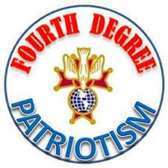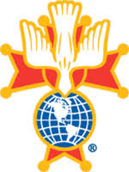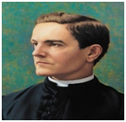A



**San Damiano**

**Knights of Columbus Assembly 3192**

**Faithful Navigator**

[**Sam Bastianelli**](mailto:sambastianelli@gmail.com)

**Faithful Comptroller**

[**Vinnie Cipriano**](mailto:vinne1248@outlook.com)

**Faithful Captain**

[**Larry Simmons**](mailto:lsimmons1965@gmail.com)

**Faithful Admiral**

[**Frank Shea**](mailto:francis.shea@floridakofc.org)

**Faithful Purser**

[**John Gallo**](mailto:jjgallosr@hotmail.com)

**Faithful Pilot**

[**Jeffery Filippi**](mailto:mdstormbusters@yahho.com)

**Faithful Scribe**

[**Mike Burk**](mailto:mlb0094@yahoo.com)

**Inner Sentinel**

[**Vinnie Alesi**](mailto:vincar@tampabay.rr.com)

**Outer Sentinel**

[**Ray Makovec**](mailto:raymak48@verizon.net)

**Trustee –1 yr.**

[**Richard Pless**](mailto:richlinp1@outlook.com)

**Trustee -2 yr.**

[**Ernie Soller**](mailto:%09Ernest%20Soller%20%3cefsoller@hotmail.com%3e)

**Trustee-3 yr.**

**Stephen Anzalone**

**Color Corp**

**Bob Hellner**



**Volume (2020) Issue (11)**

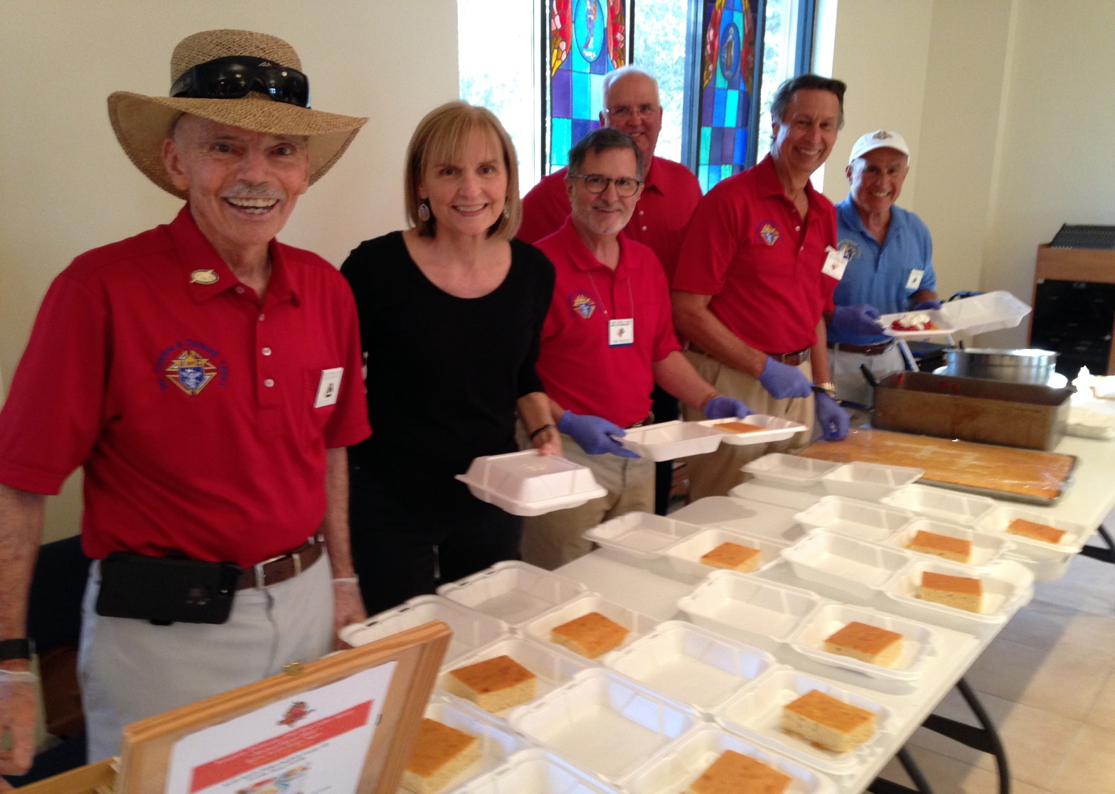

**Assembly 3192**

**Our Lady of the Angels**

**12905 70 East**

**Lakewood Ranch**

**Florida 34202**

**Phone (941)-752-6770  
Fax (941)-752-6821  
Email:** [**parishinfo@olangelscc.org**](mailto:parishinfo@olangelscc.org)

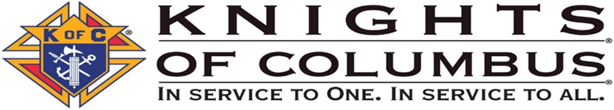

|  |
| --- |
| 3 Sir Knights participated in two Group Pinning Ceremonies in November 2019:   * 30 Veterans at Sheridan Assisted Living Facility in LWR November 5th. * 50 Veterans at Kaiser University in Sarasota November 7th.   The Sheridan event included singing of patriotic songs, individual recognition of each Veteran and each branch of the service followed by the theme song for each branch, invocation, and presentation of the pins. Approximately 30 spouses, families and friends were also in attendance.  The Kaiser University event included the University who prepared a red, white and blue ribbon with a US flag pin which was placed around the neck of the veterans who were also given a gift bag with some gift cards.  The University has about 170 students or faculty that at some point had served in the military. Approximately 60 Veterans were pinned ranging in age from their mid-20’s to 50’s.  In addition, approximately 50 spouses, families and friends were present.  This activity was coordinated by DGK John Joly, the Knights of Columbus Program Director and Tidewell Hospice Chair.  **Our Brother Knights have now participated in 2 *group* Pinning Ceremonies to date and, 26 *individual* Veteran Honors Program Pinning Ceremonies within the second half of 2019.** |

<https://tidewellhospice.org/home/programs/for-veterans/>

<https://business.facebook.com/TheSheridanatLakewoodRanch/>

<https://www.keiser-education.com/about-keiser/military>

