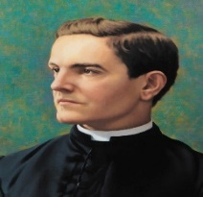
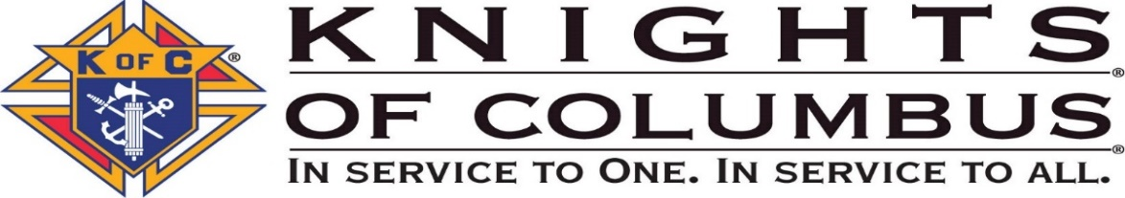
Knights of Columbus
Our Lady of the Angels Council 13341
Saints Cosmas and Damian

Fraternal Activities Report
Name of Activity: ______________________
Program (Faith, Family, Life, Membership or Community): _______________
Date(s) of Activity: ______________
Submitted by: ______________________________
Description of the Activity

Summary Report
Number of Meetings Held for this Activity

Activity Expenses – Dollars Only

Activity Profit (if applicable) – Dollars Only

Charitable Disbursements – Dollars Only

Knight’s Participant - Volunteer Hours

Other Participants* – Volunteer Hours

Miscellaneous Notes

* “Other Participants” mean people who attended who were not Brother Knights.
Names of Brothers Who Attended or Attach Sign-in Sheet
1.
2.
3.
4.
5.
6
7.
8.
9.
10.
11.
12.

Names of Other Participants Who Attended or Attach Sign-in Sheet
1.
2.
3.
4.
5.
6

Directions:
Until further notice, submit this report, with pictures, to Council Program Manager Brother John Joly for PR purposes at jojoly@earthlink.net. Be sure to identify individuals within pictures (from L-R).
Submit this report, with pictures, to Recorder Brother Jim Thompson at jimthompsoncc@gmail.com for the Newsletter publication. Be sure to identify individuals within pictures (from L-R).
Submit this report, with pictures, to Website Manager Chuck Kennedy cwk7954@verizon.net for posting on the website.
Submit this report to the WGK John Joly jojoly@earthlink.net & DGK Jerry Graceffo graceffojr@gmail.com
Submit this report to the Director of the appropriate Program (Life, Community, Family, Faith, Membership) to share at the next Council Business Meeting, and to file a summary with the Florida KofC for award consideration at the next Annual Convention.
Directors are asked to keep this report to help complete the Annual Survey of Fraternal Activities – Form 1728 which is due on January 31 every year covering the previous calendar year.

