Feast of St. Joseph
March 19th at 6:30 PM

Solemn Sung Vespers
featuring: Schola Sancti Joseph & St. Joseph Choir

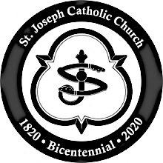

St. Joseph Church
151 W. Washington Street
Petersburg, VA 23803

For more information: amdonlon@sjcpetersburg.com

