** IF YOU’RE NOT SURE HOW TO COMPLETE THIS FORM, PLEASE SEE THE DIRECTIONS ON THE LAST PAGE **
Version 2 – August, 2018 | Highlighted Entries denote new vendors
☐I will pick up my order at Mass.
☐4:30pm ☐8:00am ☐10:00am
☐I will pick up my order in the parish office.
☐I would like my order mailed to me.
St. Bernard Parish SCRIP Order Form
Your Name:
Address:
Telephone:
Email:

Card Description | Card Value | Profit | QTY | Total
A
Abercrombie & Fitch | $10.00 | 5.00% |  | $
Ace Hardware | $25.00 | 4.00% |  | $
Advance Auto Parts | $25.00 | 7.00% |  | $
Airbnb | $10.00 | 5.00% |  | $
Amazon.com | $25.00 | 2.25% |  | $
Amazon.com | $100.00 | 2.25% |  | $
AMC Theatres | $10.00 | 8.00% |  | $
American Airlines | $100.00 | 6.00% |  | $
American Express | $25.00 | 1.25% |  | $
American Express | $100.00 | 1.50% |  | $
Apple App Store / ITunes | $10.00 | 5.00% |  | $
Applebee’s | $25.00 | 8.00% |  | $
Arby’s | $10.00 | 8.00% |  | $
AutoZone | $25.00 | 8.00% |  | $
Avis Car Rental | $50.00 | 8.00% |  | $
B
Buffalo Wild Wings | $10.00 | 8.00% |  | $
Bed, Bath & Beyond | $25.00 | 7.00% |  | $
Bath & Body Works | $10.00 | 12.00% |  | $
Barnes & Noble | $25.00 | 8.00% |  | $
Best Buy | $25.00 | 4.00% |  | $
Best Buy | $100.00 | 4.00% |  | $
Burger King | $10.00 | 4.00% |  | $
BP Gas Stations | $50.00 | 1.50% |  | $
Bass Pro Shops | $25.00 | 8.00% |  | $
Best Western | $25.00 | 12.00% |  | $
Boston Market | $10.00 | 12.00% |  | $
Budget Car Rental | $50.00 | 8.00% |  | $
Burlington (Coat Factory) | $25.00 | 8.00% |  | $
C
Chili’s | $25.00 | 11.00% |  | $
Chipolte Grill | $25.00 | 10.00% |  | $
CVS Pharmacy | $25.00 | 6.00% |  | $
Cabela’s | $25.00 | 8.00% |  | $
Cracker Barrel | $25.00 | 8.00% |  | $
Capitol ChopHouse | $25.00 | 8.00% |  | $
Caribou Coffee | $10.00 | 6.00% |  | $
Carnival Cruise Lines | $10.00 | 8.00% |  | $
Celebrity Cruise Lines | $10.00 | 9.00% |  | $
Cenex Gas Stations | $25.00 | 3.00% |  | $
Cheesecake Factory | $25.00 | 5.00% |  | $
Clarion Hotels | $50.00 | 3.00% |  | $
Cold Stone Creamery | $10.00 | 11.00% |  | $
Comfort Inn Suites | $50.00 | 3.00% |  | $
Copps Food Stores | $25.00 | 4.00% |  | $
Cousins Subs | $10.00 | 9.00% |  | $
Culver’s | $25.00 | 10.00% |  | $
D
Delta Air Lines | $250.00 | 4.00% |  | $
Dunkin Donuts | $10.00 | 3.00% |  | $
Dick’s Sporting Goods | $25.00 | 8.00% |  | $
Domino’s Pizza | $10.00 | 8.00% |  | $
Dairy Queen | $10.00 | 3.00% |  | $
Discover | $50.00 | 1.25% |  | $
Denny’s | $10.00 | 7.00% |  | $
DoubleTree (Hilton) | $100.00 | 2.00% |  | $
E
Einstein Bros. Bagels | $10.00 | 10.00% |  | $
F
Festival Foods | $25.00 | 3.00% |  | $
Famous Footwear | $25.00 | 8.00% |  | $
Fannie May Candies | $10.00 | 25.00% |  | $
Fazoli’s | $25.00 | 7.00% |  | $
Fleming’s Steakhouse | $25.00 | 8.00% |  | $
Food Fight Restaurants  (see reverse side for participating restaurants) | $25.00 | 10.00% |  | $
Foot Locker | $25.00 | 8.00% |  | $
Fuddruckers | $25.00 | 8.00% |  | $
G
Gap Stores | $25.00 | 14.00% |  | $
GNC Stores | $25.00 | 8.00% |  | $
Gordon Food Service | $25.00 | 4.00% |  | $
Grand Geneva Resort | $25.00 | 8.00% |  | $
Great Clips | $25.00 | 8.00% |  | $
H
Hilton Hotels | $100.00 | 2.00% |  | $
Hotels.com | $100.00 | 6.00% |  | $
Hampton Inn & Suites | $100.00 | 2.00% |  | $
Hardee’s | $10.00 | 5.00% |  | $
Home Depot | $25.00 | 4.00% |  | $
HyVee Stores | $50.00 | 5.00% |  | $
I
Apple App Store / ITunes | $10.00 | 5.00% |  | $
IHOP Restaurants | $25.00 | 8.00% |  | $
J
JCPenny | $25.00 | 5.00% |  | $
Jo-Ann Fabrics | $25.00 | 6.00% |  | $
Jiffy Lube | $30.00 | 8.00% |  | $
Joseph A. Bank | $25.00 | 10.00% |  | $
K
Kohl’s | $25.00 | 4.00% |  | $
Kwik Trip | $25.00 | 4.00% |  | $
L
Little Caesar’s Pizza | $20.00 | 8.00% |  | $
LL Bean | $25.00 | 16.00% |  | $
Long John Silver’s | $10.00 | 8.00% |  | $
Longhorn Steakhouse | $25.00 | 8.00% |  | $
M
Macy’s | $25.00 | 10.00% |  | $
Madison Originals  (see reverse side for participating restaurants) | $25.00 | 10.00% |  | $
Menard’s | $25.00 | 3.00% |  | $
Marathon Gas Stations | $25.00 | 3.00% |  | $
Marcus Theatres | $25.00 | 8.00% |  | $
Metro Market | $25.00 | 4.00% |  | $
Mill’s Fleet Farm | $25.00 | 3.50% |  | $
Mobil Gas Stations | $50.00 | 1.00% |  | $
N
Noodles & Company | $10.00 | 8.00% |  | $
Nike | $25.00 | 12.00% |  | $
Nordstrom | $25.00 | 6.00% |  | $
O
Outback Steakhouse | $25.00 | 8.00% |  | $
Old Navy | $25.00 | 14.00% |  | $
Office Depot / OfficeMax | $25.00 | 5.00% |  | $
Olive Garden | $25.00 | 8.00% |  | $
Overstock.com | $25.00 | 8.00% |  | $
P
Panera Bread | $25.00 | 8.00% |  | $
PF Chang’s | $25.00 | 8.00% |  | $
Pottery Barn | $25.00 | 8.00% |  | $
Pizza Hut | $10.00 | 8.00% |  | $
Pet Smart | $25.00 | 5.00% |  | $
Papa John’s Pizza | $10.00 | 8.00% |  | $
Papa Murphy’s Pizza | $10.00 | 8.00% |  | $
Piggly Wiggly Stores | $25.00 | 3.00% |  | $
Payless Shoes | $20.00 | 13.00% |  | $
Pfister Hotel | $25.00 | 8.00% |  | $
Pick ‘n Save Stores | $25.00 | 4.00% |  | $
Pizza Ranch | $25.00 | 8.00% |  | $
Pizzeria Uno | $25.00 | 12.00% |  | $
Potbelly | $10.00 | 8.00% |  | $
Q
Qdoba Mexican Grill | $25.00 | 7.00% |  | $
R
Red Lobster | $25.00 | 8.00% |  | $
Red Robin | $25.00 | 8.00% |  | $
Roundy’s | $25.00 | 4.00% |  | $
Rodeway Inn | $50.00 | 3.00% |  | $
Ruth’s Chris Steakhouse | $50.00 | 10.00% |  | $
S
Subway | $10.00 | 6.00% |  | $
Starbucks | $10.00 | 7.00% |  | $
Speedway Gas Stations | $25.00 | 4.00% |  | $
Shell Gas Stations | $25.00 | 1.50% |  | $
Staples | $25.00 | 5.00% |  | $
Shopko Stores | $25.00 | 3.00% |  | $
Sears | $25.00 | 4.00% |  | $
Sentry Stores | $50.00 | 3.00% |  | $
Southwest Airlines | $10.00 | 4.00% |  | $
Super Cuts | $25.00 | 8.00% |  | $
T
Target Stores | $25.00 | 2.50% |  | $
Taco Bell | $10.00 | 5.00% |  | $
Texas Roadhouse | $25.00 | 8.00% |  | $
TGI Friday’s | $25.00 | 9.00% |  | $
TJ Maxx | $25.00 | 7.00% |  | $
V.W
Visa | $50.00 | 1.25% |  | $
Wendy’s | $10.00 | 4.00% |  | $
Walmart Stores | $25.00 | 2.50% |  | $
Walgreens | $25.00 | 5.00% |  | $
Whole Foods | $25.00 | 3.00% |  | $
Woodman’s Markets | $50.00 | 5.00% |  | $
Woodman’s Markets | $100.00 | 5.00% |  | $

Directions for Completing This Form
To order cards, enter the number of cards you’d like in the box marked “QTY”. Multiply the card value by the QTY and write the total on the total line. For example:
Example Vendor | $25.00 | 2.50% | 6 | $150.00
Food Fight Restaurants
The following restaurants are members of the Food Fight Restaurant Group: Aldo’s Café, Avenue Club and Bar, Bassett Street Brunch Club, Canteen, Cento, Coopers Tavern, Craftsman Table & Tap, Dlux, Eldorado Grill, Everly, Fresco, Hubbard Ave. Diner, Johnny Delmonico’s, Luigi’s Pizza, Market Street Diner, Miko Poke, Monty’s Blue Plate Diner, Steenbock’s on Orchard, Tex Tub’s Taco Palace
Madison Originals
The following restaurants are members of Madison Originals: 1847 @ the Stam House, A Pig in a Fur Coat, Banzo, Bonfyre American Grille, Brasserie V, Captain Bill’s (Middleton), Charlie’s on Main (Oregon), CIRC, Club Tavern (Middleton), Cow & Quince (New Glarus), Crema Café, Daisy Café & Cupcakery, Delaney’s Charcoal Steaks, Dobhan, Dotty Dumpling’s Dowery, Essen Haus, Hafvest, Ian’s Pizza by the Slice, Imperial Garden West (Middleton), jacs Dining & Tap House, Liliana’s, Lombardino’s Italian, Manna Café & Bakery, Mariner’s Inn, Nau-Ti-Gal, Nitty Gritty (Madison, Middleton & Sun Prairie), Old Fashioned, Old Feed Mill (Mazomanie), Paisan’s, Parthenon Gyros, Pizza Brutta (Madison & Middleton), Porta Bella, Quivey’s Grove, Rockhound Brewing Co., Roman Candle, (Madison, Fitchburg, Middleton), Short Stack Eatery, Smoky’s Club (Madison), Tipsy Cow, Tornado Club Steak House, Wisconsin Brewing Tap Haus, Wonder Bar and Yola’s Café.

Order Total
Please add all of your totals together and write or type the grand total of your order in the box below:

$
order total
Payment Information

☐A check is enclosed.
☐Payment through the e~Funds system.
Please log in to your account and send payment using the
SCRIP Sales payment item.
☐Please charge my
☐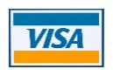
☐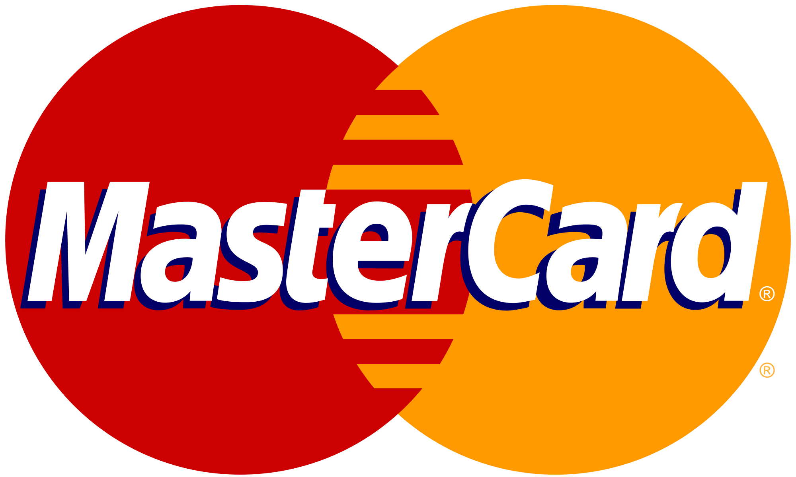
☐
credit card account number (make sure to print clearly)
card expiration date
card security code (csv)
billing address zip code
If you have any questions,
Please contact the Parish Office, 249-9256 or email scrip@sbmsn.org
Thank you for your support of our parish SCRIP Program!
Profits help our parish operations budget and buildings and grounds.

