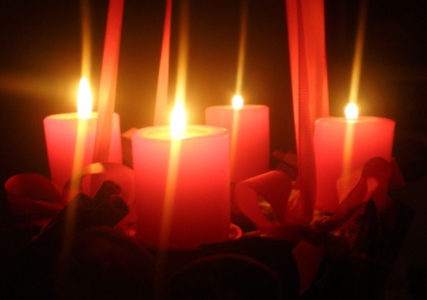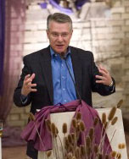

*Take a break from the hustle and bustle of Christmas preparations to renew your spirit.*

*Join us as Dan leads us in a reflection on the Advent readings as we prepare for Christ’s birth.*

Ever get too caught up in preparing for “secular” Christmas?

Does the busyness of decorating, baking and shopping prevent you from finding quiet time to ponder the coming of the Christ child?

Do the Christmas carols playing on radio stations in November cause you to skim right over Advent preparation time?

This is your chance to spend some time in spiritual preparation for the coming of Christ anew in our broken world.

With Dr. Daniel Scholz, Ph.D.

*Dean of the College of Arts and Sciences at Cardinal Stritch University*

Saturday, Dec. 2, 2017

9-11 am

In the Our Lady of the Lakes Community Room

230 Butler St., Random Lake, WI 53075

*Dan is a Scripture Scholar and has taught Scripture at Pius XII High School,*

*St. Francis Seminary and Cardinal Stritch University. He is a frequent presenter at parishes throughout the*

*Archdiocese of Milwaukee.*

*Dan and his wife Bonnie*

*have three children.*

Dr. Scholz is an engaging speaker with a good sense of humor.

ALL FAITH DENOMINATIONS ARE WELCOME TO ATTEND.

Contact Deb Hamm at [ministerofaging@hotmail.com](mailto:ministerofaging@hotmail.com) or 262-488-4542 with questions.

*Registration is appreciated, but not required.*

*Dr. Daniel Scholz*

**Join us for an**

Advent Morning of Reflection