Catholic Schools Week
Divine Savior Catholic School ~ 2017

1/29/17 ~ Sunday ~
- 10:00 mass participation and sing at Holy Cross
- Breakfast after Mass
1/30/17~ Monday ~
- Neon Day~ Our future is bright at DSCS
- Start Thank you notes for community members that help us throughout the year
- Jump Rope for Heart during gym (3K, 5K, 1st, 4th, 5th, & 6th)
- Get up and move ~ at various times of the day a song will be played over the PA and the kids (and teachers) need to get up and move!
1/31/17 ~ Tuesday ~
- Participation in daily mass
- Dress up day. Dress in ‘nice’ clothes~ dress/skirt for girls, maybe a tie for boys.
- Jump Rope for Heart during gym (2nd & 3rd)
- Game Day~ From - we will get together to play board games

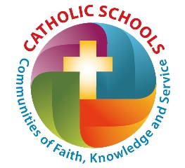
2/01/17 ~ Wednesday ~
- Wear your hood or cap
- Jump Rope for Heat during gym (4K)
- Volleyball game between teachers and 5th/ 6th grade (12:30)
- Open house with spaghetti dinner and games (5:00-6:30pm)
2/02/17 ~ Thursday ~
- Kim’s Amazing Animals 10:30-11:30
- Wear Wisconsin Day. Dress in your favorite Wisconsin team wear. (Packers, Brewers, Badgers…)
- Food Drive to do the Jive
2/03/17 ~ Friday ~
- All school Fieldtrip to Milwaukee Public Museum (load bus at 9:00am return 12:15 for lunch) Trip is from 10-11:30 am
- Wear school colors—burgundy & white
2/05/17 ~ Sunday ~
- 8:00 mass participation & sing at OLL

