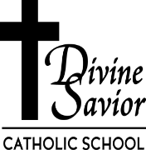
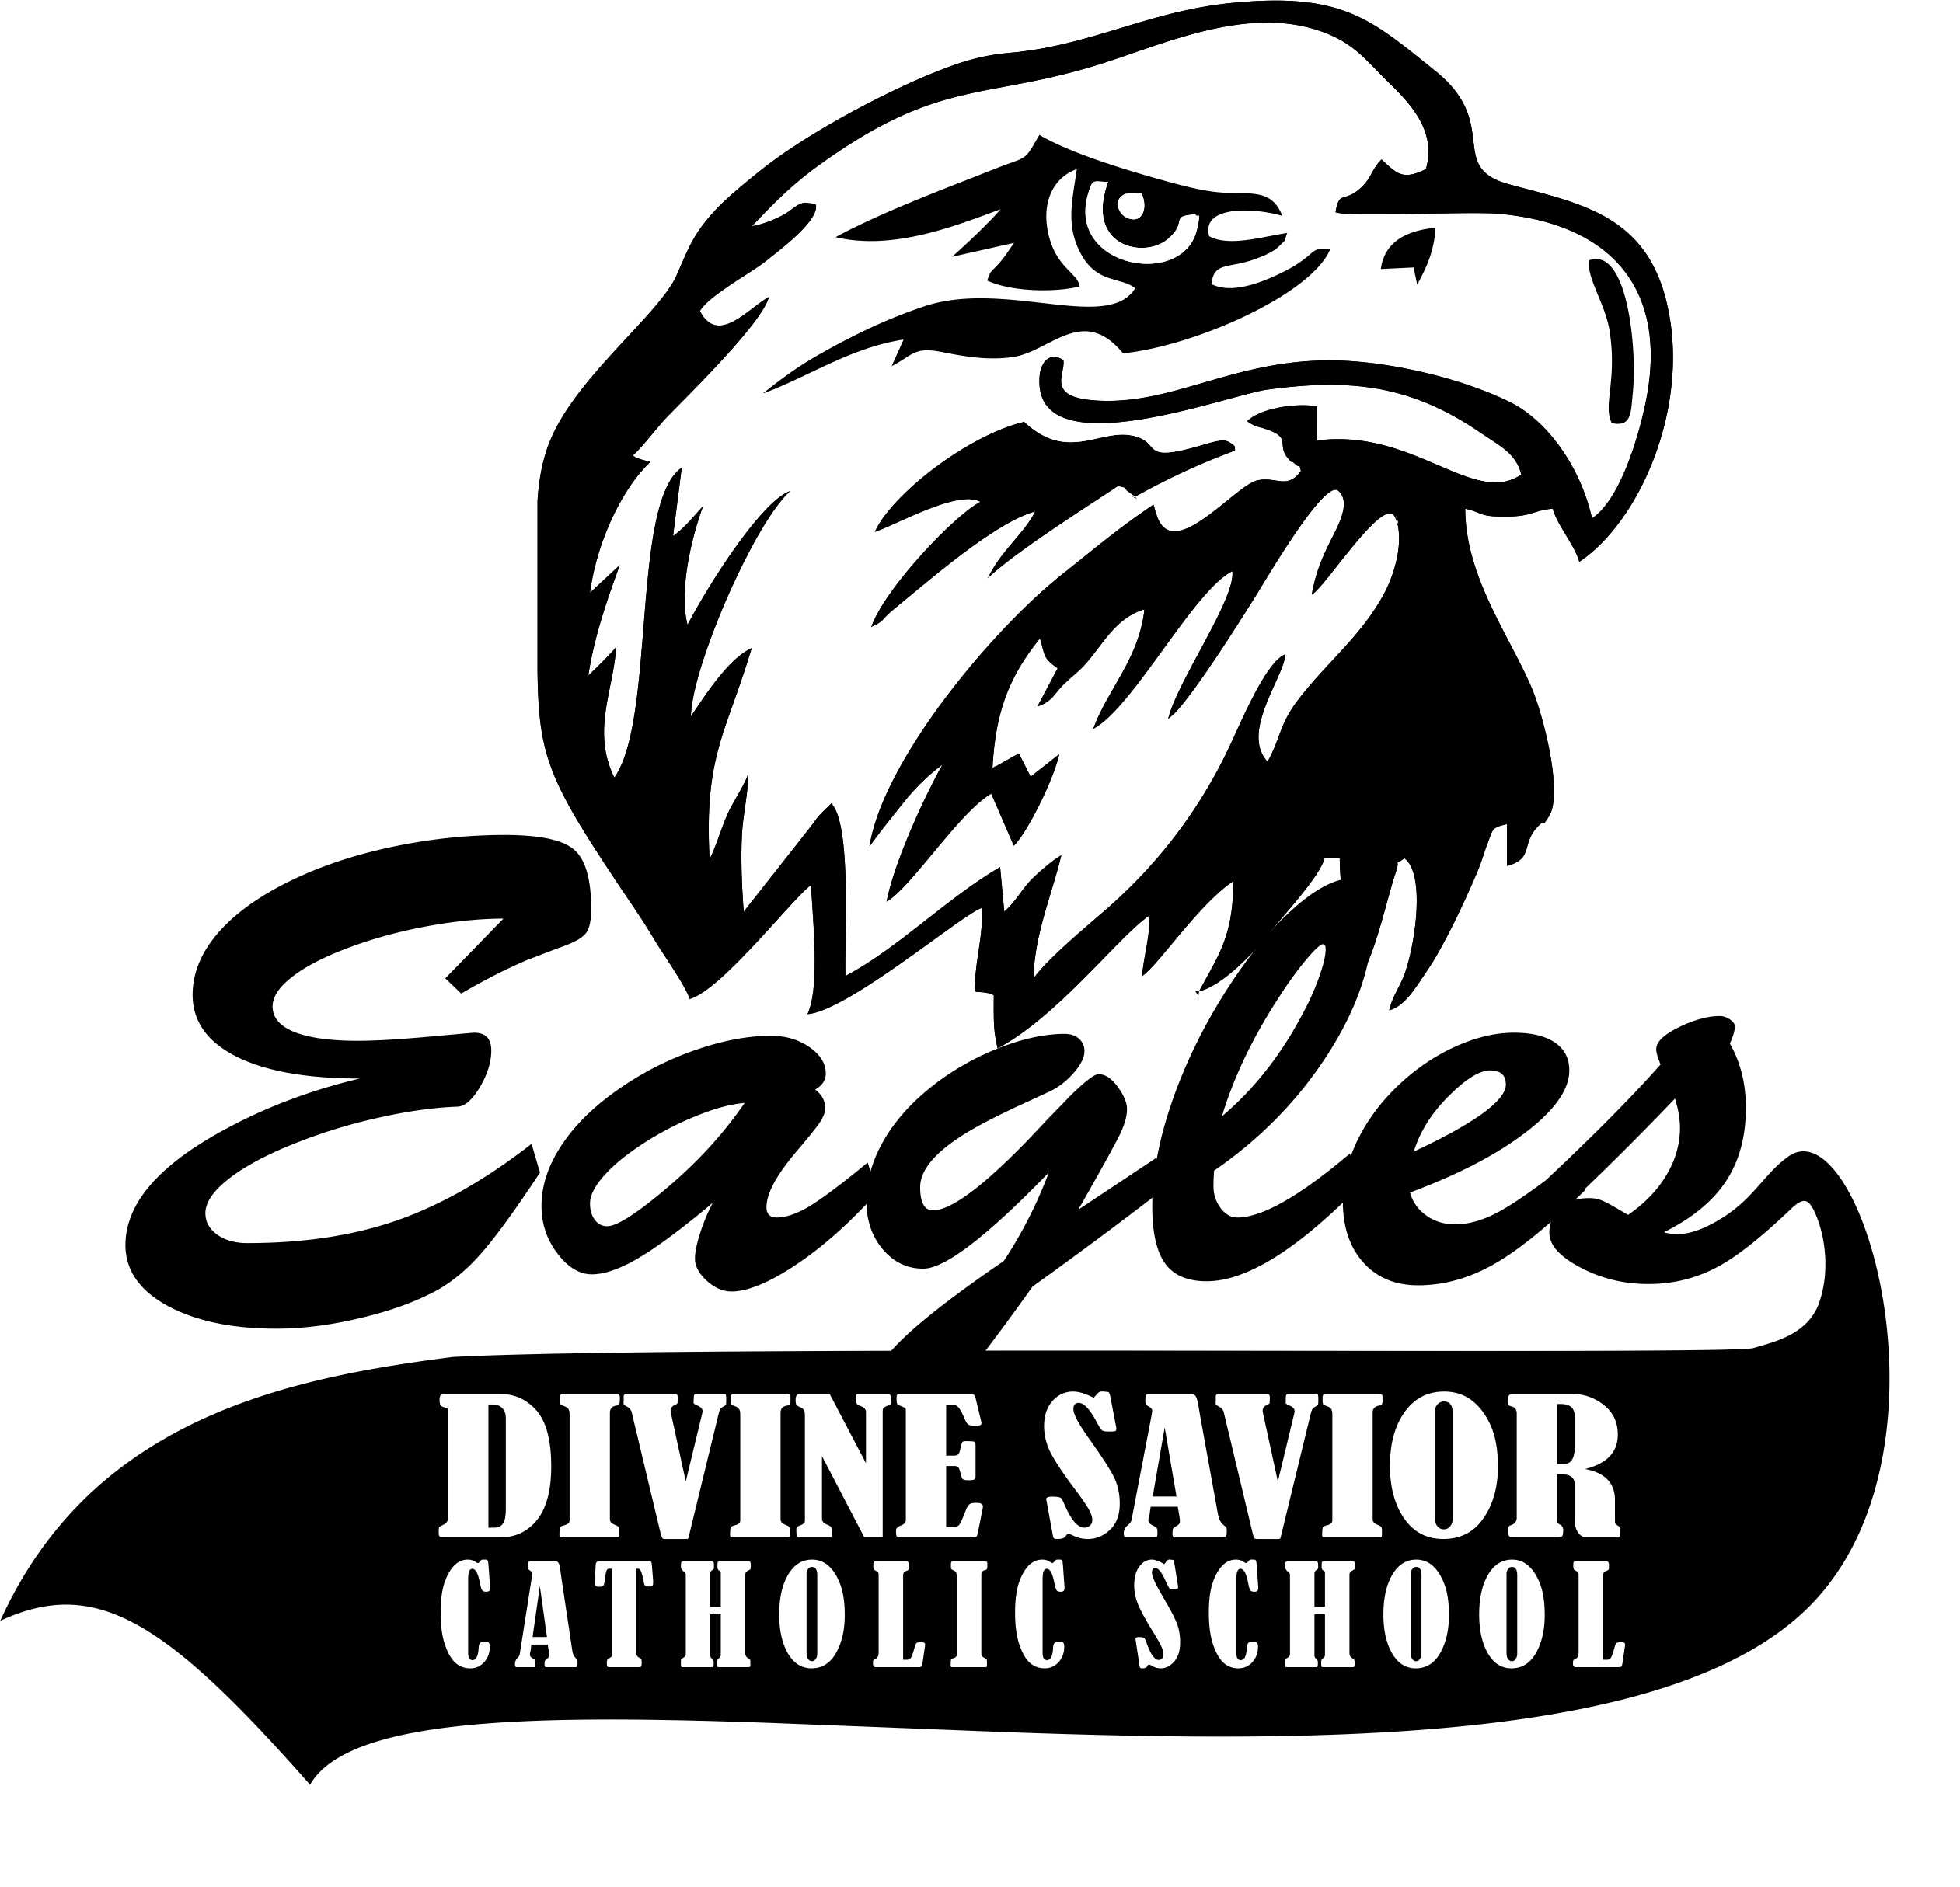
Divine Savior Catholic School Divine Dispatch January 29, 2018
School Office: Holly at hmasengarb@dscsfredonia.org
The Mission of Divine Savior Catholic School is to provide an environment for children to excel personally, academically and spiritually. Together we share in the mission of Divine Savior Parish to foster a faith filled community where Catholic values are learned through prayer, service and love. Our goal is to use these values to develop lifelong learners and compassionate leaders.
From the Desk of the Principal
Happy Catholic Schools Week! I would like to extend a huge “Thank you” to all who support the mission of Divine Savior Catholic School. We could not be successful in reaching our high academic and faith goals without the support of so many of our school families and volunteers. I would like to extend my gratitude to Father Todd for his support of DSCS, and to Deacon Malueg, Deb Hamm, and the Divine Savior Parish Council for supporting our mission. I would also like to recognize the selfless giving of our many school volunteers. Rosemary Haskey, Eugene and Marilyn Mayer, Bob Lallensack, Bill Stadler, John Thill, Barb Moths, Meg Modra, Kim Steffen, Josh Wicinski, Lud and Ann Miller and Joyce Buechler who all exhibit the very best of what it means to serve others! Special thanks must also go out to our teachers and staff for their hard work and dedication. All of our staff members go above and beyond to make DSCS the best it can be, and I am so very humbled to work with such generous, caring and thoughtful people. I must also recognize the efforts of all of our school parents who work to support our school efforts in countless ways! Lastly, I would like to thank the parish staff for the support they offer our school. Pam Smith serves as our parish administrative assistant. I cannot thank her enough for the time she dedicates toward making our school run effectively and the daily support she offers me. I must also thank Holly Masengarb who has just started as school secretary, but is already a valuable member of the team! I must also recognize our DRE Terri Riesselmann for her commitment to working together with the school to promote the Catholic faith in the lives of all of the youth in our parish. Terri Schueller, our parish bookkeeper, is also a blessing to DSCS. Her hard work helps to ensure the financial sustainability of our Catholic School and for that we are all grateful! Our students and staff are looking forward to a fun week of events planned to help celebrate Catholic Schools Week. Remember that on Wednesday night, DSCS will be hosting an Open House, Spaghetti Dinner and Family Game Night from 5:00-6:30. I hope to see you all there! Yours in Faith, Lynn Sauer

**Culver’s DSCS Fundraiser**
On January 29, 10% of the sales at the Port Washington Culver’s will go to DSCS.
YOU MUST BRING YOUR VOUCHER WITH YOU to Culver’s for DSCS to receive the portion of the sale! If you bring your voucher and use a Culver’s scrip card we receive 20% of the sale!!! Hope to see you all there!

Hot Lunch
Mon. Jan. 29 Breakfast Sandwich
Tues. Jan. 30 Popcorn Chicken
Wed. Jan. 31 Grilled Cheese
Thur. Feb. 1 Walking Taco
Fri. Feb. 2 Pizza Bagel
Mon. Feb. 5 French Toast Sticks

Mark your calendars!!!! Wednesday, January 31, 5:00pm we are having an Open House and Spaghetti Dinner/Game Night! All are welcome! Keep in mind that current families are the best way to get the word out about our school. Please feel free to being along family and friends!

Food Pantry
Items needed this week are pancake mix & syrup, hash, cereal, Manwich, tuna/chicken Hamburger Helper, pudding, Progresso Soup, oil, 16 oz, cookies & snacks, Rice-A-Roni, shampoo, coffee, dish soap

Fat Tuesday Donuts - February 13th, DSCS will celebrate Fat Tuesday by selling donuts. Donuts are $1 each. Students will be given the opportunity to choose donuts after Mass. Donuts for parents and family members can be picked up at the school’s back door from 7:30-7:50 a.m. or after Mass in the gym. Free coffee is also available. All proceeds will help support Sister Jo’s mission efforts. If you would like 6 or more donuts, please pre-order. This will ensure we have enough donuts for everyone. Pre-orders need to be submitted by February 6th. They can be emailed to Amy Dubey at adubey@dscsfredonia.org.

Our next movie is Antwone Fisher on Tuesday, January 30 at 6:00 p.m. in the OLL Community Room. Inspired by the true life experiences of its title character, Antowne Fisher tells the compelling story of a troubled sailor who is ordered to see a naval psychiatrist about his volatile temper. Little does he know that his first step into the doctor’s office will lead him on a remarkable emotional journey to confront his painful past and connect with the family he never knew (from movie jacket). PG.-13. 120 minutes. Bring your own snacks.

WHEN TO KEEP YOUR CHILD HOME:
Fever, Stomachache, Vomiting, Diarrhea, Severe Cold and Cough, and Rash or Spots. Your child may return to school 24 hours after the symptoms have cleared, without the use of fever reducing medication, or 24 hours after the start of antibiotics.

Payment Summary
With tax time coming up, many of you will want a payment summary of your Tuition, Extended Day and Morning Care accounts for tax purposes. Please use the following directions:

Access your FACTS account
Click on Consumer View on the top right hand side of your screen
Then click on View Details in the Payment Plan and Billing box
Next click the payments tab under Activity Details
You will see a light blue box with View Printable Payment Summary in it
Click on the box and it will take you to your payment summary for the year

If you have any questions or need any help, please contact the school office.

Dates to Remember *** DSCS FISH FRY’S are February 9, February 23, March 9, March 23***
Jan. 29- 2pm Scoopie visiting DSCS
Jan. 29- DSCS Fundraiser at Port Washington Culver’s
Jan. 31- 5pm Open House/Spaghetti Dinner
Feb. 2- -Discovery World Field Trip 8-11:30am
Feb. 4- 8:15am – Students sing at Mass at St. Nicholas Chapel – Dacada
Feb. 6- 9am- Poth Family Dental at DSCS 3K-2nd Grade
Feb. 7/8- Parent Teacher Conferences
Feb. 7- 5-9pm- Rel. Ed. 7-8th grade retreat.
Feb. 11- 8-9:30 Rel. Ed
Feb. 12- 5:30pm - R&R and Ed. Com. Meeting
Feb. 13- Fat Tuesday Donut Sale
Feb. 14- 8:30 Ash Wednesday service for DSCS at Dacada
Feb. 14- 6:30pm Rel. Ed.
Feb. 16- NO SCHOOL
Feb. 17- 1pm First Communion Workshop & Bread Day for 2nd grade DSCS basement
Feb. 18- 8-9:30am Rel. Ed.
Feb. 19- NO RANDOM LAKE BUS- PLEASE FIND ALTERNATE TRANSPORTATION
Feb. 21- 6:30-8:00pm Rel. Ed.
Feb. 25- 8-9:30am Rel. Ed.

