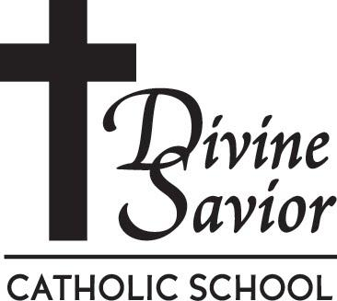
305 Fredonia Ave. Fredonia, WI 53021
262-692-2141
dscs.schooloffice@gmail.com
April, 2017
Dear Parents,
Divine Savior Catholic School is pleased to announce the 16th year of the DSCS Summer Care Program. All students enrolled in DSCS for the 2017-2018 school year are eligible to attend. Our intention is to provide quality care for our students with working parents.
Our Summer Care Program opens at 6:30 a.m. and closes at 6:00 p.m. Monday through Friday except for the Independence Day holiday. The first day of Summer Care will be Monday, June 12th, and the last day will be Thursday, August 31st.
Charges for this summer will be $4.00 per hour for the first child in the family, $3.00 per hour for the second child, and $2.00 per hour for the third child. Please enclose a $25.00 per child (up to $50 per family) registration fee with your registration form to help offset the cost of supplies needed for this summer.
Please note our new policy: Due to scheduling of staff, purchasing of snacks, and activity planning, we need to have your child(ren)’s care schedule by Thursday of the week prior during Summer Care to guarantee a spot for your child(ren). Schedules can be emailed to the Summer Care email address, or turned into the summer care staff. Drop-ins are accepted if space is available. Call the school office or email the summer care staff to check for openings. During Summer Care, once schedules are received, you will be charged accordingly.

If you have any question, please feel free to call us at 692-2141.
Thank you.

Lynn Sauer - Principal
Pam Smith - Administrative Assistant

The Mission of Divine Savior Catholic School is to provide an environment for children to excel personally, academically and spiritually.
Together we share in the mission of Divine Savior Parish to foster a faith-filled community where Catholic values are learned through prayer, service and love. Our goal is to use these values to develop lifelong learners and compassionate leaders.

