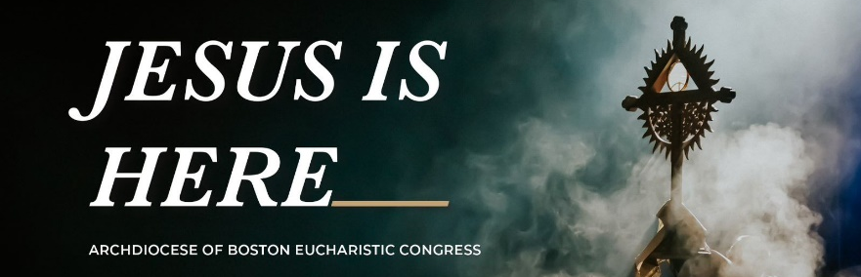
BOSTON’S EUCHARISTIC CONGRESS
Cardinal Seán O’Malley invites all the Catholic faithful in the Archdiocese of Boston and surrounding dioceses to join him in concluding their Year of the Eucharist with a day-long Eucharistic Congress, Jesus is Here, which will take place on June 18, 2022, at the Tsongas Center at UMass Lowell.
This Spiritual event with thousands of pilgrims will begin with a beautiful Mass and continue throughout the day with great national Catholic speakers and musicians, Eucharistic Adoration, opportunities for Confession, and conclude with a Eucharistic Procession throughout the streets of Lowell.
A keynote presentation will be made by Bishop Robert Barron, Auxiliary Bishop of Los Angeles and founder of Word on Fire Catholic Ministries; and more talks will be delivered by Bishop Daniel Flores, Bishop of the Diocese of Brownsville, Texas; author and Dynamic Catholic speaker Deacon Harold Burke-Sivers; and Jackie and Bobby Angel, fellows with the Word on Fire Institute. Praise and worship music will be led by Village Lights.
^{SCHEDULE - Saturday, June 18th}
6 AM – Bus departs Sacred Heart Church, 56 Sacred Heart Dr., Groton, CT
6:30 AM – Cathedral of St. Patrick, 201 Broadway, Norwich, CT
8 AM – Arrive at Eucharistic Congress, Tsongas Center, Lowell, MA, Confessions available
8:30 AM - Welcome, Music, & Celebration of Mass, followed by break & visit exhibitors, Confessions
10:45 AM - Session 1 - featuring Deacon Harold Burke-Sivers & Bishop Daniel Flores
12:15 PM - Lunch Break & Visit Exhibitors
1:30 PM - Session 2 - featuring Bishop Robert Barron, followed by break & visit exhibitors, Confessions
3 PM - Session 3 - featuring Jackie and Bobby Angel
4 PM - Eucharistic Adoration & Procession through Lowell
5 PM -Depart 6:30PM – Arrive back at Cathedral, Norwich 7 PM - Arrive back at Sacred Heart, Groton

………APPLICATION…………………………………………………………………………………………… . Please make checks payable to Sacred Heart Church. $100 NAME (PLEASE PRINT):____________________________________________________ ADDRESS: ________________________________________________________________ CITY: ____________________STATE:___ZIP CODE: ___________________________ TELEPHONE: (_____)__________________CELL (___)__________________________ EMAIL: _________________________________________________
PERSON TO BE NOTIFIED IN CASE OF EMERGENCY NAME: _____________________________________________________________________ TELEPHONE: _(____)_________________CELL _(___)___________________________
PLEASE DROP OFF APPLICATION / PAYMENT TO EITHER PARISH OFFICE or mail to: Our Lady of Lourdes Church, 1650 Route 12, Gales Ferry, CT 06335
MASS | ADORATION | CONFESSION | EUCHARISTIC PROCESSION
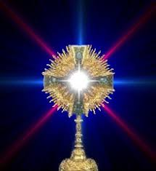
For Early Birds and strong of heart only! Deluxe motorcoach leaves Sacred Heart Church in Groton at 6AM and The Cathedral of St. Patrick in Norwich at 6:30AM, returning at 6:30PM and 7PM, respectively. Lunch will be provided. $100 cost includes admission to Eucharistic Congress, round-trip transportation, lunch, water, and snacks. To make a reservation to join us in our pilgrimage to the Jesus is Here Eucharistic Congress, or for further information, please call our parish office at (860) 445-1446 or email at secretary@ololgf.org

