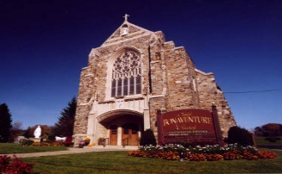
St. Bonaventure Religious Ed
Remote Lesson 8
Sunday February 7, 2021

Fifth Sunday in Ordinary Time
Preface to this week’s lesson:

The Problem of Evil
All human beings experience suffering and pain. It is difficult for us to understand why God allows evil to exist in the world. The Church teaches that evil causes the imperfections that cause human suffering. However, the meaning of suffering will always remain a mystery.

When reflecting on the problem of evil it is important to look at the power of God’s love. We believe that God is good and all-powerful. God’s Son shared our suffering and death so that our sins would be forgiven. Jesus came to save us from all sin. Jesus continues to bring God’s healing love into the world through the Church through the power of the Spirit.

In today’s gospel we find Jesus healing the sick and casting out demons. Jesus takes Simon’s sick mother-in-law by the hand and makes her well. Many people come to Jesus and he restores goodness and health to those in need. Today’s passage shows Jesus taking time to pray in order to deal with the pressures of his public ministry. Jesus’ healing love shows that good is more powerful than evil. The presence of Jesus reveals the saving love of God to the world.

Life can be quite challenging. We all have those days when we find it hard to get out of bed and face another day. Financial concerns, health issues, relational problems, and various other changes which we have to face make it difficult to get moving. How do you handle it when you are burdened? What has helped you get through those trying times in the past? Often it is someone who reaches out to you with a comforting, compassionate hand and reminds you that GOD loves you and that GOD is ultimately in control. Spending time with the Lord Jesus in prayer, even if we don’t feel any immediate relief, can also strengthen us to deal with our problems.

May you know the touching hand of GOD in your life, and may you be an instrument in the Lord Jesus’ hand as He reaches out to others through you.
- Begin by praying the family prayer for today:
Let us pray.
Loving God, you bring us comfort when we are in pain.
Thank you for your healing love.
In the name of Jesus Christ we pray.
Amen.
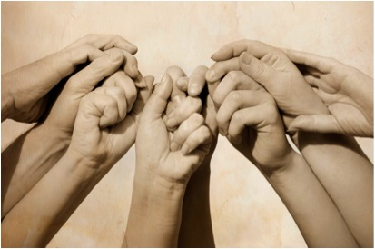
- Read todays Gospel below as a family:
Gospel Mark 1:29-39
On leaving the synagogue Jesus entered the house of Simon and Andrew
with James and John.
Simon’s mother-in-law lay sick with a fever.
They immediately told him about her.
He approached, grasped her hand, and helped her up.
Then the fever left her and she waited on them.

When it was evening, after sunset,
they brought to him all who were ill or possessed by demons.
The whole town was gathered at the door.
He cured many who were sick with various diseases,
and he drove out many demons,
not permitting them to speak because they knew him.

Rising very early before dawn, he left
and went off to a deserted place, where he prayed.
Simon and those who were with him pursued him
and on finding him said, “Everyone is looking for you.”
He told them, “Let us go on to the nearby villages
that I may preach there also.
For this purpose have I come.”
So he went into their synagogues,
preaching and driving out demons throughout the whole of Galilee.

- Sacrament Connection
The Sacrament of Anointing of the Sick celebrates the healing power of God’s love. In the sacrament of Anointing of the Sick we are given the strength to face sickness and death with courage and hope. Through the power of the Holy Spirit this sacrament continues Christ’s work of healing among us.
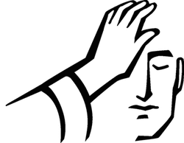
- Please complete the lessons below as a family or individually, then share what you have learned.
- Each lesson, activity or video is geared to age levels. (RED - younger kids, BLUE – older elementary to HS, GREEN – adults or adult supervision to explain.

Living the Gospel: Any age
How can you bring God’s healing and love to someone who is suffering this week?
- make Valentine Cards or door decorations for the local nursing homes or neighbors
- shovel your neighbors walk and/or driveway
- bake cookies to give to a neighbor
- I am sure you can think of many more…
https://www.youtube.com/watch?v=JsM64LHdPy8 Jesus Heals the sick (3:44)
https://f.hubspotusercontent30.net/hubfs/275132/_catholicmom/Sunday%20Gospel%20Activities/2021/2/02-07-2021/5%20OT%20B%20Coloring-compressed.pdf Jesus Heals Coloring sheet

https://www.catechist.com/anointing-sick-5-minute-video-catholic-central/ Sacrament: Anointing of the sick (4:46)
Sacrament: Anointing of the Sick facts:
- Why is the sacrament Anointing of the Sick so important?
The sacrament of anointing of the sick is a very important part of the church life because Jesus reaches out his love to those who are very sick, frail and near to death. Jesus heals the person not only their body but their soul as well. Anointing of the sick is NOT just for those dying.
- Is there a difference between last rites and anointing of the sick?
As stated above the last rites are not a sacrament, but a group of sacraments offered at or near the hour of death. ... Anointing of the sick is a sacrament that must be administered by a priest or bishop, and there are no extraordinary ministers for this sacrament like there are for baptism and Communion.
- What are the main parts of anointing the sick?
The three main parts of the Sacrament of the Anointing of the Sick are the prayer of faith, the laying on of hands, and the anointing with oil.
- How do you perform anointing of the sick?
The rite can be performed in a home or a hospital by a priest, who prays over the person and anoints his or her head and hands with chrism (holy oil). The priest may also administer the sacrament of the Eucharist and can hear a confession if so desired.
- Why do we anoint the sick with oil?
The oil represents the presence and power of God coming upon the person in an unusual way so that they can accomplish unusual tasks for Him. ... In other words, the anointing of oil in James 5:14 is thought to be sort of a symbol for the healing power of God coming upon the person to delivery them from sickness.
- What happens during last rites?
The last rites, in Catholicism, are the last prayers and ministrations given to an individual of the faith, when possible, shortly before death. They may be administered to those awaiting execution, mortally injured, or terminally ill. Last rites cannot be performed on people who have already died.
- What happens if a Catholic does not receive last rites?
Nothing physically happens to a person who dies without having the last rites administered to them. These are the final prayers and blessings a person receives that give spiritual comfort and a renewed faith that they will walk with Christ to meet their maker.

- Do last rites guarantee heaven?
Last Rites is one of the sacraments in the Catholic church. It has a couple of functions. It works like a final confession, to remove any lingering sins so you have a clean slate. It also has an emotional component.

Parents: please read and watch the Anointing of the sick information above to re-familiarize yourself with the sacrament.

https://www.youtube.com/watch?v=JJrn9rkOYH4 The Real Answer to Why God Allows Suffering (8:29)

