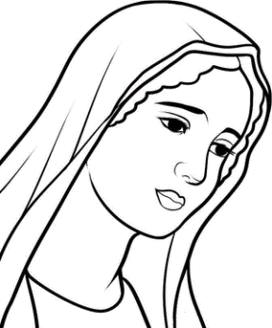**St. Mary’s Catholic Church**

**Religious Education Department**

16550 Jurupa Ave., Fontana CA 92337

First Confession

Reconciliation/Penance

Interview

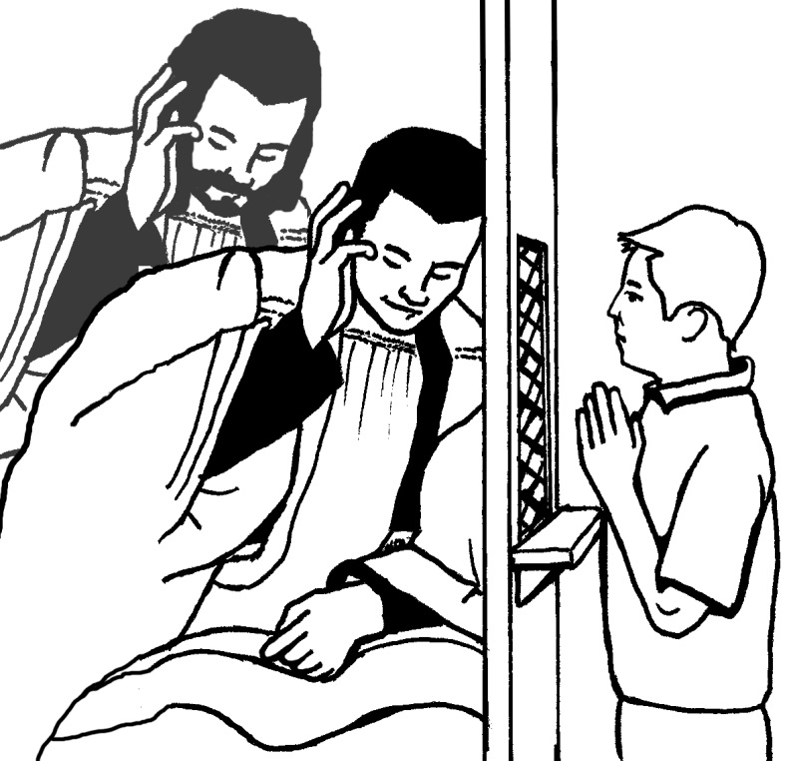

We recommend that the parents study these interview questions together with their children to help them prepare for their interview.

**Basic Prayers for ALL 1st Year Students:**

* Sign of the Cross
* Our Father
* Hail Mary
* Glory be
* Act of Contrition
* Prayer to Angel Guardian
* Confiteor (I confess…)
* Lamb of God

**Steps of Confession**

**Before you go see father you must to an**

**Examination of conscience**

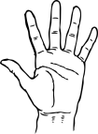 **(FIVE STEPS)**

**1. You say:** Good morning, Father.

**2. You say and do the Sign of the Cross:** In the name of the Father, the Son, and the Holy Spirit, Amen.

**3. You say:**  (Bless me Father for I have sinned.

**4. You say:** This is my first confession. {Note: In future, state how long it’s been since your last confession...example: **“It’s been a year since my last confession.”**}

**5. You say:** And these are my sins… {begin confessing your sins.}.

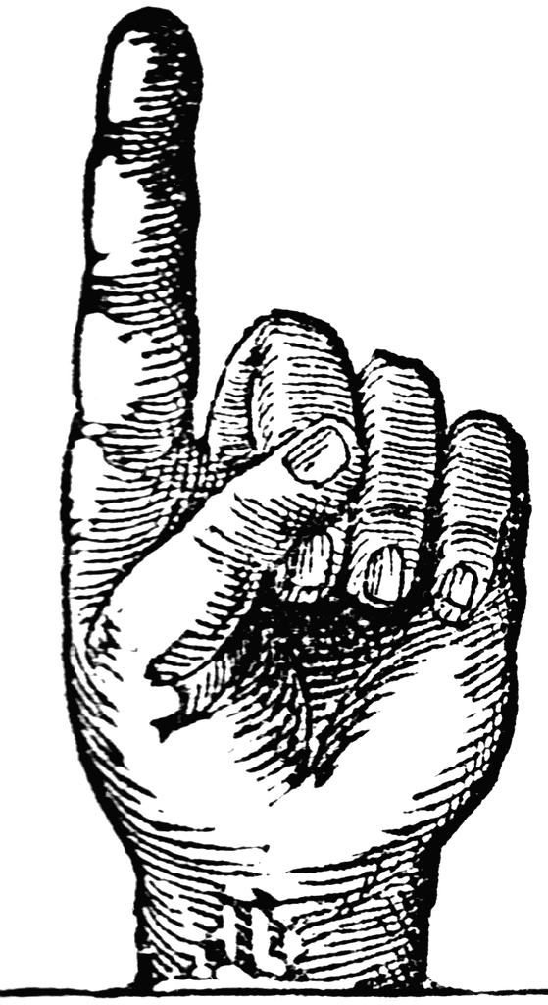**(One Step)**

**1: You say:** I’m sorry for these sins and all my sins.

Father will give you Penance - DO NOT SAY YOUR PENANCE WITH FATHER! This will be done once you leave the Confessional.

**Father says:** I absolve you from your sins.

Father **MAY ASK** you to recite the Act of Contrition. See Next Card. If you have another form of the Act of Contrition memorized, recite that one.

**Act of Contrition**

O my God, I am sorry for my sins with all my heart. In choosing to do wrong and failing to do good. I have sinned against you whom I should love above all things. I firmly intend, with your help, to do penance, to sin no more, and to avoid whatever leads me to sin. I thank my Lord Jesus Christ, my Savior, who suffered and died for us all. Amen.

**(TWO Steps)**

**Father says:** I Go in peace.

1. **You say:** Thanks be to God.

2. **You say:** Thank you, Father. {You're done; you may now leave the Confessional}

**During Penance**

**Father may ask you to say a prayer or two please remain in prayer as the other students receive their sacrament of reconciliation. Follow your catechist’s instruction.**

**Vocabulary**

* **EXAMINATION OF CONSCIENCE –** a review of my thoughts, words and actions in order to see if I have hurt God, myself or others by failing to do what God wants me to do.
* **ABSOLUTION –** Forgiveness of our sins or the ‘washing away’ of our sins.
* **PENANCE –** Something the priest gives us or tells us to do to make up for our sins

**The 10 Commandments**

MC900048038[1]

God gave us the Ten Commandments so we can know how to live a life of love. The first three commandments help us to show love and respect for God. The other seven commandments help us to show love and respect for ourselves and others.

1. Put God first/Have no other gods.

**Lamb of God**

Lamb of God, you take away the sins of the world, have mercy on us.

Lamb of God, you take away the sins of the world, have mercy on us.

Lamb of God, you take away the sins of the world, grant us peace.

2. Honor God's name.  (don’t use in in vain)

3. Honor the Sabbath day.

4. Honor your parents.

5. Do not murder. (Do not kill)

6. Do not commit adultery. (Be faithful in marriage)

7. Do not steal.

8. Do not perjure yourself. (Do not bear

false witness)

**Confiteor (I confess…)**

I confess to almighty God

And to you, my brothers and sisters, That I have greatly sinned, In my thought and in my words, In what I have done and in that I have failed to do,

**-strike breast –**

Through my fault, through my fault,

Through my most grievous fault;

Therefore I ask blessed Mary ever –Virgin, All the Angles and Saints, And to you, my brothers and sisters, To pray for me to the Lord our God. **Amen.**

9. Do not covet your neighbor’s wife.

10. Do not covet your neighbors goods.

**Angel of God**

Angel of God, my guardian dear,

To whom God’s love commits me here,

Ever this day be at my side,

To light and guard, to rule and guide.

**Amen**

**QUESTIONNAIRE**

1. **What is a Sacrament?** Sacrament is an outward sign given to us by Jesus, to give us Grace which is God’s gift of his very own life within us.
2. **What Sacrament are you preparing to receive?** Confession/ Reconciliation/ Penance
3. **What is the Sacrament of Confession/Reconciliation/Penance?** It isthe Sacrament through which Jesus offers forgiveness to us for our sins. We accept his forgiveness by confessing our sins and by being truly sorry for our sins.
4. **When did Jesus give us the Sacrament of Confession/Reconciliation/Penance?** On the evening after his resurrection Jesus showed himself to His apostles, breathed on them, and said: “Receive the Holy Spirit. If you forgive sins, they are forgiven; if you retain them, they are retained. **(Jn. 20:22-23)**
5. **What is a sin?** Sin is hurting God by not obeying His commandments.
6. **When is a sin committed?**

* The action has to be wrong
* You have to know it is wrong
* You have to do it on purpose

1. **What are the two kinds of sin?** Mortal and venial
2. **Can you define them?** Mortal sin is a **serious** offense against God, which ends our friendship with Him and separates us from His life of grace in our soul. Venial sin is a **less serious** offense against God, which hurts our friendship with Him but does not separate us from His life of grace in our soul. (Venial sins can be forgiven at the beginning of Mass in the Penitential Rite.)
3. **Why do we tell our sins to a priest?** Jesus gave the priest the divine power to forgive the sins of people in His name.
4. **Who do we hurt when we sin?**

* God * Ourselves’ * Others