First Holy Communion Preparation

Prayer

The Sign of the Cross
In the name of the Father,
and of the Son,
and of the Holy Spirit.
Amen.

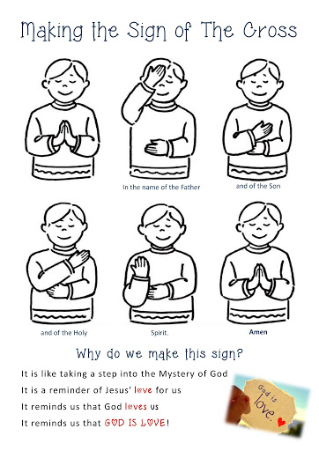

The Our Father

Our Father, who art in heaven,
hallowed be thy name; thy kingdom come;
thy will be done on earth as it is in heaven.
Give us this day our daily bread; and forgive us our trespasses
as we forgive those who trespass against us; and lead us not into temptation,
but deliver us from evil.
Amen.

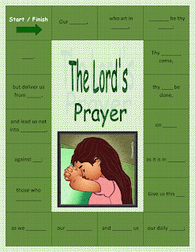

The Hail Mary

Hail Mary, full of grace, the Lord is with you.
Blessed are you among women, and blessed is the fruit of your womb, Jesus.
Holy Mary, Mother of God, pray for us sinners,
now and at the hour of our death.
Amen.

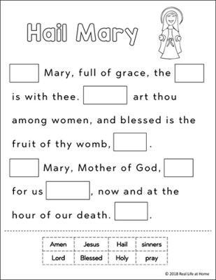
Glory Be

Glory be to the Father, and to the Son, and to the Holy Spirit.
As it was in the beginning, is now, and ever shall be, world without end.
Amen.

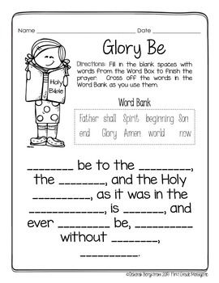

The Apostles Creed

I believe in God, the Father almighty,
Creator of heaven and earth, and in Jesus Christ, his only Son, our Lord,
who was conceived by the Holy Spirit, born of the Virgin Mary,
suffered under Pontius Pilate, was crucified, died and was buried;
he descended into hell; on the third day he rose again from the dead;
he ascended into heaven, and is seated at the right hand of God the Father almighty;
from there he will come to judge the living and the dead.
I believe in the Holy Spirit, the holy catholic Church,
the communion of saints, the forgiveness of sins,
the resurrection of the body, and life everlasting.
Amen.

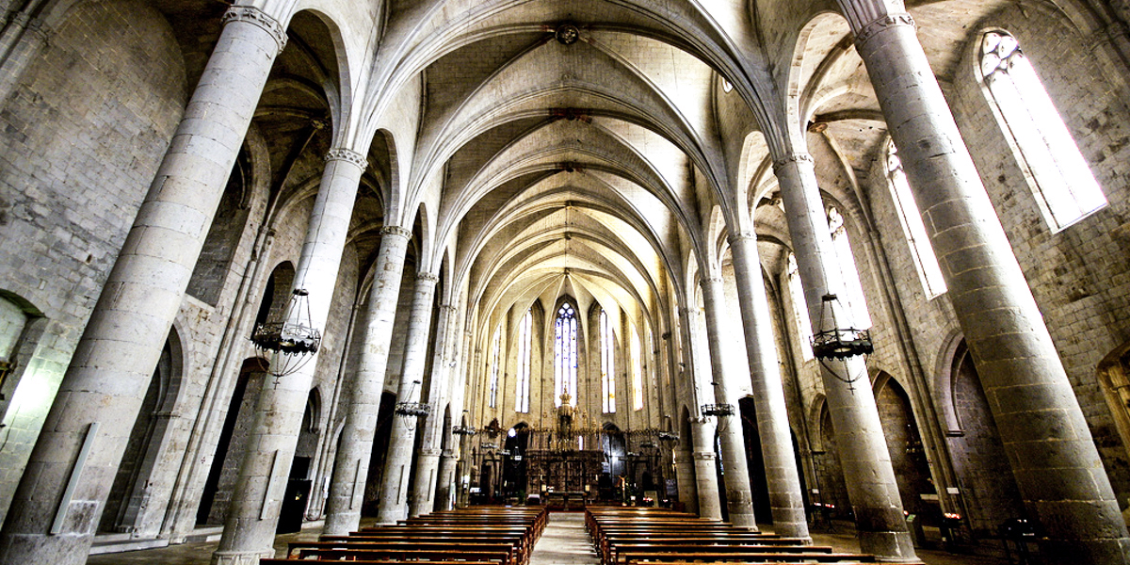

I Believe in God, the Father almighty,
Creator of heaven and earth,
Pillar 1

And in Jesus Christ, his only Son, our Lord,
who was conceived by the Holy Spirit, born of the Virgin Mary,
Pillar 2
Suffered under Pontius Pilate, was crucified, died and was buried;
He descended into hell;

Pillar 4
Pillar 3

On the third day he rose again from the dead;
he ascended into heaven, and is seated at the right hand of God the Father almighty;
from there he will come to judge the living and the dead.

I believe in the Holy Spirit,
Pillar 5

The Holy Catholic Church,

Pillar 6

The Communion of Saints,
the Forgiveness of Sins,
Pillar 7

The resurrection of the body,
and life everlasting.
Amen.

Pillar 8

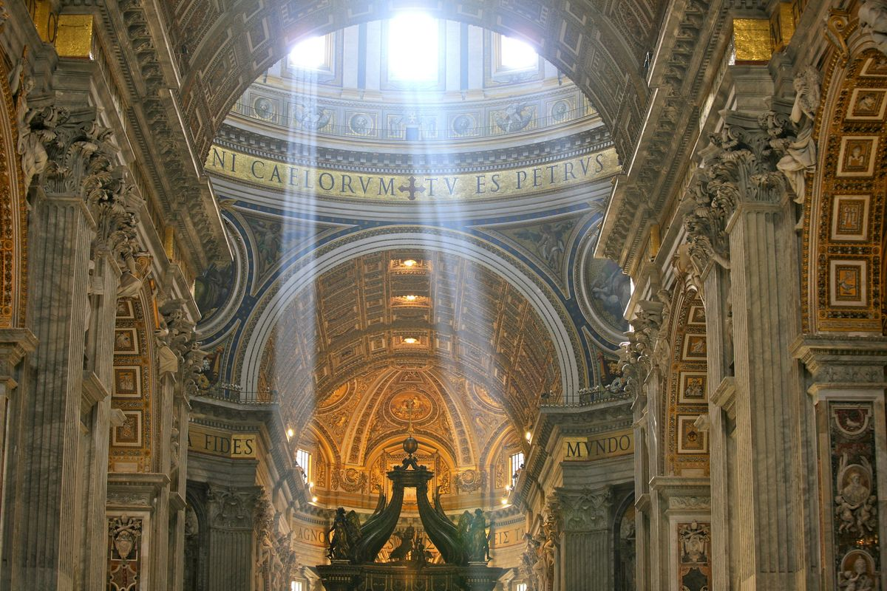
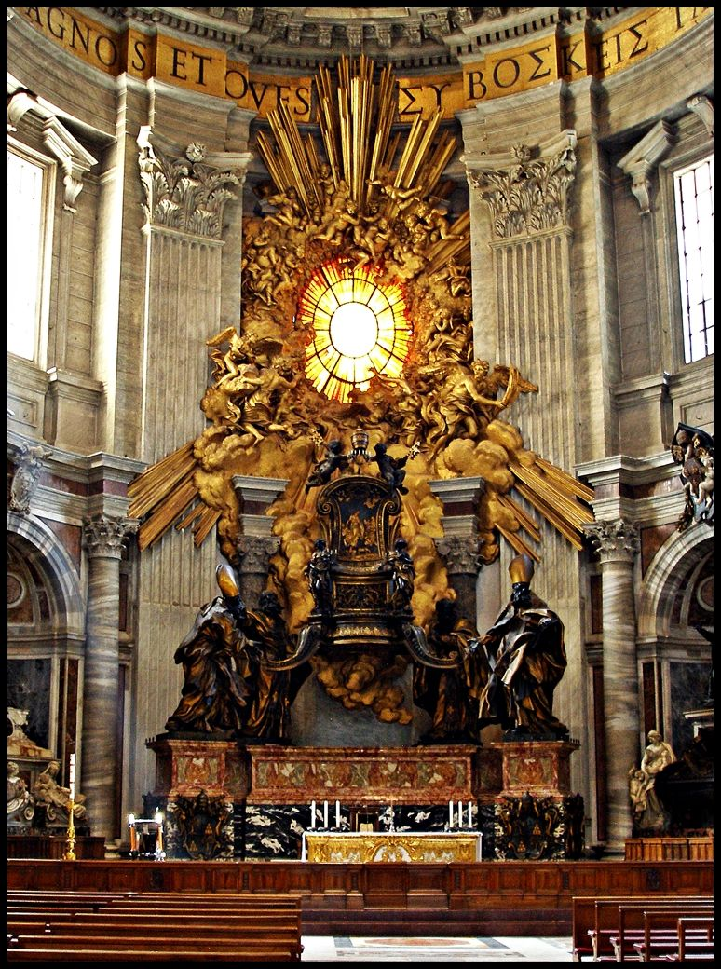
The Holy Spirit Guides the Church

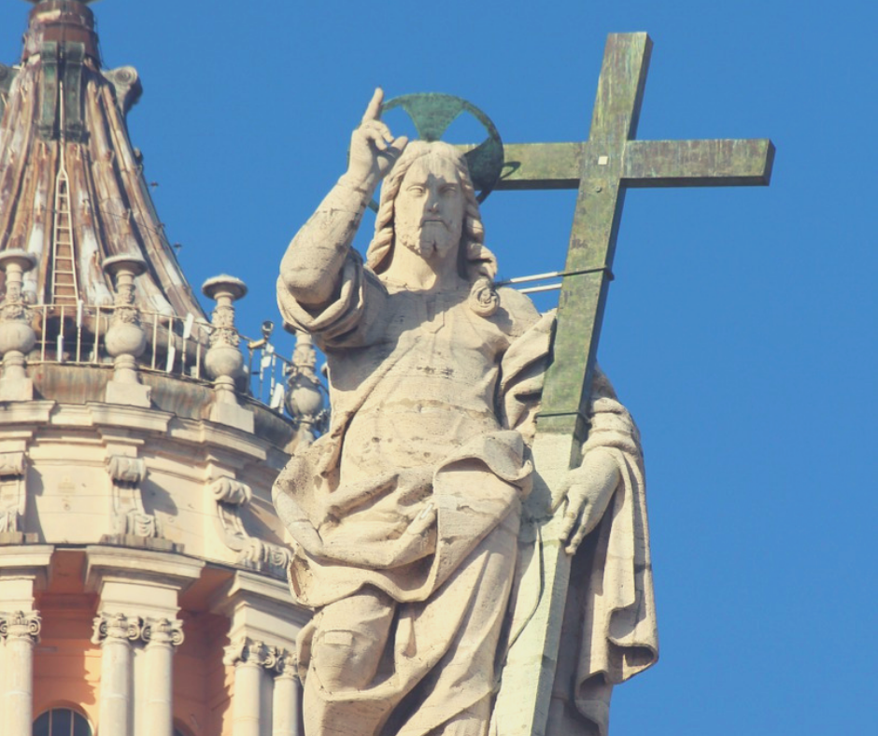

The Holy Spirit Guides the Pope
Our Pope Today is Pope Francis

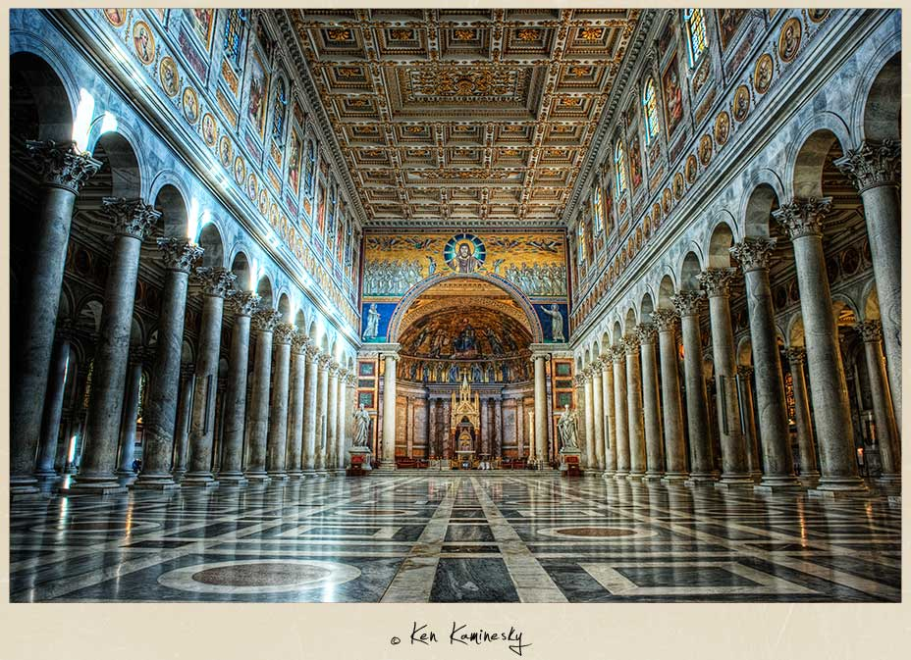

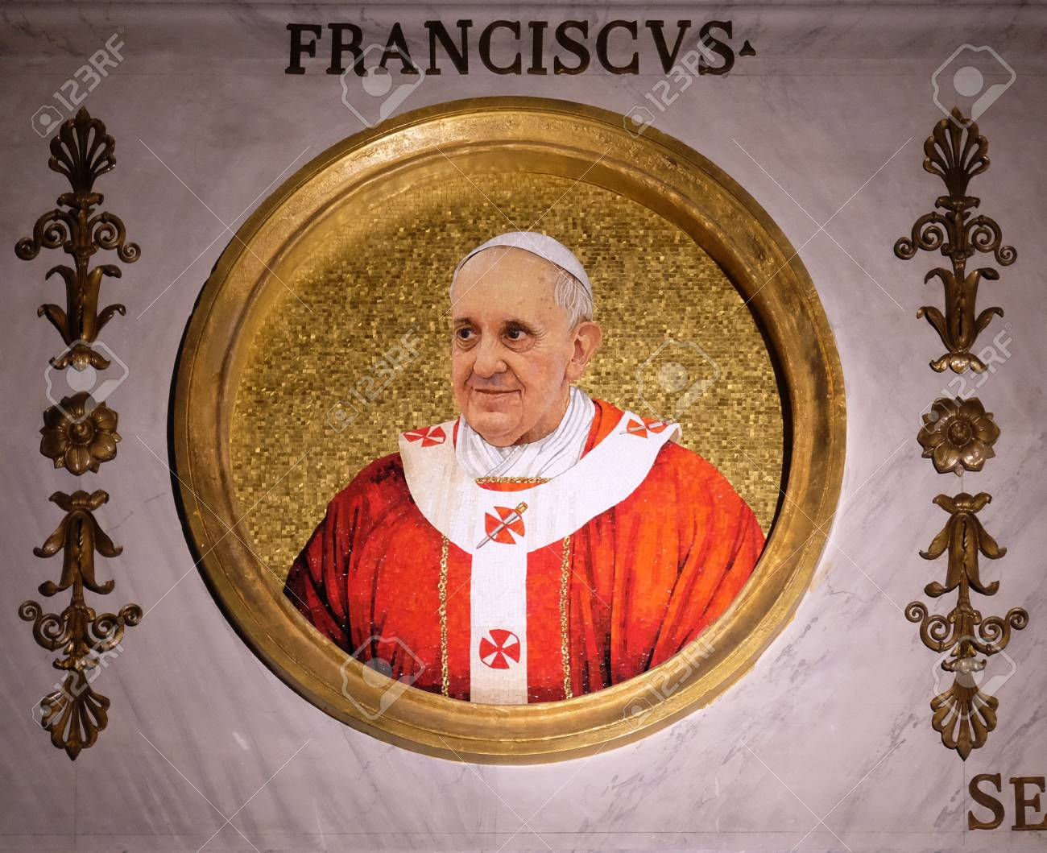
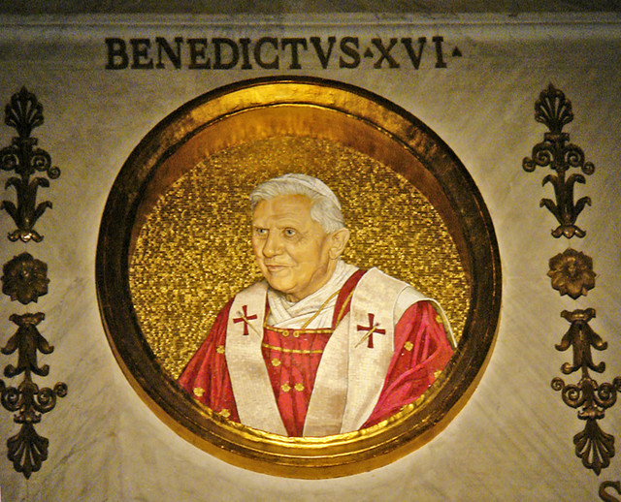

Some Pope’s Become Saints – Saint Pope John Paul II
And
Saint Pius V

