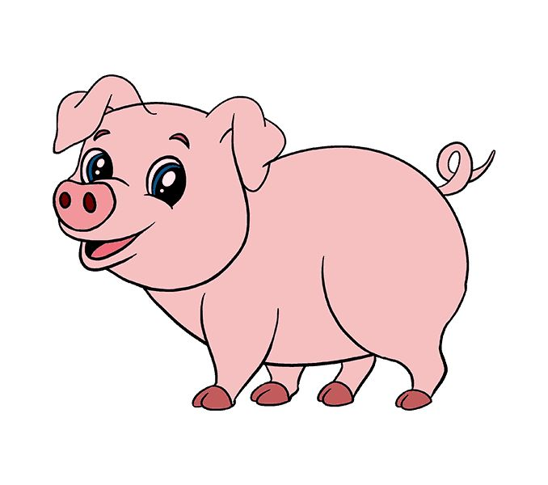

**Do I Clean Up My Mess?**

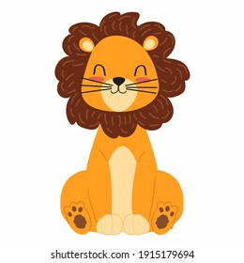

**Do I disrespect my parents or teachers?**

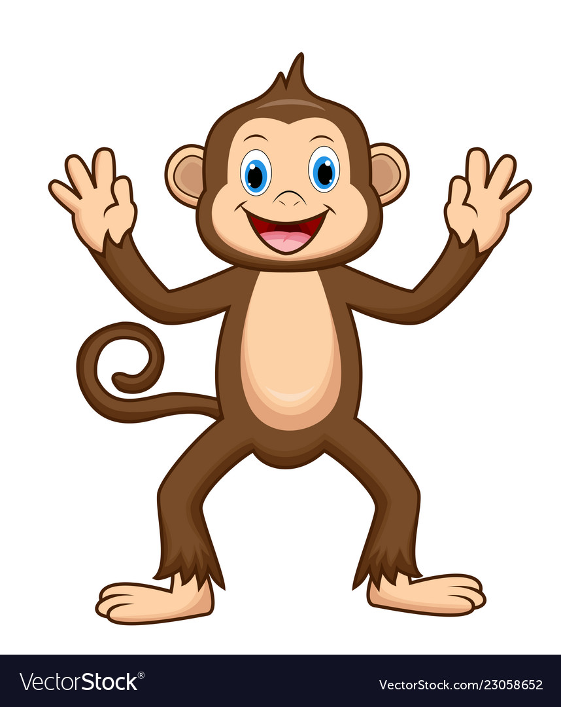

**Did I ever cheat on a test or bully another person?**

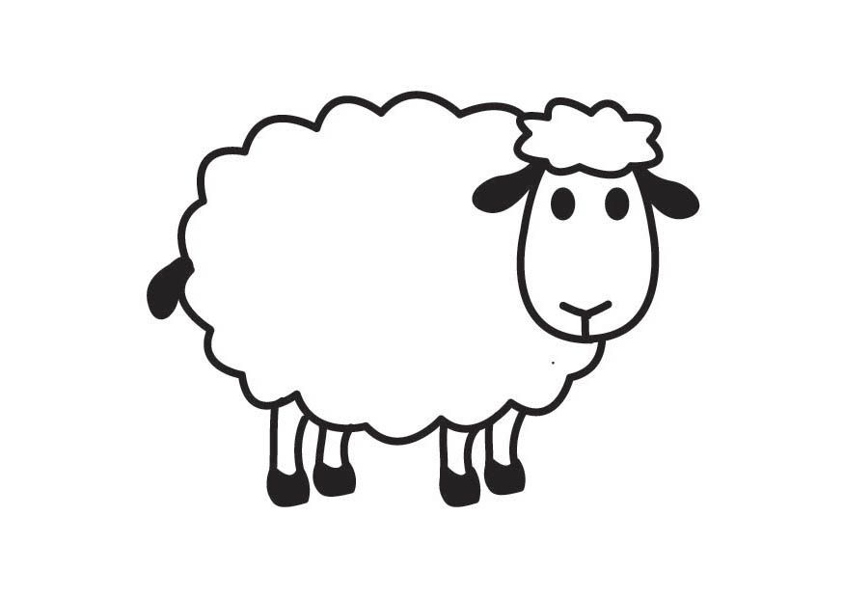

**Was I disrespectful to God?**

**Do I pray my daily prayers?**



**Did I take something that belongs to other people?**



**Was I rude to other people?**

**Examination of Conscience**

**Listen to the stories about the different animal experiences. And see if you ever acted like the animal in the story.**