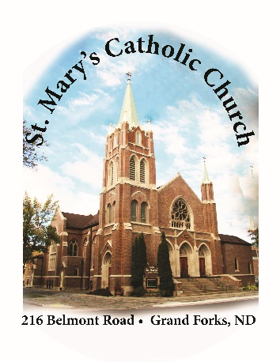
ST. MARY’S FINANCIAL SNAPSHOT NEWSLETTER
SUMMER 2021

Dear Parishioners of St. Mary’s:
We are emerging from some turbulent times in our world. That God’s grace accompanies us through it all gives us cause for rejoicing. I want to take this opportunity to update you on the financial status of our parish. Your stewardship makes it possible for us to carry out the mission Christ gives us, and I thank you from the bottom of my heart.

- Outside Assistance During the COVID-19 Pandemic
In the spring of 2020, parishes in the Diocese of Fargo were permitted to request loans from the federal government’s PPP program to assist with payroll and other essential expenses. We at St. Mary’s received a loan of approximately $85,000 and did not have to pay anything back.
In addition, the State of North Dakota made grant money available to eligible childcare centers for a period of time in 2020. While our numbers of children decreased, there were plenty of families relying on our services because the parents were essential workers or employed outside the home. These grant payments helped to offset losses of income, keep us operating, and meet our payroll costs. The State grant money varied but was received starting in April 2020 to the end of December 2020. I thank Ashley Morris, our Early Childhood Center manager, and all our employees for their compassion and service to the families of our little ones.

- Parish Endowment
Every parish and institution in the Diocese of Fargo has an endowment account in its name, administered by the Catholic Development Foundation. Since my arrival four years ago, we have funded this endowment through generous gifts from parishioners earmarked for this purpose. Our balance currently stands at $185,000. Each year we can decide to withdraw the spendable earnings to help meet expenses or “roll them back” into the account to draw interest. This endowment is off to a tremendous start and will provide for additional financial security for decades to come.

- Main Assets
For our day-to-day operations, St. Mary’s has a checking account with Alerus, into which we make deposits and from which we pay most bills. When the balance in this local account grows large, we transfer a portion of the money to our parish account in the Diocese of Fargo Deposit and Loan Fund, where in recent years it has earned an average of 2-3% interest. We have been able to build this account up nicely since the major projects we undertook in 2018, including the purchase of a new organ and renovation of the rectory. As of June, the balance in this account is approximately $370,000.
That being said, we rely on this “rainy-day fund” in the event that we should need to make any major repairs, such as replacing a boiler, air conditioner, or fixing roofing or plumbing. Our beautiful physical plant is aging, and with this comes the potential of costly maintenance. We are in a good position to handle such needs if they should arise, but it won’t take many of them to put us in a more precarious situation.

- Parish Budgeting
Every year we adjust and review the budget with the consultation of St. Mary’s Lay Directors and Finance Council. Taking into account the decreased attendance at Sunday Mass during the height of the pandemic, we lowered our projection of offertory income for 2021. To give you some perspective, our total offertory income in 2019 was $321,550, or an average of $6,183 per week. Keep in mind that this does not include endowment contributions, bequests, or other gifts. We set a goal of $270,700 ($5,206 per week) in offertory income for 2021, and during the month of May we received $24,914 (YTD $156,209) in contributions. Again, this is a reflection of your generosity as members of our community of faith. Numerous additional households have set up automatic withdrawal through the WeShare program, and especially in the cases of those who reside elsewhere part of the year or travel frequently, this method of stewardship is a great help to us during leaner times.

- Future Needs
Lastly, I think it is helpful to look forward to a couple of things we know we will have to tackle in the near future. Most of you are aware of the hospitality fund we introduced in May to pay for replacing our basement tile and installing a restroom in the social hall. As of this writing we are at about half of our goal of $60,000. I thank those who have already participated in this campaign.
We are also monitoring the condition of the main front steps of the church. There are some structural problems—the sort of thing that happens over time—and they may need to be reassembled.
Another project in our future is the restoration of our church sanctuary. The purpose is to replace the granite appointments and black tile flooring with furnishings that match more closely the worship space as a whole. Because the Diocese needs to oversee any project that changes a church sanctuary, this is the type of project where we cannot go halfway or cut corners. On the other hand, we owe it to you as parishioners to carry out this restoration as efficiently as we can.
I anticipate needing to hold a capital campaign prior to any work being done, with a timetable of 2024 or 2025. The procuring of major gifts toward this project will help to make it more feasible for our small parish community. Please feel free to speak with me if you are interested in providing any support that you may be able.

All of these plans serve the greater good—namely, to proclaim the Lordship of Jesus Christ and draw from his graces. May our Blessed Mother Mary, our patroness, increase our longing for divine wisdom and protect our families as we give glory and honor to her Son.

Fr. James Gross
Pastor

