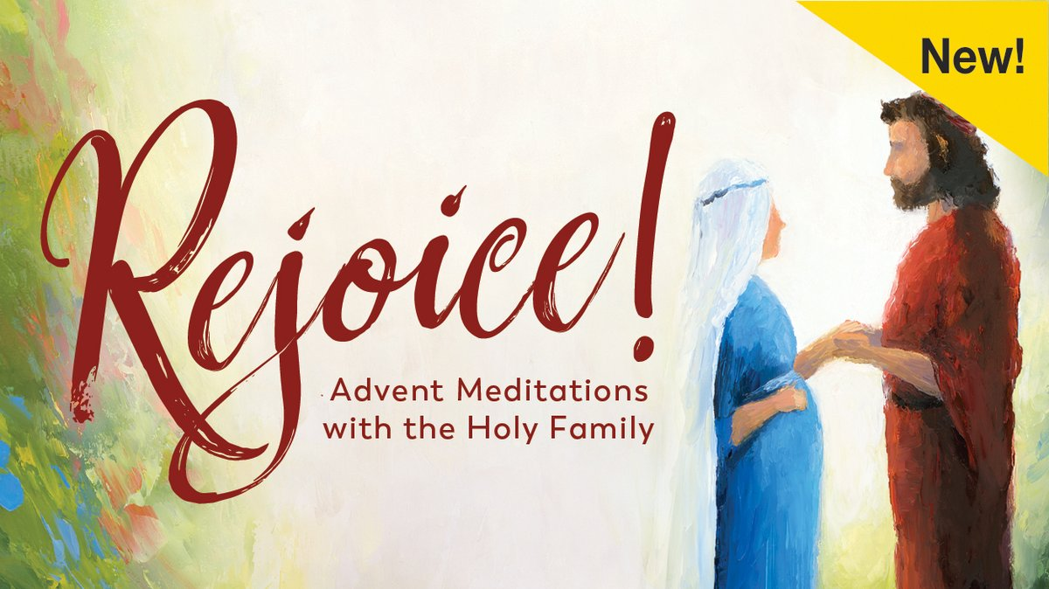
Rejoice! An Advent Journey
Advent is a special season for the Church — it is the time when the world prepares to celebrate anew the coming of Christ. Often, we lose sight of the point of this season because we get caught up in our preparations for Christmas and arrive at Christmas no more transformed than we were at the start of Advent.
This Advent we invite you to take time to join us as we seek to find a deeper way of welcoming Jesus into our lives.
The Small Group sessions will combine guided meditation videos along with your journal to help you to see the marriage of Mary and Joseph in a new light. You will ponder what was in their hearts and minds as they awaited the birth of Jesus. You will be invited to reflect on and deepen your relationships with others.

Tuesdays, 6:30-7:30 pm: December 1^{st,} 8th, 15th, 22nd
Each participant will receive a Rejoice! journal, filled with beautiful art and meaningful meditations to accompany him or her throughout the entire Advent season.
The daily reflections and journaling, along with once a week Small Group Faith Sharing on Tuesday evenings, will give you an opportunity to enter into the season of Advent intentionally and receive the grace God is waiting to give us in this holy season.

Cost of the journal is $8.
To allow us time to order materials and to plan for social distancing,
please register by Nov. 29th either by emailing Carol at cdaun@stmattoc.org
or calling 762-4200 ext. 13.
Zoom option: if you would be interested in joining the group via Zoom, we can do that as well. Please indicate your preference (in person or Zoom ) when registering

