Growing More in Faith
A Campaign for St. Thomas More Catholic Church

Pledged to Date: $1,225,800 from 43 families.
We are off to a great start!

If you would like to receive your campaign packet and pledge card before year end, please contact the Parish Office.

Our parish is planning to expand our church in order to accommodate our growing number of parishioners.

The Plan
Our new worship space will feature: seating for 1,200 people, Eucharistic Reservation Chapel that seats at least 40 people, covered entrances and enhanced accessibility, expanded parking lots, bell tower, bride/family room, expanded offices, relocated patio, added classrooms in the lower level.

Construction Goal: Raise $4,500,000
This will allow us to raise enough cash to start construction and pay off our remaining debt of $300,000.

Memorial Opportunities:
Naming opportunities are a great way for family members and friends to pool their gifts and honor someone who is important to them. A limited number of naming opportunities are still available on a first come basis. Each room will recognize the donor or honoree with a modest plaque next to the door of the room.

Please contact Katie in the Parish Office if you have any questions.

ITEM | VALUE
Tower | $500,000 | 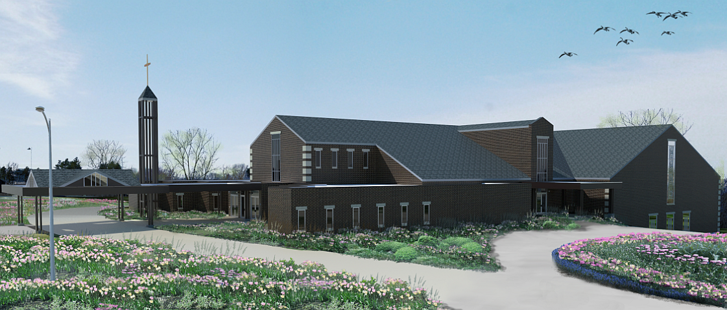
Gathering Space | $250,000
Pastor's Office | $100,000
Finance Office | $75,000
Reception Area | $100,000
Rel. Ed. Office | $50,000
Music/Lit. Office | $50,000
Conference Room | $50,000
Brides Room | $50,000
Front Entrance | $50,000
Classrooms (12) | $50,000
Lower Level Hall | $150,000

