PUT YOUR FAITH INTO ACTION
Help a low-income family build their dream of home ownership by working with Habitat for Humanity.
St. Thomas More is working with St. Mary’s and other faith communities by participating in the Iowa Valley Habitat for Humanity Interfaith Build Project.
Put the planned St. Thomas More work days of June 22 and July 20 on your calendar. (The dates are contingent on weather.)
The address for the build is 2764 Blazing Star Drive, Iowa City. It is a duplex that will house two families.
What you need to know:
- Days are divided into 4 hour morning and afternoon shifts. You can choose to work either a half or whole day.
- All volunteers must be at least 16 years old.
- Sixteen and 17 year olds cannot use power tools and cannot get more than 6 feet off of the ground. If you are under 18, it is best to contact the volunteer coordinator in advance to determine the tasks that will be completed during your shift.
- Everyone ages 18 and under must provide a waiver signed by their parent or guardian.
- Everyone must fill out an annual safety waiver. You must be there at the start of your shift to review safety instructions and daily tasks.
- Everything you need will be at your volunteer location, but you are welcome to bring your own tools &/or materials. There is a limited supply of work gloves, so bring some if you wish.
- Wear comfortable, layered, weather appropriate clothing. Close toed shoes are required.
- No prior knowledge or skills in construction is necessary.
If you are interested in working on this project, please sign up by emailing or phoning Peggy Lyon at lyon1013@gmail.com or (319)230-3059. Or you can call the Habitat for Humanity volunteer coordinator, Leda Rouse, at (319)337-8949. Let her know that you are working with St. Thomas More’s group. For more information, contact Peggy Lyon .

MEET THE TWO FAMILIES:
Habtamu & Ebsitu’s Family
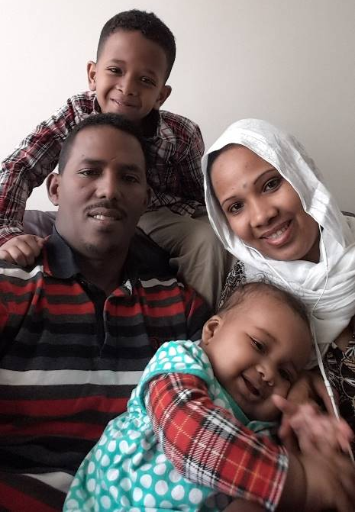
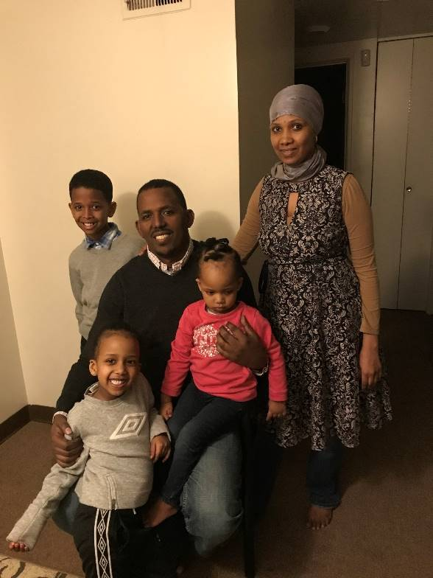
"Still I don't believe it," says future Habitat homeowner Habtamu. "Every week I drive past the site of our future home—every Saturday."
Habtamu and his wife Ebsitu and children moved to the United States after escaping their native Ethiopia where political turmoil made them concerned for their safety. After living in a refugee camp in Nairobi, Kenya, in 2014 they were able to come to the United States through a refugee program. After a difficult first winter in Ohio, without a vehicle, good jobs, or social connections, the family moved to Iowa City in 2015.
They now live in a two-bedroom apartment where their son Hangasu (9) sleeps in one room, and his sisters Bilisumma (3) and Asli (1) sleep in their parents’ room. Their eldest son Morkata (12) is living in Ethiopia with his grandmother; they hope he will be able to reunite with the family and live in their new home in Iowa City next year.
The family feels unsafe in their apartment and neighborhood. They hear of shootings and the police are often in the area investigating criminal activity. This spring, water seeped into the ground floor of their apartment complex and into their apartment, something that the family says happens several times each year. Hangasu says it is difficult to do homework with his sisters running around and playing. He has no space of his own.
Habtamu says the family has spent much time wondering what would happen to them. With the promise of a Habitat home, uncertainty about the future has been replaced with stability, allowing them to concentrate on their work and education. Habtamu, who taught language at an Ethiopian college for nine years and worked for the government as a translator, now wants to continue his education once the family moves into their Habitat home. Ebsitu was employed as a social worker in Ethiopia. She currently takes ELL classes and hopes to pursue a college degree in the future.
“The kids will feel safe. They will have their own home and not have to move from place to place,” says Habtamu. “They will feel responsible for their own house and they will be able to play outside more in a safer neighborhood.”
Habtamu adds that a house is a basic human need, especially with children, "It's like food, like clothes," he says. “We want our kids to grow up in a home we own. Our Habitat home will bring freedom inside our house. This is part of our dream."

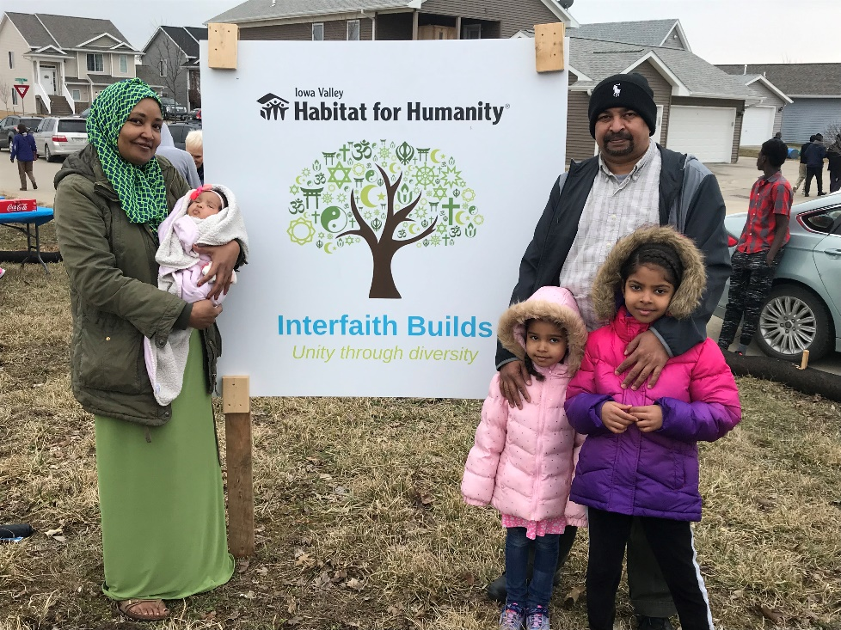
Hatim & Sayeda’s Family
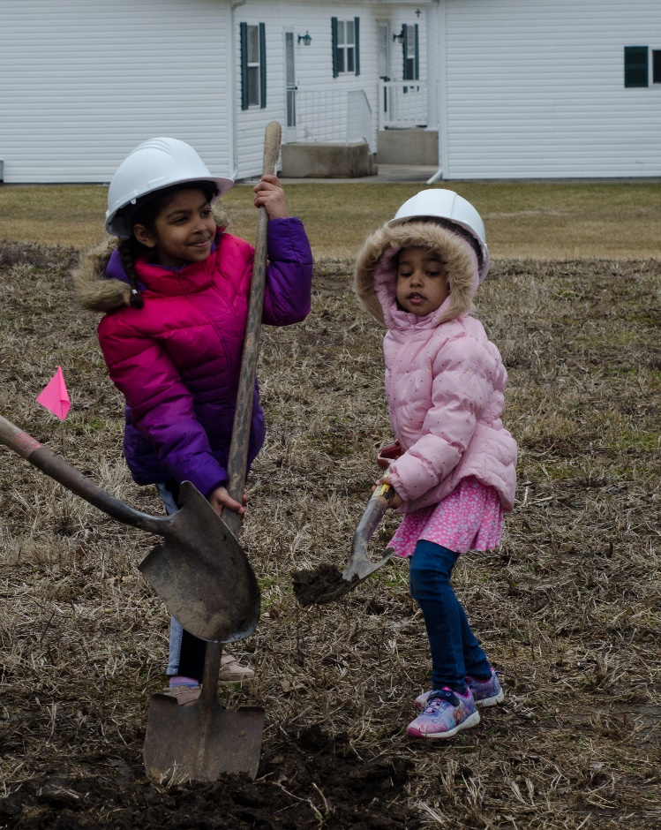
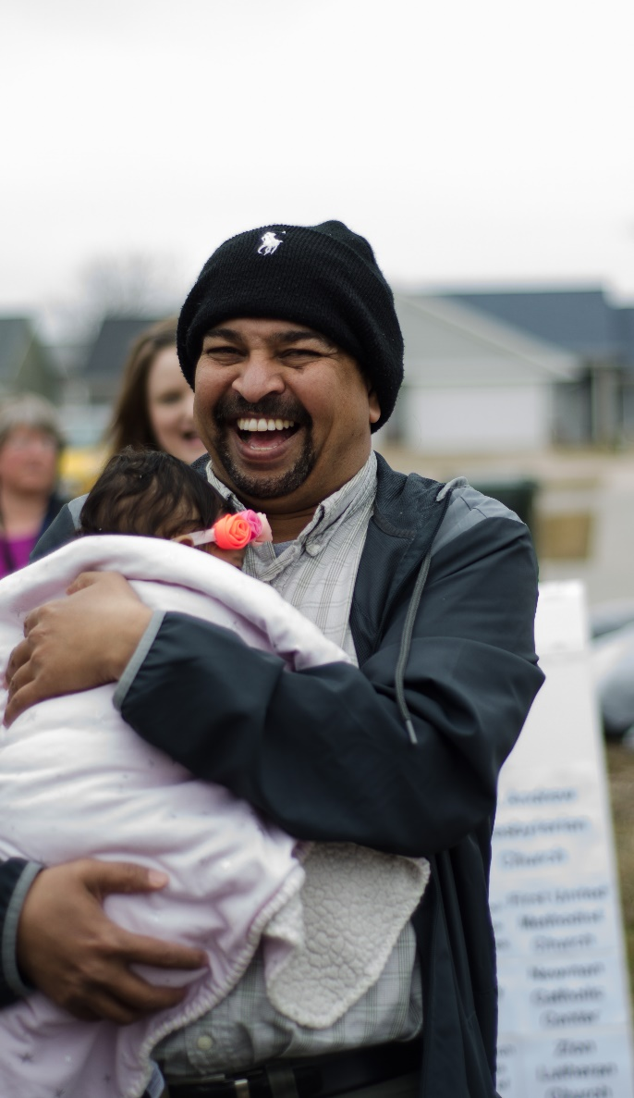
There are a lot of students in this household—five to be exact, counting the parents who take college classes and their three eldest children, ages 7 to 14—and not enough room to study around the small table in the cramped living and dining area in their apartment.
Hatim and Sayeda, who are scheduled to move from their small three-bedroom apartment into a Habitat for Humanity home in August, look forward to having quiet spaces where they can all study and work. In fact, when Hatim needs a quiet place to study, he will often go to the public library. Originally from Sudan, the couple has five children: two boys, Mohamed (14) and Nadir (11), and three girls, Elaf (7), Elan (4), and Eileen who was born in January 2019. They are very familiar with the Habitat program, having volunteered to help build other homes. Hatim says the family would never have the cash or capital for a down payment on a traditional mortgage. “When I got the letter saying our family was accepted, it changed my life,” he says. "It is a big, big opportunity for our kids to have a good foundation for their future.”
In 2003 the political situation in Sudan forced Hatim to flee to Egypt with only the clothes he was wearing and his passport. Sayeda joined him later. The couple came to the U.S. through a United Nations Resettlement Program in 2006. They moved to Iowa City in 2009 after more than a year in Dallas where Hatim worked at the airport, and some time in Fargo, North Dakota, where he attended school and worked at a Smucker's factory. “Then a friend suggested Iowa City, and when we came to look, we loved it,” Hatim says. “The neighbors are good people. You can just walk out the door and if you need help, there will be someone to help. The town is also quiet, safe, good for kids.” Hatim now works at a social services organization in Iowa City and drives a cab on weekends. Sayeda is employed at a childcare center in Iowa City. After Hatim finishes his program in aviation maintenance, Sayeda plans to complete her B. A. program in early childhood education.
They are excited about the advantages the Habitat home will offer their children. Two of their current three bedrooms are barely large enough for a bed and the family of seven shares one bathroom. Sisters Elaf and Elan talk excitedly about how they plan to paint their new bedroom in rainbow colors with a garden scene including grass, plants and a sun, and they look forward to having a backyard.
“This is for the kids more than for us,” says Hatim. They need a place to play, a place that feels like home. When I told them about the house, they said ‘No way. You’re kidding. No lie!’” Construction of the Habitat home will likely be done by August of this year and the family will move in shortly after.

