HELP BUILD A DREAM!
Help a low-income family build their dream of home ownership by working with Habitat for Humanity.
St. Thomas More is working Habitat for Humanity (HOH) to help Lena and Rashadi realize their dream.
Put the planned St. Thomas More work days of June 10, July 8 and August 5 on your calendar. (The dates are contingent on weather.)
Their home will be one side of a duplex that HOH is building for two families at 221 Sierra Park Drive, Hills, Iowa.
MEET THE FAMILY AND LEARN THEIR AMAZING STORY:
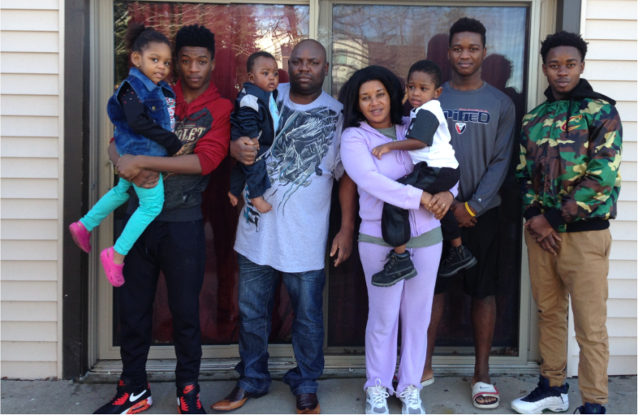
Rashidi and Lena hail from the area directly north of Lake Tanganyika in east Africa, with Rashidi being born and raised in Bujumbura, Burundi and Lena from the border town of Uvira, Democratic Republic of Congo. Violence destabilized the region in the late 1990s and Rashidi and Lena left the comforts of the familiar for a refugee camp in Tanzania. Life in the refugee camp was harrowing; no indoor plumbing, the daily trek to the nearest water source and a lack of electricity were the least of their concerns. Uncertainty of if and when they would ever have a chance to leave the camp made the experience even more difficult to endure. The couple and their young children lived in the refugee camp for more than a decade before being granted legal residency in the United States. The young family first arrived in Michigan in 2010 and eventually settled in Iowa City in 2013.
Rashidi currently works as a machine operator at Whirlpool. He enjoys the peace and tranquility of Iowa, yet is concerned about his family’s living conditions. The family of eight (Mpenda 18, Amani 17, Maisha 14, Amina 3, Ali 3, Adan 1) live in a cramped two bedroom apartment. Despite their best efforts, the teenagers are often late for school as all eight members of the family share a single bathroom. The older children often stay awake late studying -after tending to their work and family responsibilities- and interrupt the sleep of their younger brothers and sister, who sleep on the floor. Despite the confined space, the family is close and loving. They like to joke and reminisce about good memories, watch movies and look forward to spending time together at family meals. The eldest son, Mpenda, explains, “We fight sometimes, but we love each other. We would do anything for each other.”
Upon hearing that the family was accepted in the Iowa Valley Habitat for Humanity Homeownership Program, Rashidi was brought to tears. Finding a home that is large enough for an eight-person family is difficult, but finding a home this size that fits a tight budget is impossible. Mpenda sums up the problem, “We don’t have the means to get what we need.”
On average, Iowa Valley Habitat for Humanity homeowners save 25-30% on heating and cooling costs in addition to the savings that accompany an affordable mortgage payment. Rashidi and Lena will be able to use the savings to build a stronger, more stable, autonomous family. Lena thanks Iowa Valley Habitat for changing her life, “Thank you very much. I don’t have anything to give you, but I am so thankful.”
Rashidi adds, “Thank you again and keep doing the same to others.”

What you need to know:
- Days are divided into 4 hour morning and afternoon shifts. You can choose to work either a half or whole day.
- All volunteers must be at least 16 years old.
- Sixteen and 17 year olds cannot use power tools and cannot get more than 6 feet off of the ground. If you are under 18, it is best to contact the volunteer coordinator in advance to determine the tasks that will be completed during your shift.
- Everyone ages 18 and under must provide a waiver signed by their parent or guardian.
- Everyone must fill out an annual safety waiver. You must be there at the start of your shift to review safety instructions and daily tasks.
- Everything you need will be at your volunteer location, but you are welcome to bring your own tools &/or materials. There is a limited supply of work gloves, so bring some if you wish.
- Wear comfortable, layered, weather appropriate clothing. Close toed shoes are required.
- No prior knowledge or skills in construction is necessary.
If you are interested in working on this project, please sign up by contacting the Habitat for Humanity volunteer coordinator, Cherie Cool-Rudd, at (319)337-8949 or at volunteer@iowavalleyhabitat.org.
Inform them that you are working with the St. Thomas More group.
For more information, check the St. Thomas More website, or contact Peggy Lyon at lyon1013@gmail.com or (319)230-3059 or Mark Ray at (804)243-0562 or markdavray@gmail.com

