The St Thomas More Knights of Columbus are donating a new Washer and Dryer set to the Iowa City Catholic Worker house.
Value = $1,350.00
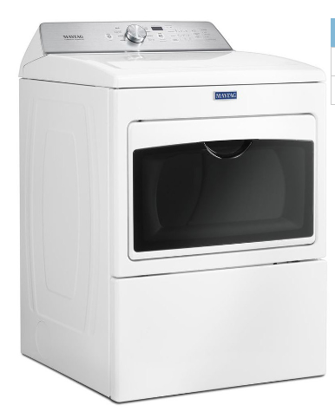
Maytag 7.4 Cu Ft Electric Dryer
Maytag 4.7 cu ft High Efficiency Top Load Washer

