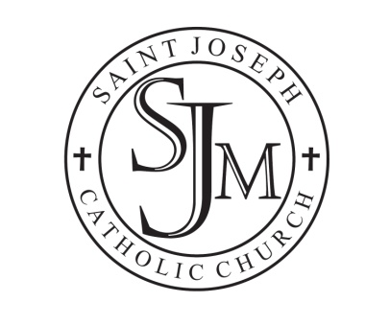

May 14, 2020

Dear Friends in Christ:
The Parish Staff is working hard to develop a plan to efficiently and safely restart public Mass. Here is what we know so far:
Beginning Monday, May 25th:
Our regular public Mass schedule will resume. Because May 25th is a holiday (Memorial Day), Mass will be at 9 a.m. All other morning Masses will be at the usual 8 a.m. time.
The Confession schedule remains unchanged: Fridays from 8:30 – 9:30 a.m., and Saturdays from 3:30 – 4:45.
The Parish and School Offices will open.
All parish ministries may resume face-to-face meetings on campus (although Zoom meetings are still encouraged.) Chairpersons should contact Chris Baltes in the Parish Office, and she will schedule you in the appropriate meeting space according to your group’s size.
The Perpetual Adoration Chapel will remain closed until further notice. Dates, times and procedures will be evaluated once we get public Mass up and running again.

SUNDAY MASS PROCEDURES BEGINNING MAY 30/31:
The Bishop has dispensed all Catholics from the Sunday obligation until further notice.
If you are compromised in any way (elderly, sick, have pre-existing conditions), please refrain from coming to Mass.
We will continue live-streaming every weekday Mass and the 9 a.m. Mass on Sunday. These can be viewed at any time from our Parish Facebook page and YouTube Channel (both found at: St. Joseph Parish, Maumee)
Every other pew will be roped off, so we will essentially be at 50% capacity. There will be some limited seating in the Family Center as well (Mass will be live-streamed to the screen, and a Eucharistic Minister will come to the Family Center to distribute Communion). Guests are encouraged to come early, and to consider attending a less-populated Mass (7 a.m. or 6 p.m.)
When we reach our 50% capacity, we will encourage people to watch from their cars, and Communion will be brought to them after Mass.
You are asked to keep a 6ft. distance from anyone who is not from your immediate household.
The Bishop asks that the reception of Communion be from your hand. Please make sure your hand is flat to avoid contact. Communion cannot be received with gloves on.
All are encouraged to wear a mask during Mass. If you don’t bring one, we will have a limited supply.
Bathrooms will be thoroughly cleaned and sanitized once a day, and guests are encouraged to use them only in case of emergency.
Hymnals have been removed from the pews. All music will be printed in the bulletin.
The entrance/recessional processions, offertory procession, sign of peace, reception of the Precious Blood, and any gatherings in the Family Center (i.e. coffee/donuts) are all suspended until further notice.
****************************************************
We will continue to update you with any additions or changes as they arise.
May God bless us all with a spirit of charity as we navigate through these unchartered waters. Above all, “let us live in a manner worthy of the call we have received., with all humility and gentleness, with patience, bearing with one another through love, striving to preserve the unity of the spirit through the bond of peace. “ – Ephesians 4:1-3

