Ss. Peter and Paul CCD Calendar of Events 2021-2022
Sept | Oct | Nov | Dec | Jan | Feb | Mar | Apr | May | 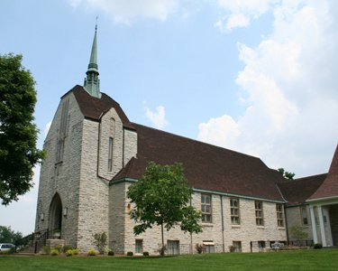
1 First Class | 6 | 3 | 1 | No class teacher in service | 2 | 2  Ash Weds | 6 | 4
8 | 13 | 10 | 8  No Class Holy Day | 12 | 9 | 9 | 13  Holy week  WE WILL HAVE CLASS
15 | 20 | 17 | 15 | 19 | 16 | 16 | 20
22 | 27 | 24  No Class Thanksgiving Break | 22 | 26 | 23 | 23 | 27
29 29 |  |  | 29  No Class Christmas break |  |  | 30
Class times will be 6:30- 7:30
1st 1st Reconcilition retreat will be Nov. 20th with the Sacrament conferred also.
1st communion retreat will be April 9th
1st communion will be May1st at the 9:30 Am Mass
Please use the back doors, to enter, not the side door.
To report absences call or text me 937-638-1280 or your teacher
Make sure a staff member is around before leaving your child
Please try to park along cemetary

