St. Joseph Before School Kids Program
2020-2021 School Year
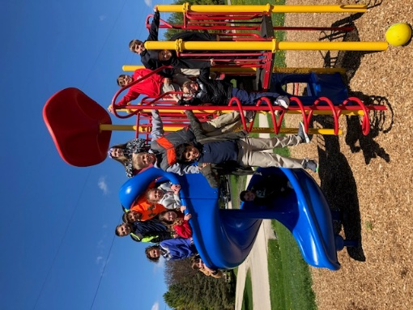
Director: Linda Skarr
lskarr@stjoesbb.com 414.218.6661
St. Joseph School: 262.662.2737

St. Joseph School provides before school care services for parents sending their children to our school. The goal of the program is to provide a safe, fun and educational place for children to be dropped off before school starts.

HOW IT WORKS:
We are located in the cafeteria. Parents must walk their child(ren) into the school and sign them in. Students are allowed to be dropped off beginning at 6:30am at the Cafeteria Delivery Door. Students are allowed to bring a breakfast or snack.

UTILIZING THE PROGRAM:
Whether you need to utilize BSK on a regular basis or just some days during the week, you must:
- Pre-register
- Pay a one-time non-refundable registration fee of $25.00 ( Unless you already paid the registration fee for ASK, then you do not need to pay the BSK registration fee.)
- Pre-pay on a weekly basis.

BEHAVIOR EXPECTATIONS:
Children are expected to follow all school policies and guidelines, including behavior expectations and parents will be informed if failure to do so. Should the problem continue, Mr. Van Rixel will be contacted.

BEFORE SCHOOL CARE BILLING:
- All payments need to be paid by the Friday prior to the week your child will attend.
- Before School Kids payment can be given directly to the office or by kid mail. Please label on the envelope “Before School Kids” payment.

St. Joseph Before School Kids Program
2020-2021 School Year

- $25 Registration Fee payable to St. Joseph’s School must accompany this form and paid prior to using the service. If you already paid the registration fee for A.S.K., this fee is waived.

- School Emergency Contact Form: A copy of this school form will be given to the director to be used in the event of emergencies. School Office must have this form on file prior to using services.

- The next page is a schedule to be completed. If you plan to change from that schedule, please inform staff.

Weekly Fee Schedule

Number of Children | Part-Time  (1-3 days per week) | Full-Time  (4-5 days per week)
1 Child | $15 | $25
2 Children | $25 | $45
3 Children | $35 | $65
4 Children | $45 | $85

- Families will be required to submit their pay the Friday prior to the week your child(ren) will attend before school care.

- Please note if your payment is not made in advance, your child cannot attend the following week.

(Registration form on attached page.)

Before School Kids Registration Form

Family Name: ___________________

Email Address #1: ______________________________________
Email Address #2: ______________________________________

Please fill out typical days and time your child(ren) will be attending:
Student’s Name | Grade | Monday | Tuesday | Wednesday | Thursday | Friday

Emergency Contact Information:
(1) Name: ___________________________________________________________________
Relationship to Family ______________________________
Phone Number: __________________________

(2) Name: ___________________________________________________________________
Relationship to Family ______________________________
Phone Number: __________________________

(3) Name: ___________________________________________________________________
Relationship to Family ______________________________
Phone Number: __________________________

