Corpus Christi Catholic CHurch
Religious Education
K - 8
Student Drop Off, Student Pick Up
and Classroom Protocols

2021-22 School Year

Dropping off protocol/ Route for students to enter Parish facilities

The driveway along the building will be blocked off at the entrance and at the fire lane so cars will not drive along the front of the building while children are being dropped off for classes. Parents may park and walk children up to the lawn (mandatory for kindergarten, 1st year and 2nd year classes) or park to drop off older children able to cross the parking area alone.
Children will line up in the lawn area by the classrooms. Classrooms will each be assigned a number corresponding with a number on the sidewalk along the lawn.
1 St Elizabeth Ann Seton
2 San Juan Diego
3 St Lorenzo Ruiz
4 St Francis
5 St Mary Magdalene
6 St Therese of Lisieux
The lines of children will proceed with a Catechist or volunteer into the parish building by number starting at number 1 through number 6. Lines 1, 2 and 3 will use the doors by the Religious Education office and lines 4, 5 and 6 will use the stairs.

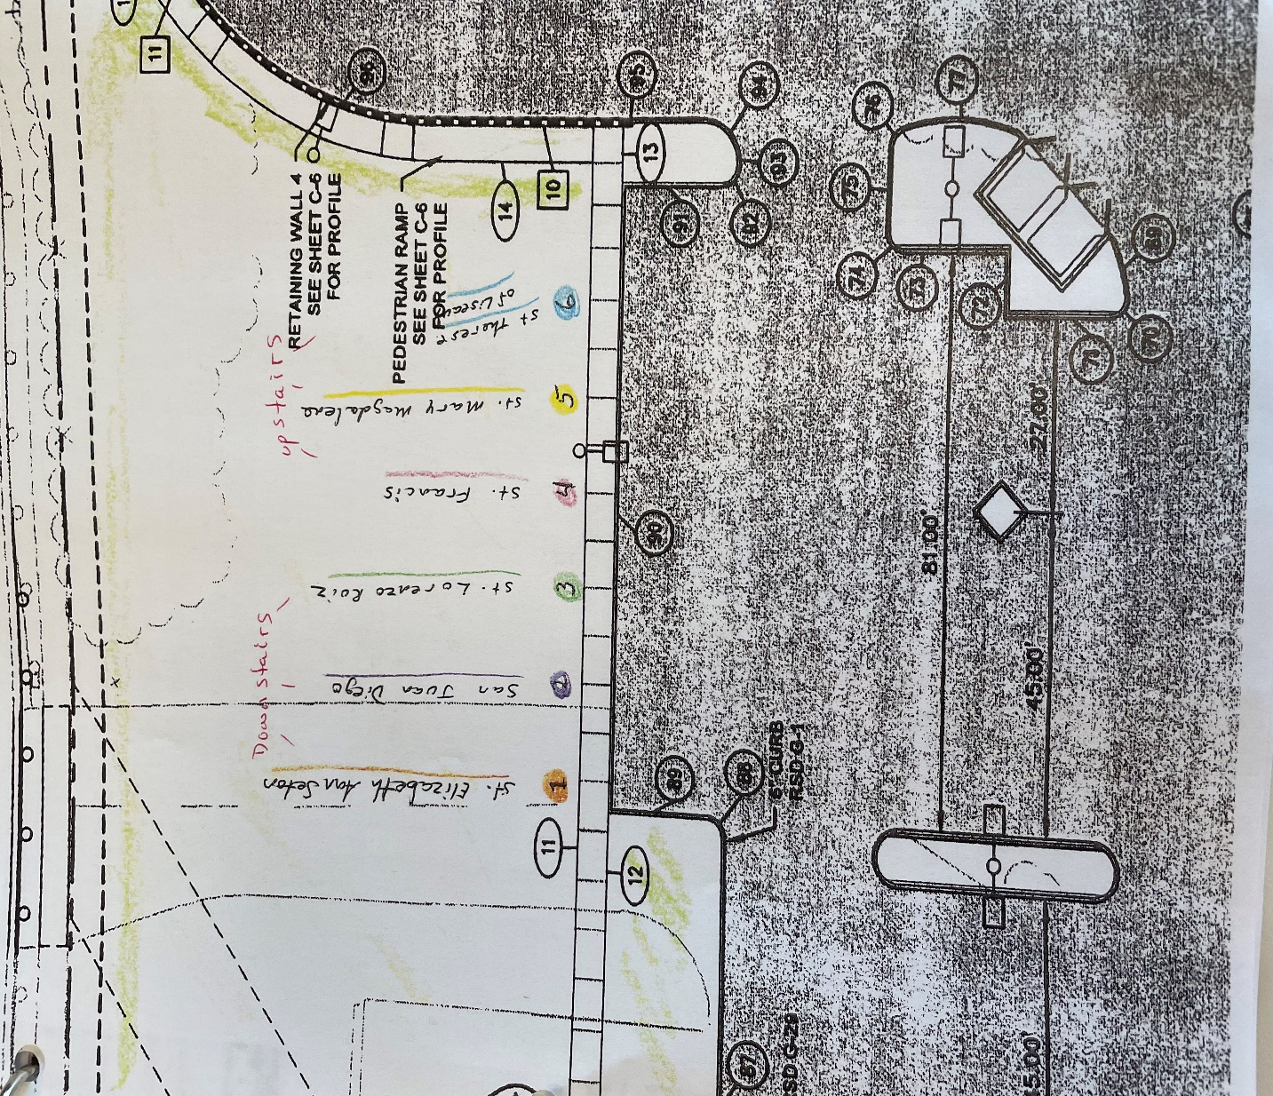

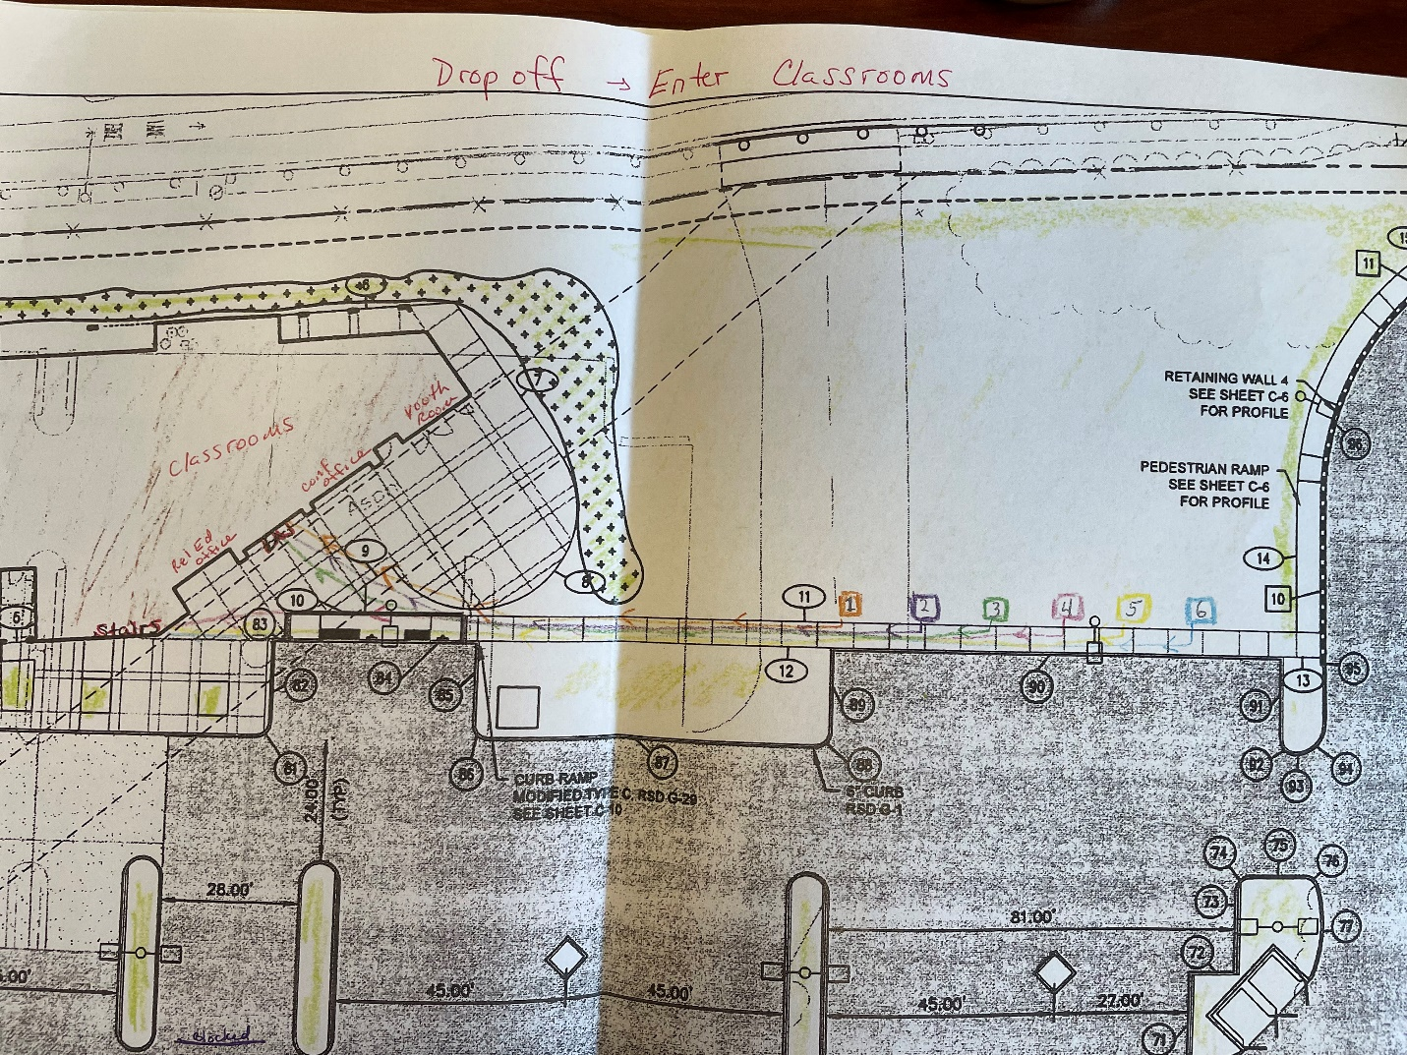

Classroom Protocols
Children will enter the classroom single file seating from the rear of the room forward.
Students exiting classroom will begin from front row to back row walking out single file.
Consistent with the guidance provided for Catholic Schools, faith formation will require all students including staff and volunteers to wear a mask in indoor settings regardless of their vaccination status (exemptions include persons younger than 2 years old, persons with a medical condition, mental health condition, or disability that prevents wearing a mask, his includes persons with a medical condition for whom wearing a mask could obstruct breathing or who are unconscious, incapacitated, or otherwise unable to remove a mask without assistance; persons who are hearing impaired, or communicating with a person who is hearing impaired where the ability to see the mouth is essential for communication).
Hand sanitizer will be available in each classroom.
There is no eating in the classrooms. Children may bring a personal water bottle.
The air conditioning will be on during class.
Books and the child’s personal supplies will be kept individually in a sealed plastic bag. The books will be distributed to the students by the catechist for the day’s class then collected by the catechist at the end of class for storage in the classroom.
Classrooms and restrooms will be disinfected daily and in between classes. A cleaning log will be kept.

Positive COVID 19 Case Notification.
If a positive case is reported in our facility the parents of the class effected will be notified.
Parents will be asked to monitor and screen their children for symptoms such as fever of 100.4 Fahrenheit or higher, cough, severe headache, sore throat, loss of taste and smell, difficulty breathing, vomiting or diarrhea. The parent will need to contact the Parish Religious Education office to notify us that their child is ill.
The non-vaccinated will need to quarantine for 10 days after last close contact and be symptom free for at least 24 hours or have a negative COVID 19 test and be symptom free for at least 24 hours to return. Those vaccinated with no symptoms do not need to quarantine.
Please refer to next 2 pages for more information.

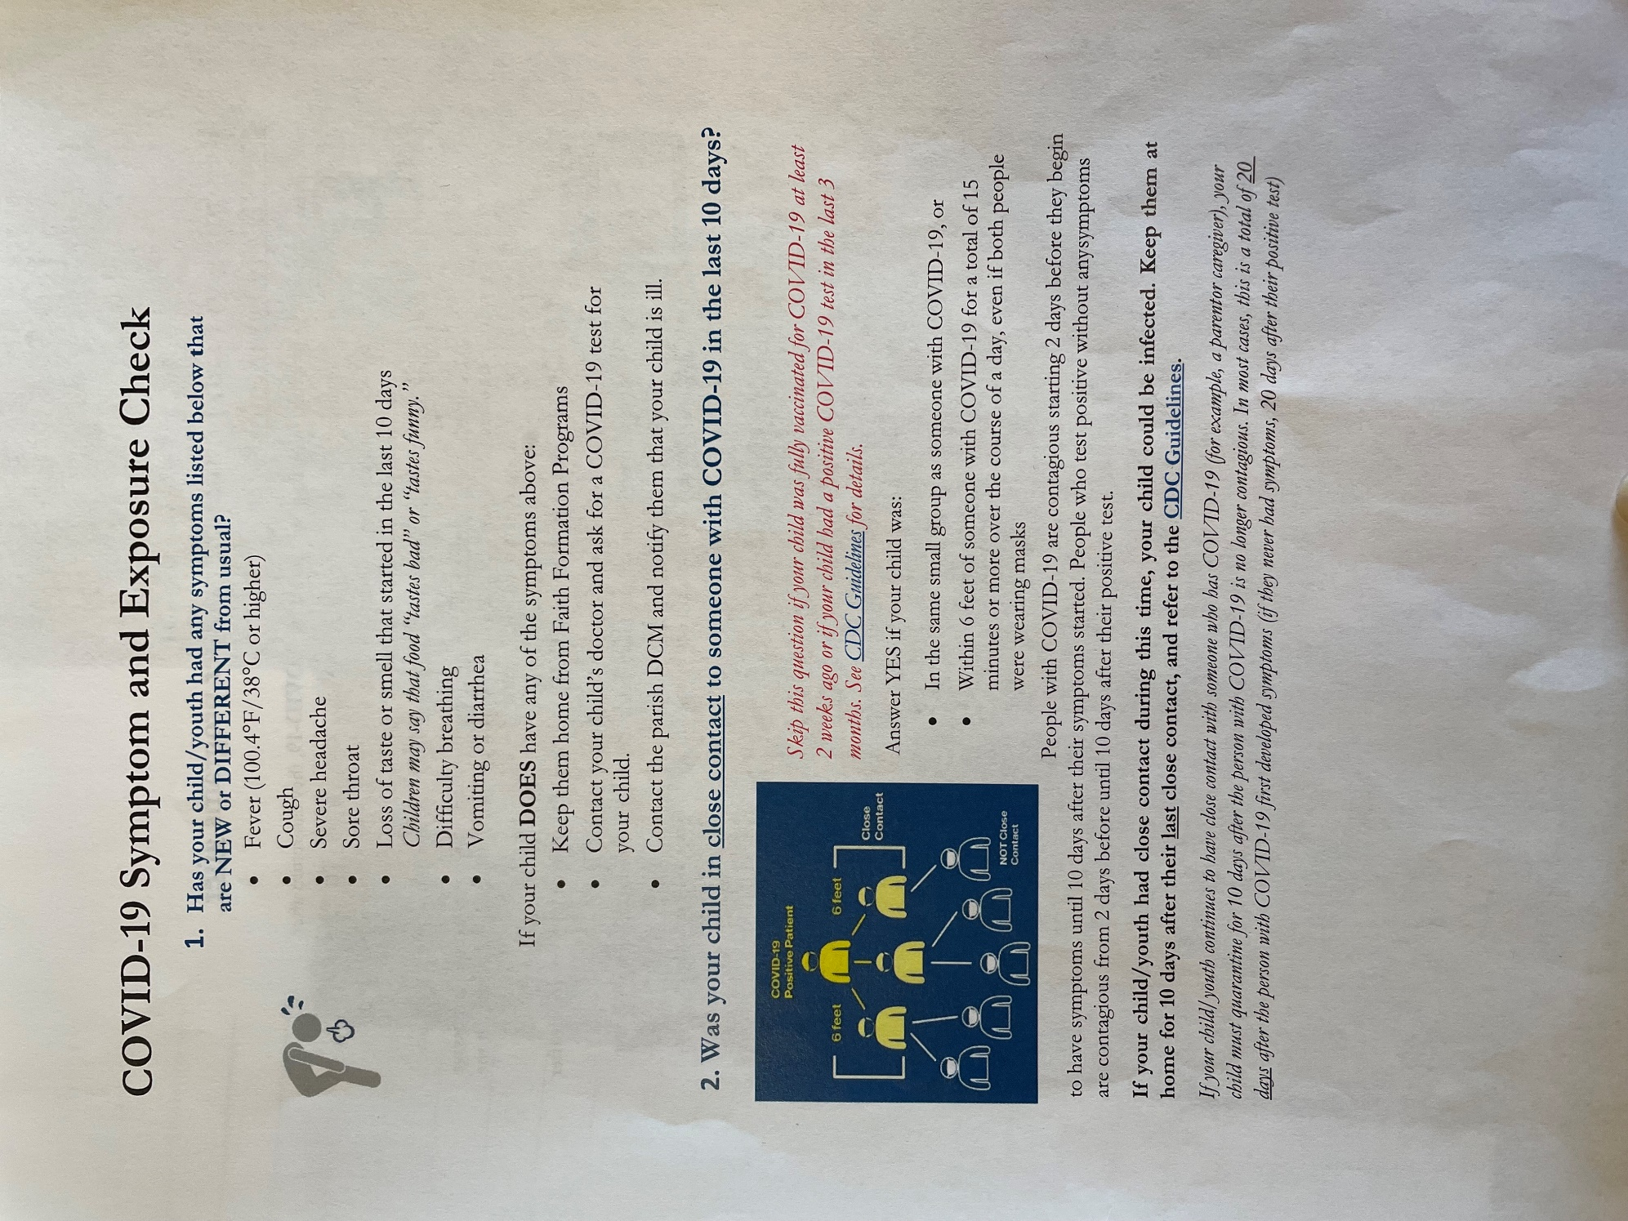
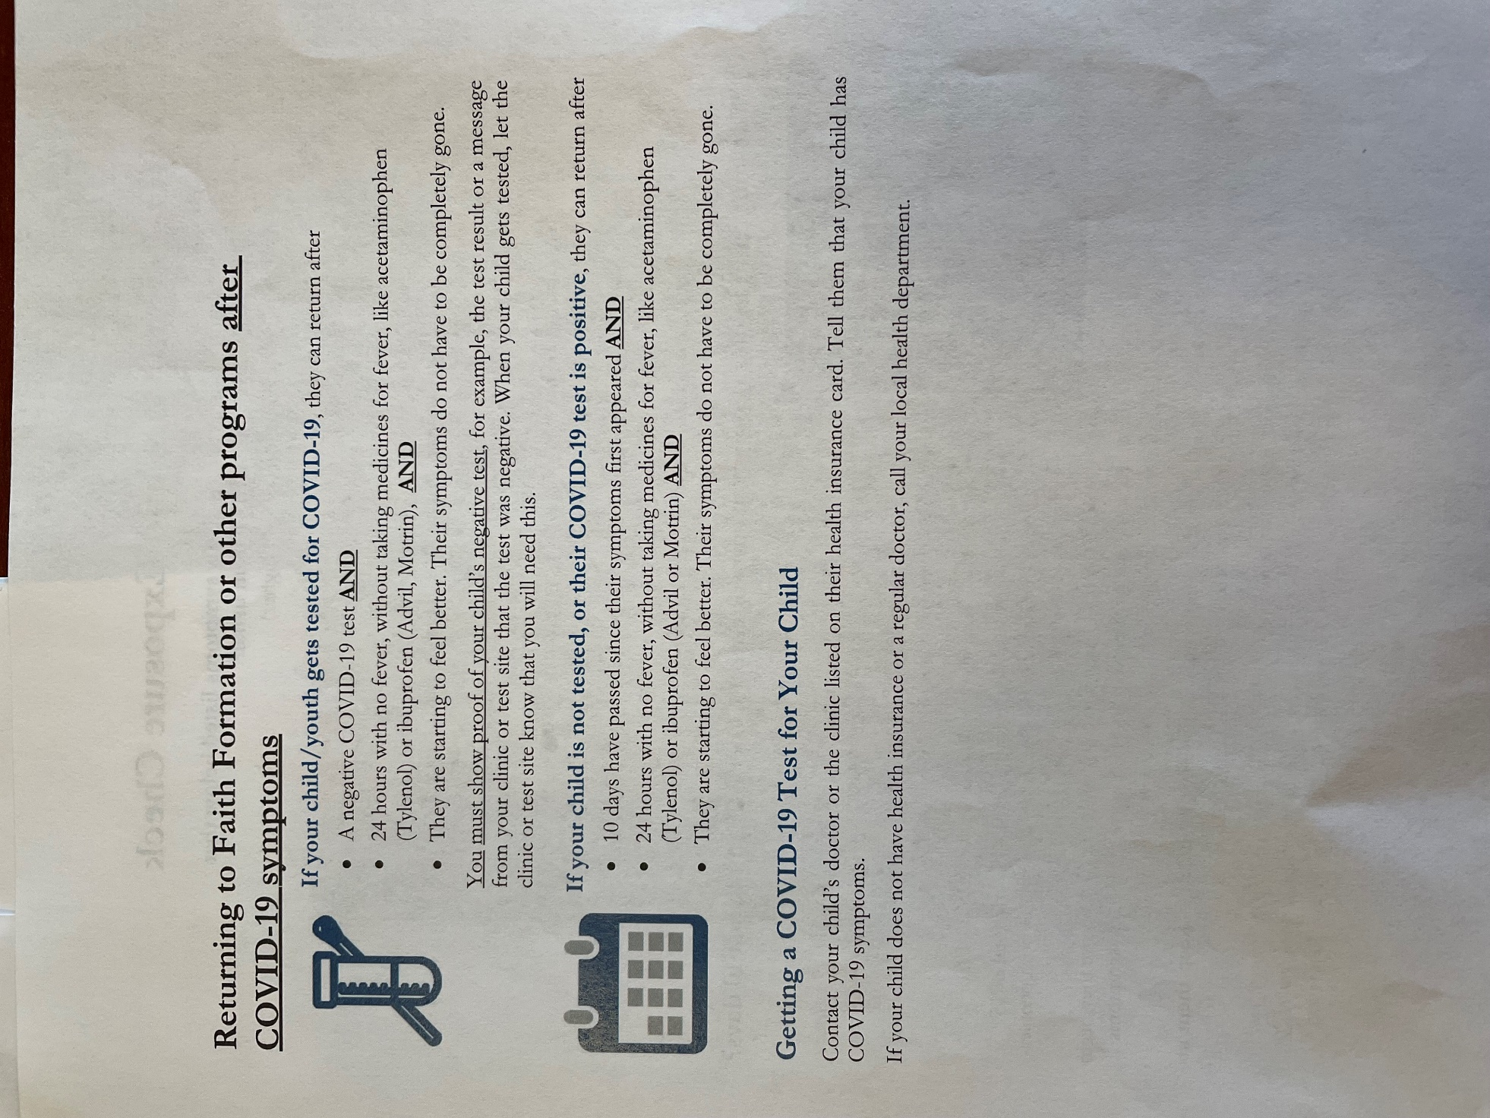

Picking Up protocol/ Route for students to exit Parish facilities

The driveway along the building will be blocked off at the entrance and at the fire lane so cars will not drive along the front of the building while children are being Picked up from classes.
The children will line up at their classrooms 5 minutes prior to the end of class time and the lines of children will exit with a Catechist or volunteer from the parish building by number starting at number 6 through number 1. Lines 3, 2 and 1 will use the doors by the Religious Education office and lines 6, 5 and 4 will use the stairs.
Children will line up in the lawn area by the classrooms. Classrooms are assigned a number corresponding with a number on the sidewalk along the lawn.

6 St Therese of Lisieux
5 St Mary Magdalene
4 St Francis
3 St Lorenzo Ruiz
2 San Juan Diego
1 St Elizabeth Ann Seton

Parents may park and walk to children lined up on the lawn (mandatory for kindergarten, 1st year and 2nd year classes) or park to pick up older children able to cross the parking area alone.

