Church of Saint Henry Drop-Off & Pick-Up Policy for Faith Formation
2020-2021

General Principals to Remember:
+ Be respectful of others and stay 6-feet apart whenever possible
+ Observe one-way flow for arrival and dismissal: enter through Door #1 (main doors), walk through the gathering space, hallway, down the north hallway, through the gym, and up the south hallway, and exit through the Door #2 (office doors). Door #2 is open for late arrivals.
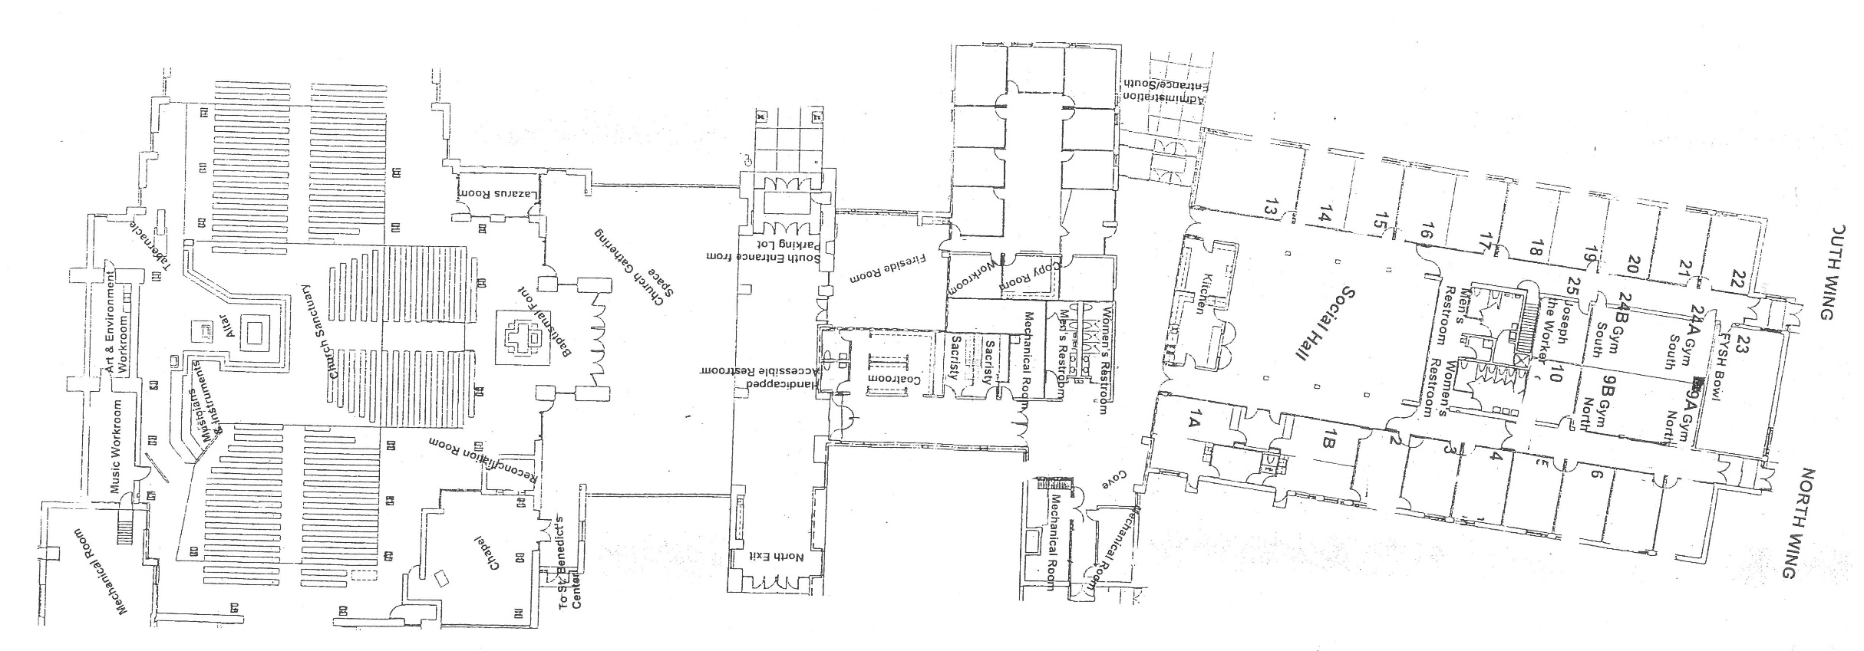

=
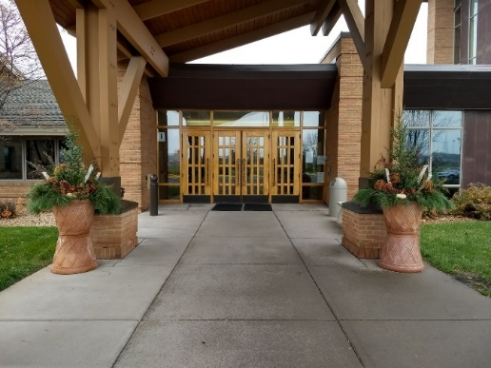
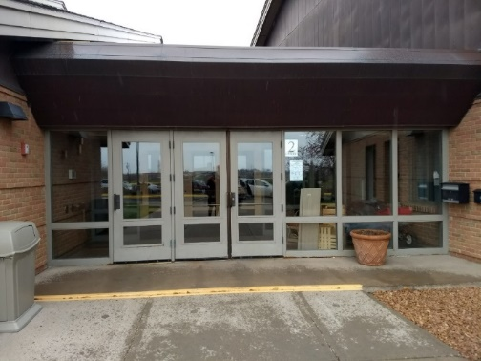
3:25pm PreK-5th Grade Faith Formation Session

Door #2 EXIT & LATE ARRIVALS ONLY
Door #1 ENTRANCE ONLY
Drop Off/Arrival:
- Because of COVID-19 restrictions, we ask students and families not to arrive earlier than 10 minutes prior to each session.
  - For the 3:25pm session, students/families should not arrive earlier than 3:15pm
  - For the 6:00pm session, students/families should not arrive earlier than 5:50pm
  - For the 7:15pm session, students/families should not arrive earlier than 7:05pm
- The 3:25pm and 7:15pm sessions will begin with a prayer service in the Main Church. Upon arrival of these session, students and/or families must enter through Door #1 (main doors) of the church and take their seat (assigned spaces) in the Main Church.
  - A section of pews will be assigned to each classroom. Within the assigned spaces, catechists and students are to observe social distancing: no more than two or three persons to a pew, spaced 6-feet apart.
  - Students are not allowed to gather in the Gathering Space before or after class.
  - Students are not allowed to walk down to their classrooms until after the prayer session, when classes are individually dismissed to walk as a group to their classes.
  - Classes are to observe the one-way flow signs (see one-way flow map)
- The 6:00pm session will begin in classrooms. Students and families should make their way down to their clasrooms. Upon arrival of this session, students must enter through Door #1 (main doors) of the Church and make their way down to their classroom (see one way flow map).
  - Students and families should observe one way flow (see one-way flow map)

Pick Up/Dismissal:
- Students in grades PreK-6th must be picked up at their classroom door. In order for catechists to ensure that students are going home with the correct designated pick-up person, it is important that they are picked up at the classroom. We also do not want any unattended children on the sidewalks or in parking lots for their safety. This is especially important in the winter months when it is dark early. Therefore, students in grades PreK-6th will not be allowed to leave the building without a parent or designated pick up person. A written and signed note must be given to the Faith Formation Director and catechist if a student is to be take home by someone other than the parent or person designated on your registration form. Parents, please park in the parking lot, enter the building through Door #1 (main doors), and make your way through the building observing the one way flow and stop by the classrooms of your child(ren) along the way. Parents and students are expected to leave the building in an orderly manner and are to walk at all times.
- Students in grades 7th-High-School may depart on their own, due to the fact that some students drive themselves of with an older sibling. Students are expected to leave the building in an orderly manner, observing social distance and one-way flor, and are to walk at all times.
- Each session will run the full length of the scheduled time period. Students are to remain in their classrooms until the bell rings (and for PreK-6th grade, picked up by their parents).
Locked Doors:
- Doors #1 & #2: Doors #1 will be locked 5 minutes after each session has begun for security reasons. If a student or parent is arriving late or needs to enter the building for any other reason once the session has begun, they must go to Door #2 and visit the office (see note about late arrivals below)
- Social Hall & Gathering Space Doors: After the prayer service and once students are in their classroom spaces the Social Hall doors and Gathering Space doors will be closed and locked for security reasons, as well. Because of COVID-19 restrictions, classes/ groups are to remain in their assigned classroom spaces, as much as possible. (At this time, we discourage visits to the chapel, as that requires moving through other groups’ spaces [Social Hall, Cove, Hallway, Gathering Space, etc.] and will disrupt their class time. If classes would like to plan a trip to the Chapel, please plan it with Faith Formation Director in advance, and catechists will be given a temporary FOB.)
- Doors will be opened 5 minutes prior to the end of each session for pick-up/dismissal.

Late Arrival:
- As noted above, Door #1 (main doors) will be locked 5 minutes after each session has begun for security reasons. If for some reason a student arrives later than 5 minutes past the session has begun, they must enter through Door #2 and visit the office to be escorted to their class.

Early Dismissal from Class:
- Commitment to Religious Education is important, therefore, sports practices or games do not constitute a valid reason for being tardy or for early dismissal. If a student must be excused from class for an urgent reason, the parent must notify both the Faith Formation Director and the catechist. Additionally, a note signed by the student’s parent/guardian is to be given to the catechist by the student at the beginning of class that evening. The note should contain the reason and time of early dismissal as well as the name of the person authorized to pick the student up. The authorized adult must come to the office to pick up the student early from class.
Contact Information:
Director of Faith Formation for PreK-6th Gr. Director of Faith Formation for 7th-12th Gr. Main Office
Jessica Soden Jenna Leighton Sue Kunkel or Vikki Buck
763-271-3079 763-271-3092 763-271-3070
jsoden@sthenrycatholic.com jleighton@sthenrycatholic.com info@sthenrycatholic.com

