**Everyday Stewardship**

What do you own and what owns you? You can find this question asked many times in several different contexts. Are you looking to find some kind of financial freedom? How about trying to live simply in a complex world? Has a mountain of stuff invaded your home garage to the point where parking a car inside is only a dream?

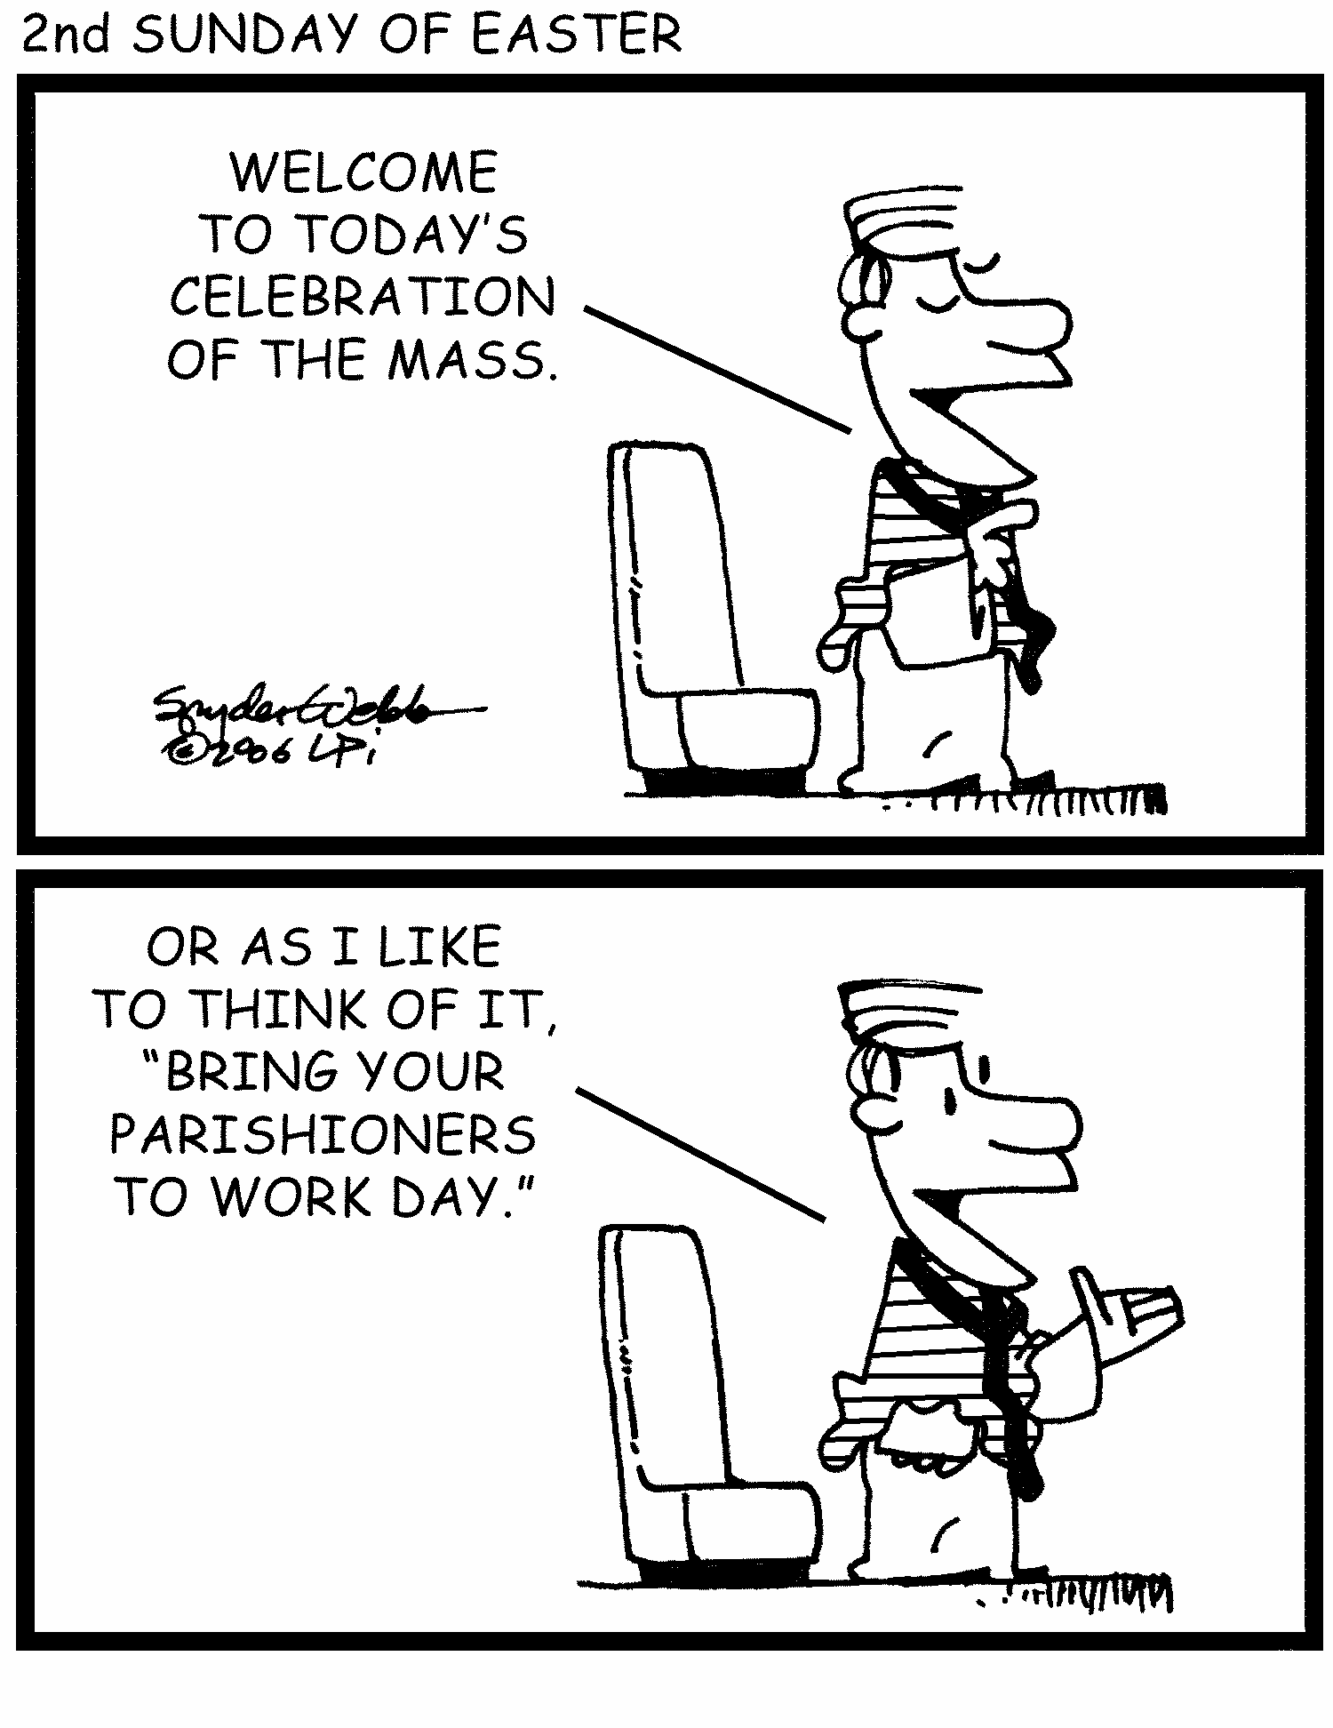The early Church practiced a radical form of fellowship called koinonia, which literally means "sharing in common." Those who had homes and other major possessions would sell them and then place the proceeds in the care of the Apostles to be shared with the entire community. People focus mostly on the fact that people sold all their possessions for the benefit of the community. However, the real point is the action that occurred after every selling: the proceeds were given to Church authority, in essence, to God first. I wasn't just selling my house and then giving the money to random people. My offering was to God and it was for the Apostles (those who personally encountered Jesus and now represented him on earth) to decide how to divide up the wealth.

Why do such a thing? One could say it was so that no one wanted for anything. If we push that thinking too far, as some in history have done, we can create a system that takes from some to give to others. Nothing was taken from anyone in that first Christian community. It was freely given. And perhaps the reason why people were moved to do so lies at the heart of stewardship: because all we have already belongs to God anyway. --Tracy Earl Welliver, MTS

• Cana

• Bethsaida

• Mount Carmel

• Mount of Olives

• Via Dolorosa

• Mount Tabor

• Capernaum

• Stella Mares

• Gethsemane

• Nazareth

• Holy Sepulcher

/Users/oliviacook/Desktop/LLFtrans.pdf

**APRIL 6, 7, & 8TH**

**BANDS: Friday-7:30 Foret Tradition**

**Saturday-5:00 Kenny Fife & Bac Trac Band**

**8:30 Mike Broussard**

**Sunday-1:30 NaNaSha**

***4:30 Hip Boot Joe***

***For more information check us out***

***on Facebook:*** Light Lane Festival

**Great food, rides, games, fair store,**

**live and silent auction**

**PRAYING THE DIVINE MERCY CHAPLET**  
Begin with the Our Father, Hail Mary, and the Apostles Creed.

Using regular rosary beads, work your way around the five decades with the following prayers below.

* On the standalone beads, pray: "Eternal Father, I offer you the body, blood, soul, and divinity of your dearly beloved Son, our Lord Jesus Christ, in atonement for our sins and those of the whole world."
* On the decade beads, pray: "For the sake of his sorrowful Passion, have mercy on us and on the whole world."
* At the end, pray the following three times: "Holy God, Holy Mighty One, Holy Immortal One, have mercy on us and on the whole world."
* It is typical to conclude the Divine Mercy Chaplet with the words: "Jesus, I trust in you."

**Holy Land Pilgrimage**

**with St. Joseph & St. Stephen Catholic Church**

September 2-11, 2018

**Spiritual Director: Fr. Jason Palermo**

**Pilgrimage Highlights:**

• Peter’s Primacy

• Caesarea Philippi

• St. Anne’s Church

• Holocaust Memorial

• St. Peter in Gallicantu

• Mount of the Beatitudes

• Church of the Nativity

• Qumran & Dead Sea Scrolls

• Grotto of the Annunciation

• Boat Ride on the Sea of Galilee

• Tabgha, Site of the Miracle of Multiplication

**All are Welcome!**

If interested, call the office, 225-698-3110.