FORMED●ORG
A virtual multi-sensory Catholic library at your very fingertips...movies, programs, audio, books for everyone in your family...children’s videos, teen programs, programs for engaged and married couples, documentaries, audio talks, stories about our faith HEROS... the Saints. Learn about the sacraments in depth. Your questions about the bible, the Catholic faith, symbols, and traditions answered. A wealth of information, entertainment, and faith formation for all ages.

Learn how to live as a modern-day disciple and how the first disciples really lived.

It’s simple and FREE for you to use. Sign in under St. Joseph Parish, French Settlement, Louisiana 70733!
“How-To Sign In” DEMOS
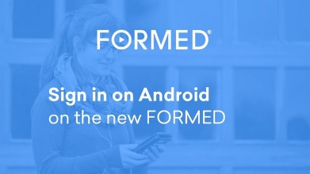
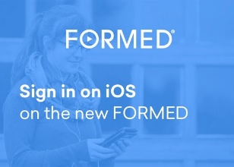
00.56 seconds
00:57 seconds
00:54 seconds
01:29 seconds
Watch, listen and read. Anywhere, anytime.
FORMED provides the very best Catholic content from more than 60 organizations to help parishes, families and individuals explore their faith anywhere. Supporting thousands of movies, children’s programs, ebooks, audio, parish programs and studies direct to your browser, mobile or connected device.

Mobile
Enabling content on the go with offline playback on your mobile phone or tablet. Supporting iOS and Android devices.
Connected Devices Providing faith-filled, engaging content direct to your living room with Roku, Apple TV, Amazon Fire, XBOX, and Chromecast among others.

For daily devotions, new content and feature updates, get the FORMED Daily, direct to your inbox.

Materials Titles Include:
Beloved The Wild Goose Why Believe Presence Mary of Nazareth
The Reluctant Saint Symbolon: The Catholic Faith Explained Forgiven
Grieving With Great Hope (audio) Marriage Unique for a Reason
Desire of the Everlasting Hills (You design your life. The choices we make change our life. They don’t merely change the world around us, they change us.) PRAY LIKE A SAINT

The Battle within YDisciple fACING yOUR fEAR Brother Francis (Animated videos: Join Brother Francis as he helps children up to 8 years old understand how to live a joy-filled Catholic life.)
The Animated Bible Series The Giant King The Saints and Heros Collection
The Jesus Stories (10 minute stories created to help children apply lessons found in the parables of Jesus.)

