St. Augustine Food Pantry News

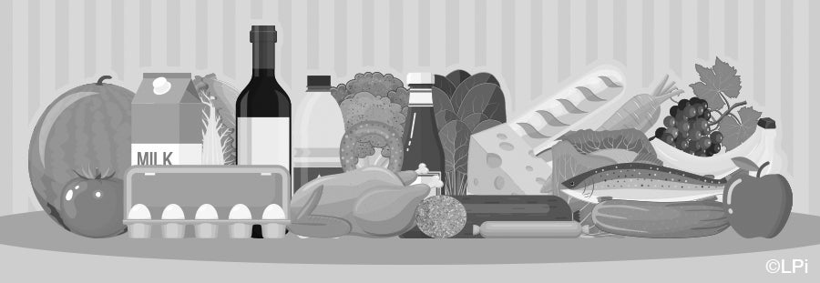
A big thank you to all the wonderful people who have been so generous with both monetary and food product donations to our food pantry.
In addition, our school, Notre Dame Academy, presented Father Bill with $400 in Walmart gift cards to be used to purchase supplies for our food pantry. The money used to purchase gift cards for both the Cathedral and St. Augustine food pantries was raised by the students and faculty of Notre Dame, and we thank them for their generosity.
March 13-21, Mike and Debbie Clover will hold the St. Joseph Table food collection out in the gathering space. Please watch the bulletin for additional information regarding this collection. All food products collected on the St. Joseph’s Table will benefit our food pantry.
As we do every year, we will be giving out an extra bag of food to our food pantry clients for Easter which will include a canned ham, makings for green bean casserole, corn, a boxed potato product, mac and cheese, peanut butter, brown & serve rolls, fresh fruit and a dessert. Most of the items being included in this bag have already been purchased.
Ginny is looking for a volunteer or 2 to help her pack the bags at the rectory on the afternoon of Tuesday, March 23rd, and, if needed, the morning of Thursday, March 25th. If you are interested in helping, please call Ginny at (618) 660-8886.

