Christ Our Light Women’s Retreat
March 6-8, 2020
@ Camp Onomia in Onamia
The Spiritual Practice of Self-Compassion
You are invited…
The women of the parish and friends are invited to our 7th annual women’s retreat. Come to get away and find some peace, laughter and prayer in the beauty of the woods. Spend the entire time, just Saturday or whatever works for you. We will be exploring the theme of self-compassion – something we could all work on!
Come away and rest…

Presenter: Donna Nordang is a retired psychologist who is currently a spiritual director and lives in St. Cloud with her family. Nature feeds her soul, whether it be trees or plants, rocks, water, clouds, insects, or any critters. She is committed to respond to the suffering in the world by helping people treat themselves, others, and all of God’s creation with compassion. Choosing to be compassionate is a courageous response to life. It is an invitation to grow in the kind of love that motivated Jesus to be a compassionate presence.

Last Name ________________________ First Name ____________________

Cell Phone ________________________ Do you text? Y N
Email ________________________________________________
City ______________________________________________________________

Cost includes meals, room & supplies. Saturday includes lunch and dinner.
One Night ($90) ____ Two Nights ($140) ____ Just Saturday ($45) ______

Special Dietary Needs. (Vegetarian, Gluten-free, dairy-free etc)
____________________________________________________________________________________________________________________________________

If needed, could you drive? Y N Do you need a ride? Y N
Emergency Contact:
Name ___________________________________ Relationship _________________
Primary phone # ___________________________
Insurance Provider and Policy # ___________________________________________

Please share any medical concerns that would be helpful for us to know.

Rooms are double occupancy – if you’d like to stay with someone, please request it on your registration form. Please bring your own bedding and pillow. Financial assistance is available. Please contact Molly Weyrens, Pastoral Associate @ mollyw@christourlightmn.org

## We plan on leaving Princeton at 6:00 pm on Friday . Eat dinner before you come on Friday. On Sunday we will attend Mass at Holy Cross in Onamia and return to Princeton by 1 pm. Please return registration to church with payment. Checks can be made out to COL.
Registration is due on February 23rd.

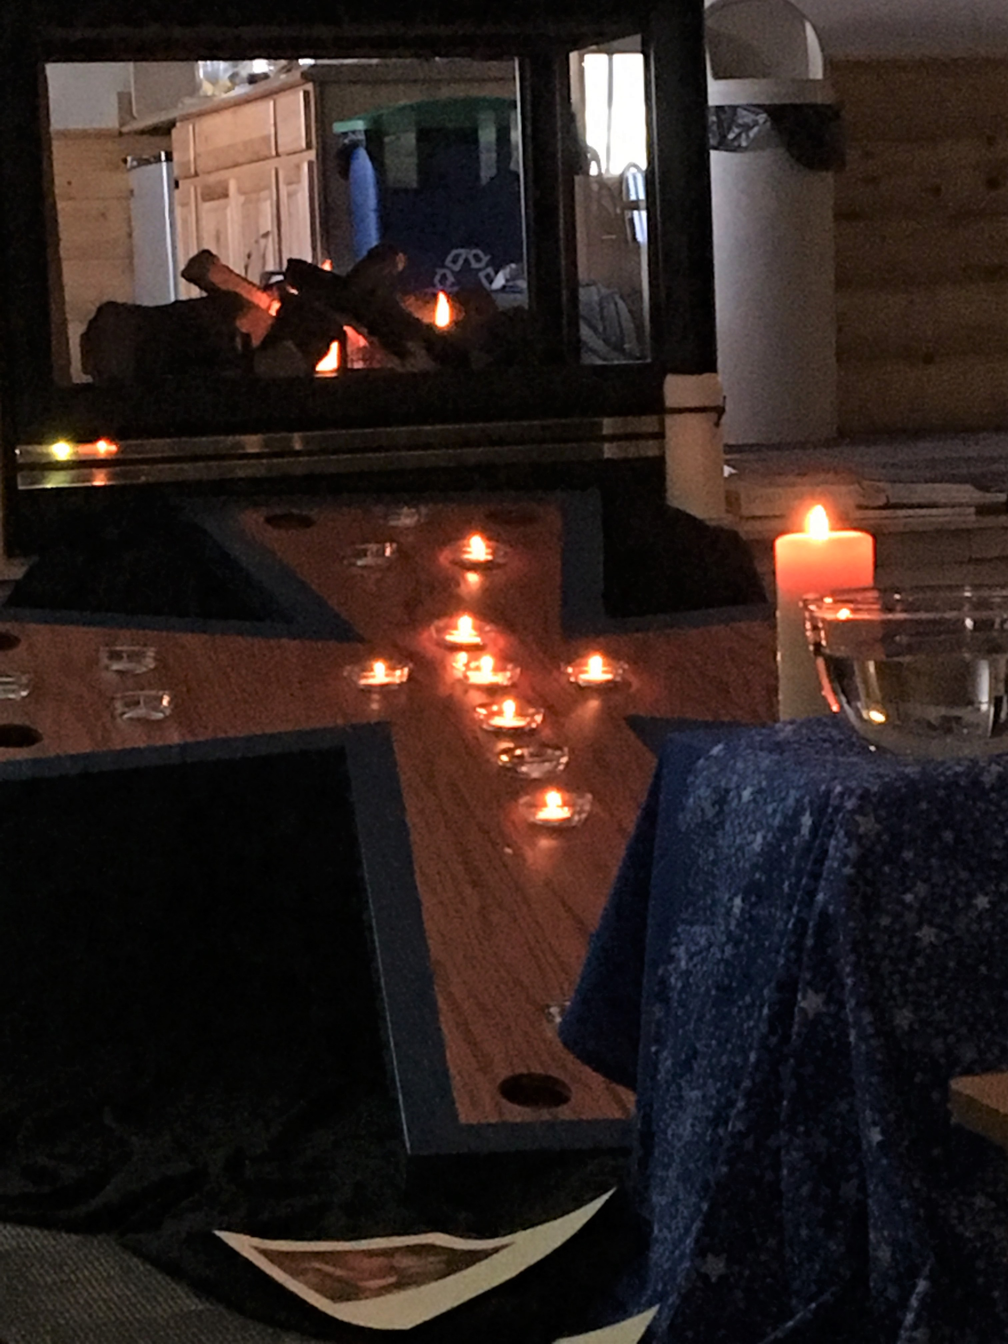
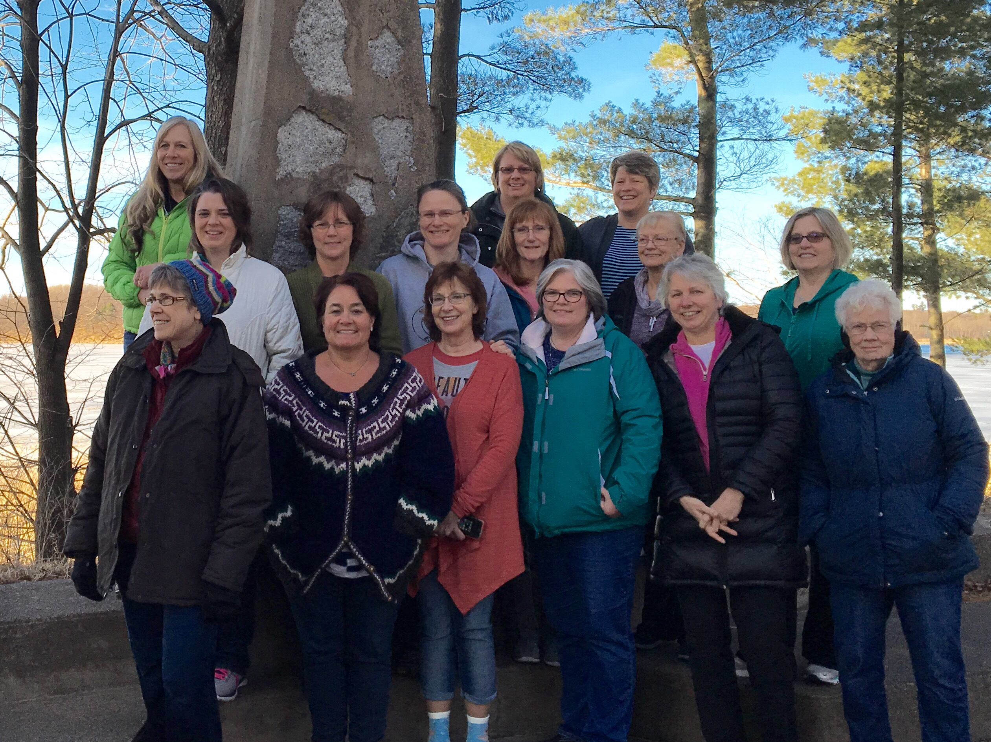
Good Times!

