COL
Women’s Retreat
March 16-18, 2018
@ Camp Onomia in Onamia
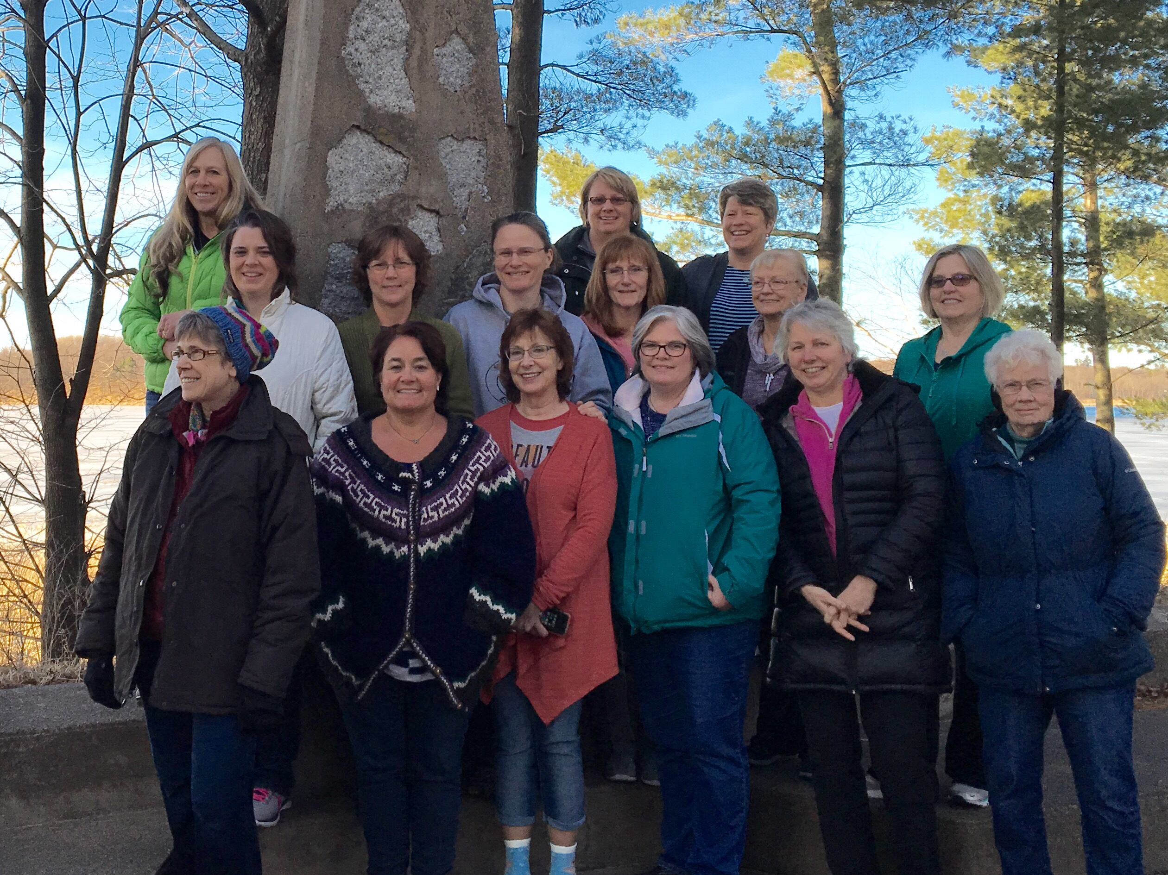

Last Name ________________________ First Name ____________________

Cell Phone ___________________ Do you text? Y N
Email ________________________________________________
Address ______________________________________________________________

Cost includes meals, room & supplies. Saturday includes lunch and dinner.
One Night ($75) ____ Two Nights ($125) ____ Just Saturday ($45) ______

Special Dietary Needs. (Vegetarian, Gluten-free, dairy-free etc)
____________________________________________________________________________________________________________________________________

If needed, could you drive? Y N
Emergency Contact:
Name ___________________________________ Relationship _________________
Primary phone # ___________________________
Insurance Provider and Policy # ___________________________________________

Please share any medical concerns that would be helpful for us to know.
_______________________________________________________________________________________________________________________________________________________________________________________________________________________________________________

Rooms are double occupancy – if you’d like to stay with someone, please request it on your registration form. Please bring your own bedding and pillow. Financial assistance is available. Please contact Molly Weyrens, Pastoral Associate @ mollyw@christourlightmn.org

## We plan on leaving Princeton at 6:00 pm on Friday and for those staying 2 nights, we will return on Sunday in time for 10:30 am Mass. Eat dinner before you come on Friday.
Please return registration to church with payment. Checks can be made out to COL.
Registration is due on March 9th.

