Ash Wednesday, Lent, Triduum, and Easter
Parish Schedule
Unless specified, all services and Masses held at St. Thomas the Apostle Church

March 6, 2019
Ash Wednesday,
Masses: 8am, 7pm at St. Elizabeth Church

March 8, 2019 /Friday Stations of the Cross/St. Elizabeth Church, 7pm

Lenten Homily Series:
The Spiritual Disciplines of Lent
March 9/10, 2019
First Weekend of Lent, Prayer
Masses: 4:30pm Sat/9am Sun

March 15, 2019 /Friday Stations of the Cross/St. Elizabeth Church, 7pm

March 16/17, 2019
Second Weekend of Lent, Fasting
Masses: 4:30pm Sat/9am Sun

March 22, 2019 /Friday Stations of the Cross/St. Elizabeth Church, 7pm
March 23/24, 2019
Third Weekend of Lent, Almsgiving
Masses: 4:30pm Sat/9am Sun

March 29, 2019 /Friday Stations of the Cross/St. Elizabeth Church, 7pm
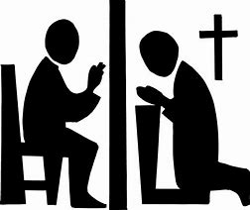 March 24, 2019
REP Confessions, 10:15am
Parish Confessions, 3pm
March 28, 2019
Service of Christian Unity, 7pm

March 30/31, 2019
Fourth Weekend of Lent, Meditation
Masses: 4:30pm Sat/9am Sun

April 5, 2019 /Friday Stations of the Cross/St. Elizabeth Church, 7pm

April 6/7, 2019
Fifth Weekend of Lent, Solitude
Masses: 4:30pm Sat/9am Sun

April 12, 2019 /Special Friday Stations of the Cross/St. Thomas Church, 7pm

April 13/14, 2019
Palm Sunday
Sixth Weekend of Lent, Pilgrimage
Masses: 4:30pm Sat/9am Sun

TRIDUUM
April 18, 2019
Holy Thursday
Mass of the Lord's Supper, 7pm
** at St. Teresa Church, Union City
April 19, 2019
Good Friday
Service of the Lord's Passion, 3pm
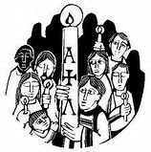 April 20, 2019
Holy Saturday
Mass of the Easter Vigil, 8:30pm

April 21, 2019
Easter Sunday
Mass: 9am

