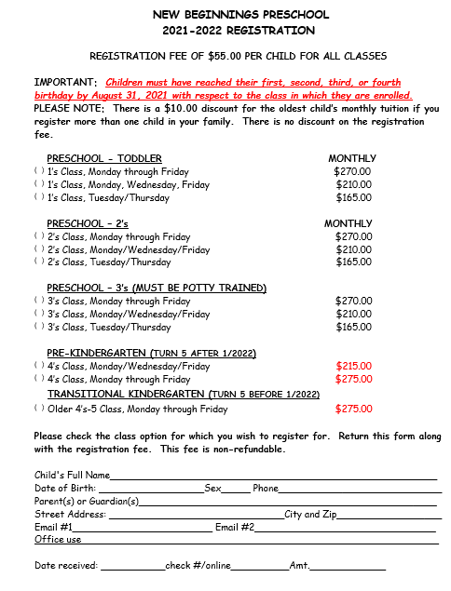
New Beginnings Preschool
Family Information

Child’s Full Name: ________________________________________DOB: ___________

Address:_________________________________ City:_________________ Zip:________

Is there anything you would like us to know about your child? (Special interests, fears, anxieties, etc.)______________________________________________________________________________________________________________________________________________________________________________________________________________________________________

Mother/Guardian Name:___________________________________________________

Address:_________________________________ City:_________________ Zip:________

Cell Phone:__________________ Email:________________________________________

Employer:____________________________________ Work Phone:_________________

Father/Guardian Name:____________________________________________________

Address:_________________________________ City:_________________ Zip:________

Cell Phone:__________________ Email:________________________________________

Employer:____________________________________ Work Phone:_________________

Emergency Contact #1 (Other than parent)  Name:_______________________________  Relationship:________________________  Phone Number:______________________ | Emergency Contact #2(Other than parent)  Name:_______________________________  Relationship:________________________  Phone Number:______________________
Alternate Pick Up #1 (Other than parent)  Name:____________________________________  Relationship:_____________________________  Phone Number:___________________________ | Alternate Pick Up #2 (Other than parent)  Name:____________________________________  Relationship:_____________________________  Phone Number:___________________________
Alternate Pick Up #3 (Other than parent)  Name:____________________________________  Relationship:_____________________________  Phone Number:___________________________ | Alternate Pick Up #4 (Other than parent)  Name:____________________________________  Relationship:_____________________________  Phone Number:___________________________
Health Information

Physician’s Name:_________________________________ Phone:__________________________

Physician’s Address:________________________________________________________________

Allergies/Medical Conditions:_______________________________________________________

Dentist:_______________________________________ Phone:______________________

Hospital Preference:_______________________________________________________

If you answer “YES” to any of the following questions, you will be given additional forms that must be completed by you AND your child’s physician.

- Does your child have asthma? ________

- Does your child have food allergies that require a special diet? _______

- Does your child have a serious medical condition that may require monitoring or special treatment at school (Ex: Diabetes, Cystic Fibrosis, Seizure Disorder, Cancer)? _______

- Is your child taking medication that will need to be administered at school (This includes prescription and over-the-counter medication)? ________

I, the undersigned, authorize the staff of New Beginnings Preschool to take what emergency medical measures are deemed necessary for the care and protection of my child enrolled in the program.

__________________________________________________________________________________
Signature by Parent or Guardian Date
Publicity Agreement

Child’s Name: ______________________________________________________________
Class/ Teachers: _________________________________ Date: ________________

I, _____________________________ give New Beginnings Preschool permission to take and use still photographs or videos of my child __________________________ in the following ways:
(Please write or type “yes” or “no” in the appropriate box)
 | Use of child’s Photograph | Use of child’s First Name
Online: Saint James Catholic Church Public Website
Online: New Beginnings Preschool Public Website
Online: New Beginnings Preschool Public Facebook Page
Online: New Beginnings Preschool Private Classroom Facebook Pages
Media: Including but not limited to Newspaper Articles, Church Bulletins and/or Television Coverage

______ I understand that it’s my responsibility to update this form if I wish to retract permission in any category listed above.

______ I understand that permission is given for the entire period of my child’s current school year unless I update the form.

Parent Signature: _______________________________ Date____________

EMERGENCY MEDICAL CARE FORM
In the event that my child ___________________________ may require medical care when I am unable to be reached, I hereby authorize New Beginnings Preschool to accompany my child in the evaluation and treatment as deemed necessary by the doctor and/or hospital administering care.

Child’s Name:_________________________________________ DOB:_________________
Allergies:_____________________________________________________________________
Present Medications:_________________________________________________________
Medical History:______________________________________________________________

Surgical History:______________________________________________________________
Family Physician:_________________________________ Phone:____________________
Health Insurance Co:________________________________________________________
Member Number: ___________________________________________________________

Person(s) able to provide authorizing signature when parent(s) are unable to be reached:
- Any Staff Member of New Beginnings Preschool
- (Emergency Contact 1):__________________________________________________
- (Emergency Contact 2):__________________________________________________

Date of permission: ___________________
Parent’s Signature: ___________________________________________________________
Address: __________________________________City:___________________Zip:_______
Home phone: ________________________ Work Phone: ___________________________
Mom’s Cell: ___________________________ Dad’s Cell: ___________________________

AUTHORIZATION IS TO BE LEFT WITH THE RESPONSIBLE ADULT AND PRESENTED TO THE HOSPITAL STAFF AT THE TIME EMERGENCY MEDICAL AND/OR SURGICAL CARE IS REQUIRED
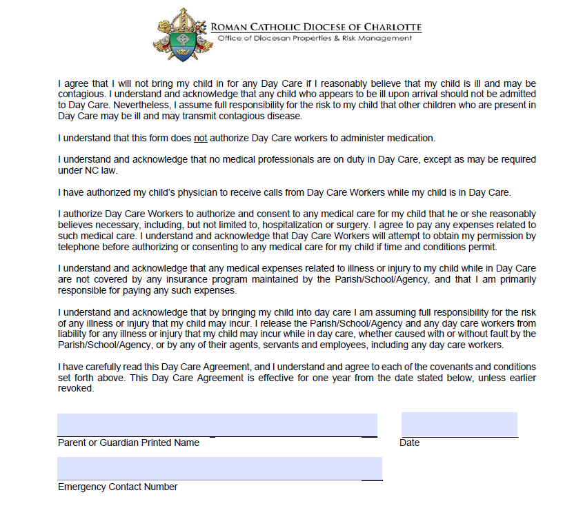

Acknowledgement of Forms Submitted
- I hereby agree to promptly notify New Beginnings Preschool of any changes of the above information. I understand that I am fully responsible for the terms of this agreement as stipulated.

- I have read, understand and agree to comply with the policy and procedures and information for parents/care givers given to me by New Beginnings Preschool in the Parent Handbook and the Covid-19 Policies and Procedures.

- I understand that I am responsible to provide a copy of my child’s most current immunization record to New Beginnings Preschool within 30 days of childcare to avoid interruption in my child’s enrollment.

- I have signed and submitted the Child Care Illness and Injury Agreement, provided to me by New Beginnings Preschool, with my other required forms.
Immunization Records may be sent to New Beginnings Preschool by means of:
- Mail in- along with all other required forms to:
New Beginnings Preschool
139 Manor Ave. SW
Concord, NC 28025
- If you have a digital copy of your child’s most current immunization record you can send it via email to Suzanne Carney (Director of New Beginnings Preschool) at suzannec@saintjamescatholic.org

- You can have your child’s physician fax a copy of your child’s most current immunization record to (704-720-0610)

Parent Signature_____________________________________ Date___________________

