St John the Evangelist Religious Education
First Communion Year 1; 2023-2024; 9:00am to 10:15am in Roseroom

CURRICULUM COLOR INDEX
IN PERSON CLASS AT HOME PARENT LED
2024-2025 All classes will be in-person

August
27 – In Person: Parent Orientation

September
03 – No Class: Labor Day
10 – In Person: First Day of Class
17 – At Home: Review Prayers
24 – In Person: Matthew 3:13-17

October
01 – At Home: Chapter 1
08 – In Person: Genesis 1:1-2:3
15 – At Home: Chapter 2
22 – No Class
29 – At Home: Review Prayers

November
05 – In Person: Psalm 150
12 – At Home: Chapter 3
19 – In Person: Mark 2:1-12
26 – No Class: Thanksgiving Break

December
03 – At Home: Chapter 4
10 – In Person: Advent
17 – At Home: Review Prayers
24 – No Class: Christmas Break
31 – No Class: Christmas Break

January
07 – In Person: Exodus 3:1-7
14 – At Home: Chapter 5
21 – In Person: Matthew 28:1-20
28 – At Home: Chapter 6

February
04 – In Person: John 3:1-21
11 – At Home: Review Prayers
18 – No Class: Presidents Weekend
25 – In Person: Luke 4:16-22

March
03 – At Home: Chapter 7
10 – In Person: Luke 19:1-10
17 – At Home: Chapter 8
24 – In Person: Stations of the Cross
31 – No Class: Easter Sunday

April
07 – At Home: Review Prayers
14 – In Person: Romans 12:1-8
21 – At Home: Rite of Reconciliation
28 – In Person: Last Day of Class

May
05 – 2nd Year First Communion 10:30am

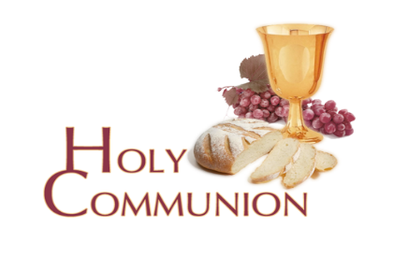
Mass Attendance: It is important for parents and children to be familiar with the Order of Mass. Attending Mass helps prepare students for both Reconciliation (1st Yr.) and Communion (2nd Yr.).

Youth Mass: Attendance and Participation is required on the 3rd Sunday at the 10:30am Mass.

Class Attendance: We understand life happens as do absences; however, missing classes excessively will result in the student repeating the year.

