Blessed Mother Catholic Church

Religious Education Program Handbook

2025 - 2026

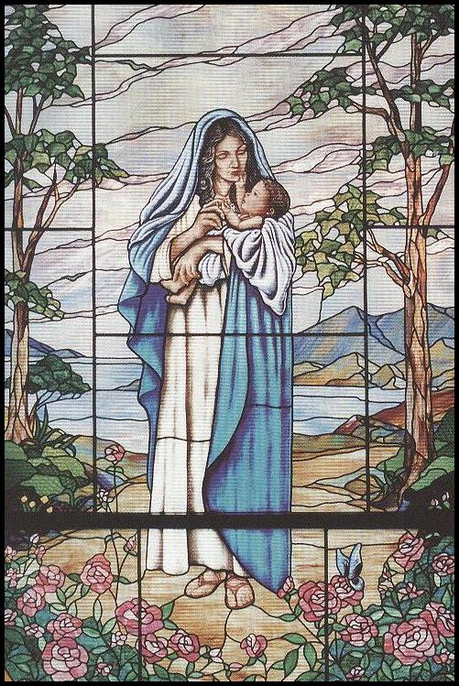

601 E. 23rd Street

Owensboro, KY 42303

(270) 683-8444

**Cost~ $30/Student, $50 for 2 Students, $75 for 3 or more Students**

**Welcome!**

Dear Parents / Guardians,

Welcome to the K-8 Religious Education Program at Blessed Mother Catholic Church! In this handbook, you will find all the information you need regarding your child’s religious education and sacramental preparation.

We are eager to launch this year’s Religious Education Program, and get to know all of you- especially your children! Please do not hesitate to contact me with any needs or concerns you may have.

Please register early so that enough materials can be ordered. Materials for your child will not be ordered until you have registered. In person classes will begin on September 7, 2025.

Take note of the Marian artwork found throughout this booklet. Mary is the patron saint of our Parish, which is why we celebrate the Solemnity of the Assumption each year on August 15. Traditionally, she is called “the Seat of Wisdom” because the Son of God, Jesus Christ, resided within her for nine months and undoubtedly sat on her lap and received instruction from her when He was a young boy. Since her mind was not clouded by sin, she was the wisest of mothers. Her son, of course, was the wisest of sons. We ask for her guidance and her prayers as we strive to share with your child the wisdom of Jesus Christ and His Church.

You took on a grand task when your child was baptized. You accepted the obligation of nurturing your child in the faith of the Church and preparing your child for the sacraments. You did this so that he or she could truly experience the life of the Church and a relationship with Jesus Christ. We are here to help you reach that goal, and we are humbled by your willingness to share this task with us. There is nothing more important than the heart and soul of your child, and we want to bring these to maturity in Christ Jesus.

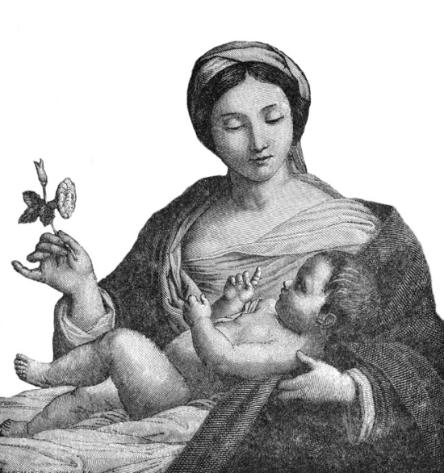If you have any questions or concerns, please do not hesitate to contact me. You can call the office at (270-683-8444) or send an email to blessedmamayouth@gmail.com. Please pray for all of us – children, parents, godparents, catechists, priests, and all involved – as we work together to do the Lord’s will this year.

May you be blessed with the Peace of Christ.

Christina Barnard

Director of Religious Education

**Diocesan Mission Statement**

We know that Jesus left the faith community – called Church – to carry on His mission into time. Jesus sent the Spirit into the Church on that first Pentecost. Since that day, the Church has been busy evangelizing the world. We take the mission of Jesus from Luke’s Gospel, chapter 4, verse 38 ff. Jesus clearly states in Luke that He must go to the world (other towns) to announce the Good News of the reign (love) of God. Jesus says, “For that is why I was sent.”

Jesus then sends for the apostles and disciples to continue announcing that Good News – to continue to evangelize the world. Jesus carried out His mission basically by proclaiming and celebrating the Good News of God’s love and by acting out that love in His healing mission.

We, as the Church in Western Kentucky, must carry on this mission in these thirty-two counties to nearly 800,000 people of western Kentucky. We approach our command to go forth in three primary ways: by proclaiming the Good News, by celebrating God’s love and by reaching out to all of God’s children, especially those who have special needs, e.g., the homeless, lonely, sick, hungry, etc.

We are aware that this mission is first carried out in our families – the domestic Church. Thus, all ministry is, in one way or another, geared to impact family life. While the three areas of ministry (Education, Worship and Social Concerns) are essential to carry out the mission of the Church, there are two essential support ministries – namely, administration and personnel – that must also be exercised in any church. It is the development of these areas of ministry that will enable this Church to effectively evangelize the world in which we live.

Pope Paul VI in his letter on evangelization says that any faith community by its very nature is an evangelizing community – a community that indeed is carrying on the mission of Jesus – and now the Church.

**Blessed Mother Parish Mission Statement**

Blessed Mother Catholic Church is a faith-filled community inspired by the Holy Spirit. Our parish family worships and grows together to accomplish the same God-given mission as Jesus through evangelization and active concern for all.

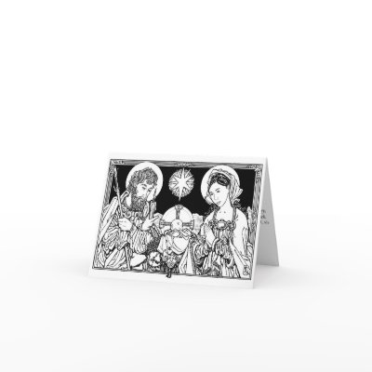

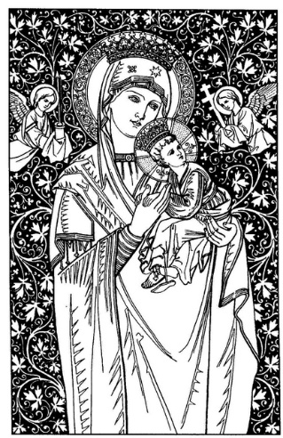**Parish Religious Education Personnel**

Pastor: Fr. Brandon Williams

(270)683-8444

brandon.williams@pastoral.org

Parochial Vicar: Fr. Ramesh Kattermetla

(270)683-8444

Ramesh.kattermetla@pastoral.org

Director of Religious Education: Christina Barnard

(270)683-8444

blessedmamayouth@gmail.com

**Religious Education Catechists**

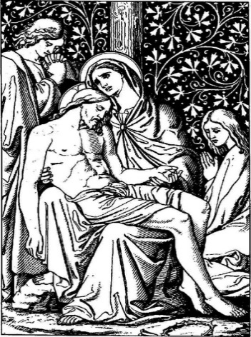

K and 1st Grade: Jennifer Salvina

Amanda Hirtz

2nd and 3rd Grade: Melissa Bivins

4th and 5th Grade: Lori Dant

Brittany Brasher

6th, 7th and 8th Grade: Charles Zambrano

Ken Keller

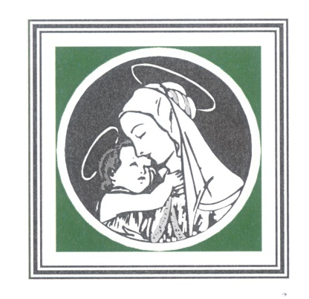**2025 - 2026 Religious Education Calendar**

**Blessed Mother Catholic Church**

**September** 7: Welcome; Meet & Greet

14: Safe Environment

21: Class

28: Class

**October** 5: Class

12: ***No Class*** (Fall Break)

19: ***No Class*** (Fall Break)

26: Class

**November** 2: Class

9: Class

16: Class

23: ***No Class*** (Thanksgiving Break)

30: ***No Class*** (Thanksgiving Break)

**December** 7: Class

**IMPORTANT INFORMATION**

**When:** Sundays 8:30 - 9:30 AM.

**Where:** Family Life Building

**Pickup:** Parents are to wait in the hallway for children to be dismissed.

***Children are not permitted***

***to walk home.***

14: Class

21: ***No Class*** (Christmas Break)

28: ***No Class*** (Christmas Break)

**January** 4: ***No Class*** (Christmas Break)

11: Class

11: **Confirmation Retreat (11:30-3:00)**

18: ***No Class*** (MLK, Jr. Day)

25: Class

31: **1st Reconciliation Retreat (9-11am)** **February**  1: **1st Reconciliation (2pm)**

1: Class

8: Class

15: ***No Class*** (PTC)

22: Class

**March** 1: Class

8: Class

15: Class

22: Class

29: Class

**April** 5: ***No Class*** (Happy Easter)

12: ***No Class*** (Spring Break)

14: **Confirmation Practice (5:30pm)**

15: **Confirmation (6:30pm)**

18: **1st Communion Retreat (9-11am)**

19: **1st Communion (2pm)**

19**:** Class

**26: LAST CLASS**

**Sacramental Preparation Calendar 2024-2025**

**1st Reconciliation/ Communion Parent Meeting**

* Parent Meeting TBA

**First Reconciliation**

* Saturday, January 31 Retreat (w/ parent) 9 am – 11:00 am Parish Hall
* Sunday, February 1 First Reconciliation 2 pm Church

**First Communion**

* Saturday, April 18 Retreat (w/ parent) 9 am – 11:00 am Parish Hall
* Sunday, April 19 First Communion 2 pm Church

**Confirmation**

* Parent Meeting TBA
* Sunday, January 11 Retreat (w/ sponsor) 11:30 am – 3:00pm Church
* Tuesday, April 14 Practice 5:30 pm – 6:15 pm Church
* Tuesday, April 15 Confirmation 6:30 – 8:00 pm Church

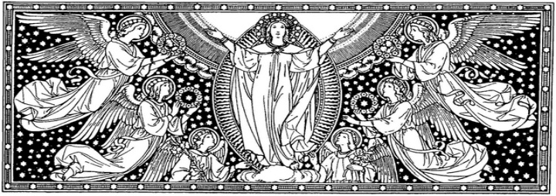

**K-8 Religious Education Curriculum**

Students will use one of three editions for Kindergarten through eighth grade, each containing lessons based on scripture. Depending on their grade level, students will also be studying various prayers, the Liturgy/Communion, Reconciliation, the Beatitudes, Confirmation, the Rosary, Parables, and Other Points of Catholic Teaching. Intothedeep.co

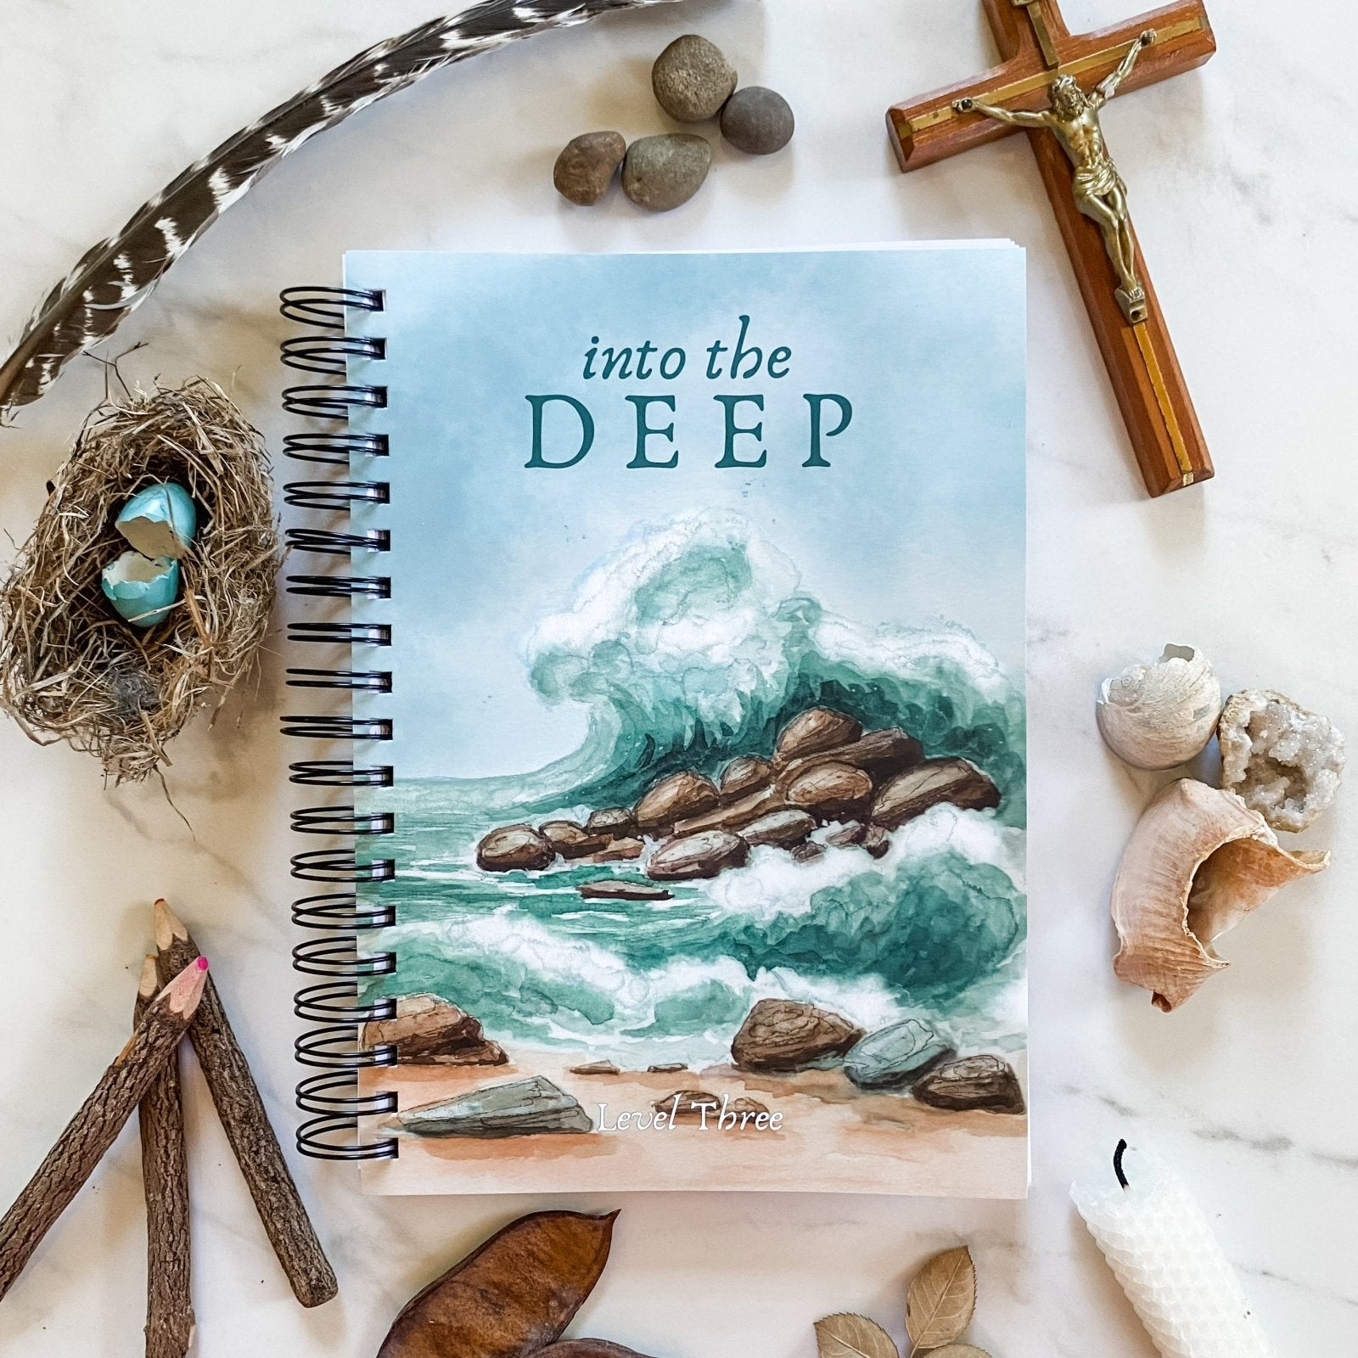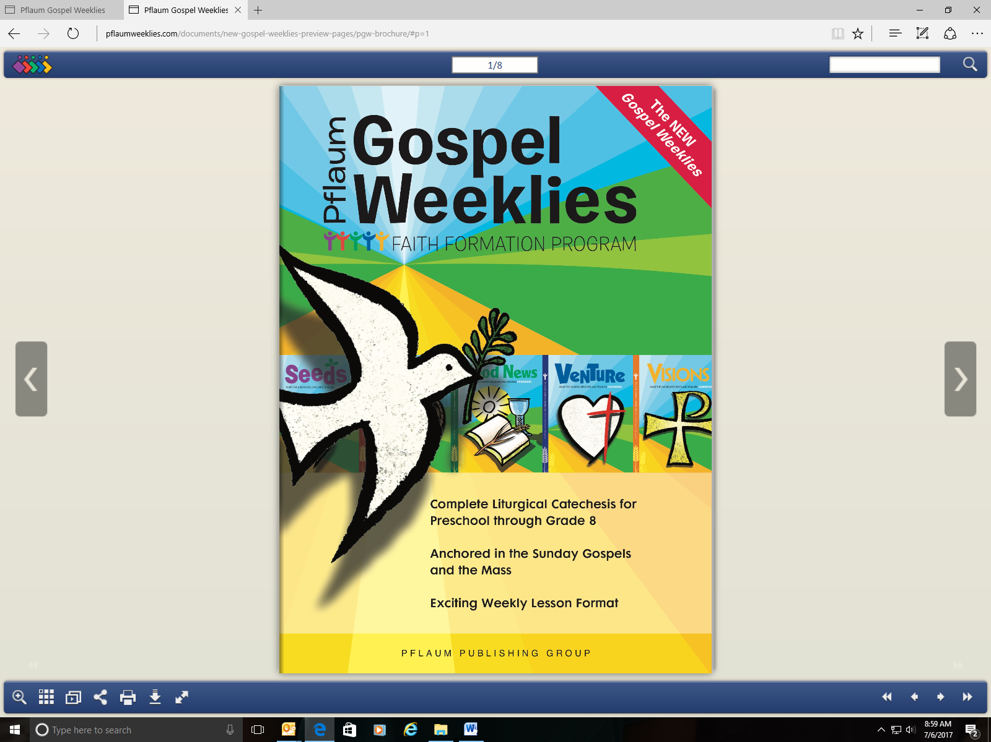

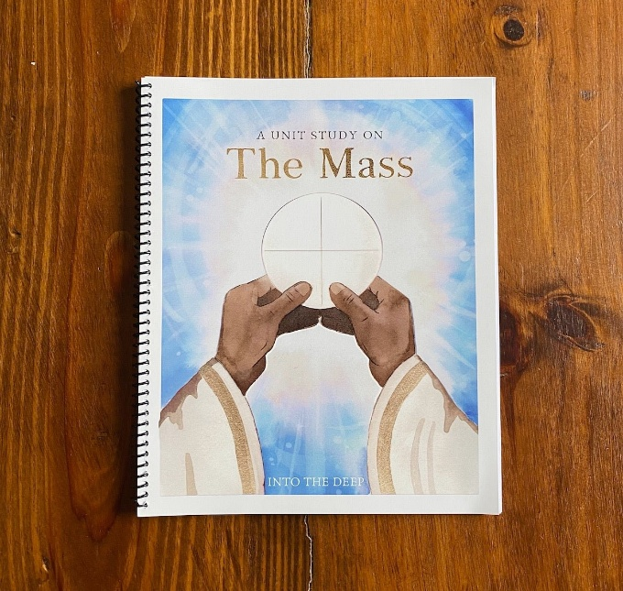

**K-8 Religious Education Sacramental Preparation**

As the 2nd & 3rd grade classrooms and the 7th & 8th grade classrooms are combined, both grades will receive Sacramental preparation during one of the monthly classes throughout the Religious Education Calendar year. The students will receive different instruction over both years. Please review the Sacramental Preparation in the Calendar for those information dates.

**Sacramental Preparation Program from Dynamic Catholic**

Families wanting extra sacramental study materials for home use to complement Blessed Mother’s Religious Education program, might consider the following:

<https://dynamiccatholic.com/blessed> and <https://dynamiccatholic.com/confirmation>

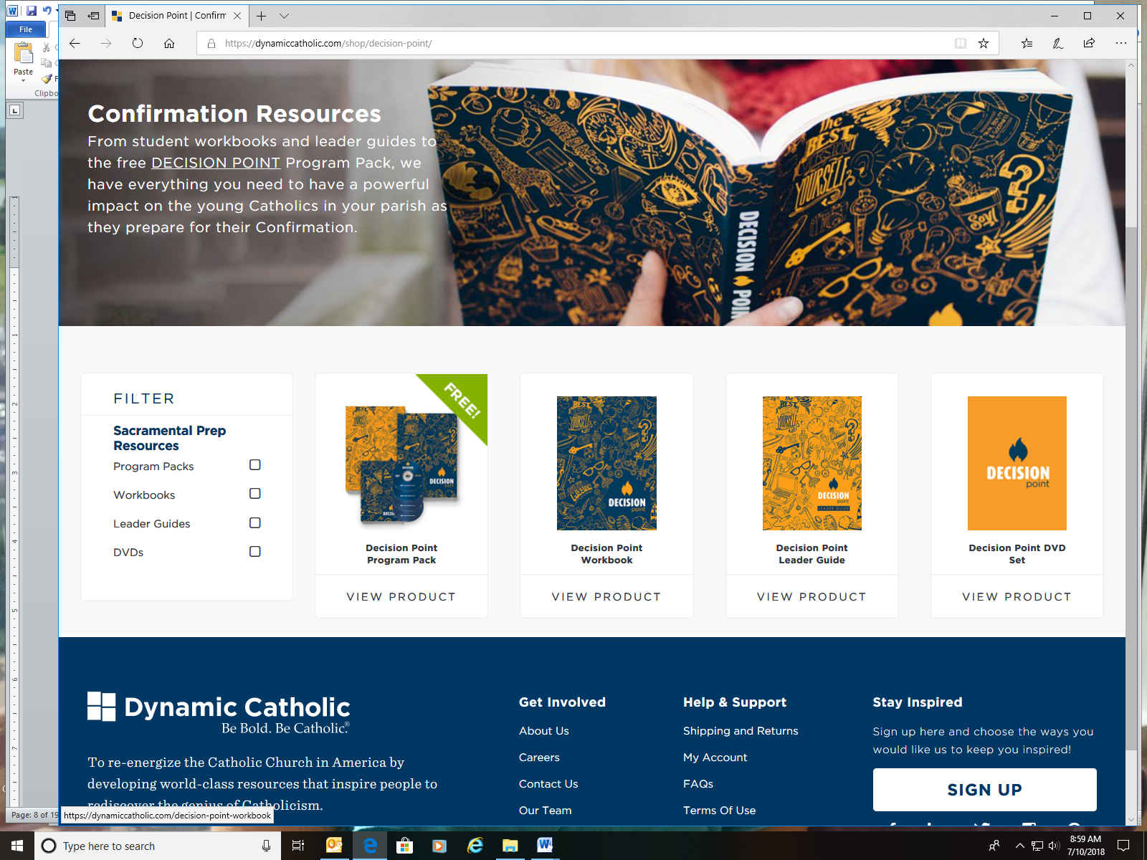

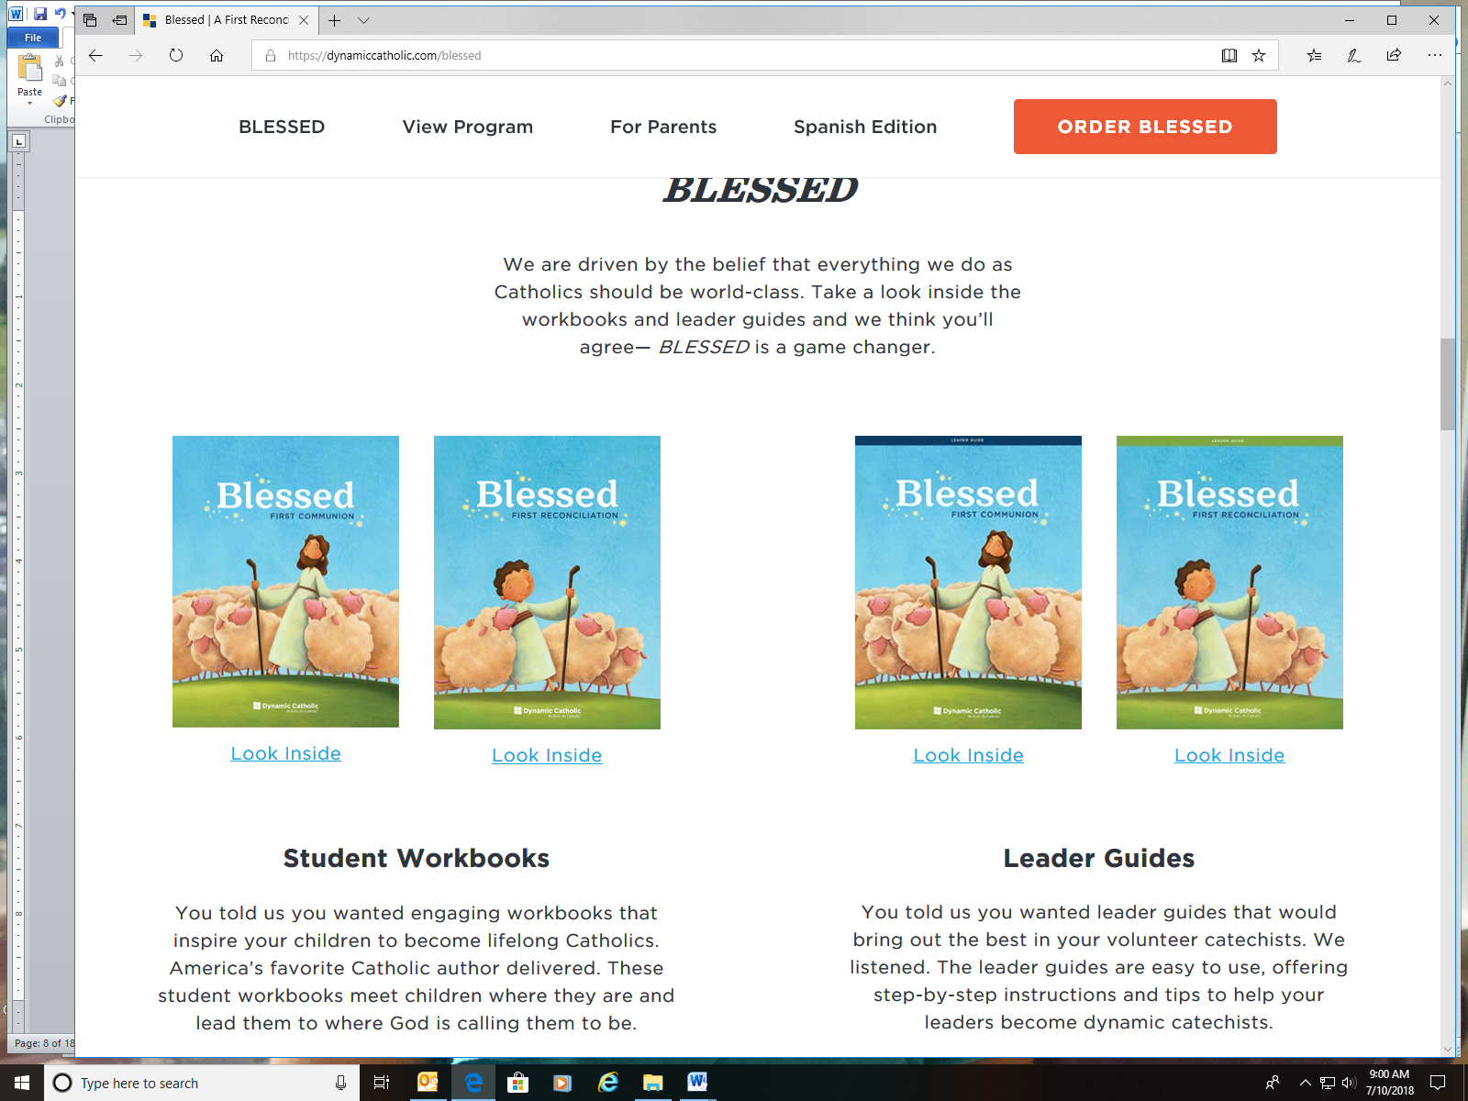

**Responsibilities for Program Participants**

**General Responsibilities**

Parents:

* Ensure that their child attends classes regularly and on time
* Communicate any special needs or circumstances that may affect their child
* Be an active part of their child’s learning and be involved in the classroom at the catechist’s request (i.e., help with special projects or disciplinary issues)
* ***Ensure that the child attends Sunday Mass regularly***

Children:

* Behave in a Christian manner, showing respect and being cooperative with adults and other children
* Actively participate in classroom activities and discussions
* Attend class regularly and complete any assignments or homework
* Abide by the Code of Conduct as set forth by the Diocese
* ***Attend Sunday Mass regularly***

Catechists:

* Provide a loving, Christian learning environment for the children
* Be prepared to teach each lesson
* Teach only what the Catholic Church teaches
* Be a Christian role model
* Communicate regularly with and involve parents in the faith development of their children
* Attend catechist meetings
* Continue training in religious education and the faith



**Sacramental Obligations**

First Reconciliation:

* Regular attendance in class
* Parent attendance at parent meeting
* Copy of Baptismal certificate
* ***Attend Sunday Mass regularly***
* Attendance at mini-retreat

First Eucharist:

* Regular attendance in class
* Parent attendance at parent meeting
* Copy of Baptismal certificate
* ***Attend Sunday Mass regularly***
* Attendance at mini-retreat and practice

Confirmation

* Regular attendance in class
* Attendance at parent meeting
* Copy of Baptismal certificate
* ***Attend Sunday Mass regularly***
* Attendance at retreats and practice, completion of service hours

**Fundamentals of the Faith**

There are certain prayers and truths of our faith that every child should know. These are the things that make us Catholic. Most, if not all, of them will be taught in the classroom … ***but we need your help!*** Often times, the best way to memorize something is through repetition. By praying with your children, teaching them the truths of the faith, and helping them to grow spiritually by your daily witness and example, you can help them to truly learn what it means to live and pray as a Catholic.

I encourage you to take an active role in your child’s education by reviewing the following prayers and truths with them. Once they know these basic elements, they will have the means with which to delve deeper into their Catholic faith.

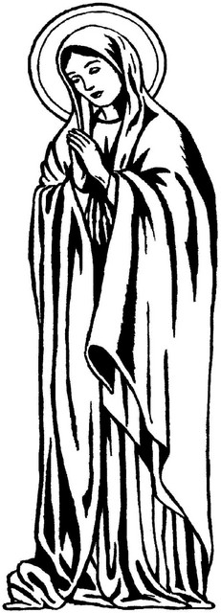**Kindergarten:** Sign of the Cross

Prayer before Meals

Glory Be

**First grade:** Our Father

Hail Mary

Guardian Angel Prayer

**Second grade:** Act of Contrition

Responses at Mass

**Third grade:** Seven Sacraments

Ten Commandments

Holy Days of Obligation

**Fourth grade:** Beatitudes

*Memorare*

**Fifth grade:** Apostles’ Creed

Hail Holy Queen

Fatima Prayer

Rosary

**Sixth grade:** Prayer to St. Michael the Archangel

Corporal Works of Mercy

Spiritual Works of Mercy

**Seventh grade:** Morning Offering

Angelus

Nicene Creed

**Eighth grade:** Precepts of the Church Fruits of the Holy Spirit

Gifts of the Holy Spirit Prayer to the Holy Spirit

**Sign of the Cross**

*In the name of the Father, and of the Son, and of the Holy Spirit. Amen.*

**Prayer Before Meals**

*Bless us our Lord, and these, thy gifts, which we are about to receive, from thy bounty, through*

*Christ, our Lord. Amen.*

**Glory Be**

*Glory be to the Father, and to the Son, and to the Holy Spirit, as it was in the beginning, is now,*

*and ever shall be, world without end. Amen.*

**Our Father**

*Our Father, who art in heaven, hallowed be thy name. Thy kingdom come, thy will be done, on*

*earth as it is in heaven. Give us this day our daily bread and forgive us our trespasses, as we*

*forgive those who trespass against us. And lead us not into temptation, but deliver us from evil.*

*Amen.*

**Hail Mary**

*Hail Mary, full of grace, the Lord is with thee. Blessed art thou among women, and blessed is the*

*fruit of thy womb, Jesus. Holy Mary, Mother of God, pray for us sinners, now and at the hour of*

*our death. Amen.*

**Guardian Angel Prayer**

*Angel of God, my guardian dear, to whom God’s love commits me here. Ever this day (night), be at my side, to light, to guard, to rule, to guide. Amen.*

**Act of Contrition**

*Oh, my God, I am sorry for my sins with all of my heart. For in choosing to do wrong, and failing to do good, I have sinned against You- whom I should love above all things. I firmly intend, with your help, to do penance, to sin no more, and to avoid whatever leads me to sin. Amen.*

**Responses at Mass**

The responses of the faithful at Mass can be found in the missal.

**Seven Sacraments Ten Commandments**

1. Baptism 1. I am the Lord your God. You shall have no other gods
2. Confirmation 2. You shall not take the Lord’s name in vain
3. Eucharist 3. Remember to keep holy the Lord’s day
4. Reconciliation 4. Honor your father and mother
5. Marriage 5. You shall not kill
6. Holy Orders 6. You shall not commit adultery
7. Anointing of the Sick 7. You shall not steal

8. You shall not bear false witness against your neighbor

9. You shall not covet your neighbor’s wife

10. You shall not covet your neighbor’s goods

**Holy Days of Obligation. All Sundays and …**

* + **January 1:** the solemnity of Mary, Mother of God;
  + **Thursday of** **the Sixth Week of Easter:** the solemnity of the Ascension;
  + **August 15:** the solemnity of the Assumption of the Blessed Virgin Mary;
  + **November 1:** the solemnity of All Saints;
  + **December 8:** the solemnity of the Immaculate Conception;
  + **December 25:** the solemnity of the Nativity of Our Lord Jesus Christ.

**Beatitudes**

1. Blessed are the poor in spirit, for theirs is the kingdom of heaven.
2. Blessed are those who mourn, for they shall be comforted.
3. Blessed are the meek, for they shall inherit the earth.
4. Blessed are those who hunger and thirst for righteousness, for they shall be satisfied.
5. Blessed are the merciful, for they shall obtain mercy.
6. Blessed are the pure in heart, for they shall see God.
7. Blessed are the peacemakers, for they shall be called sons of God.
8. Blessed are those who are persecuted for righteousness’ sake, for theirs is the kingdom of heaven.

***Memorare***

*Remember, O most gracious Virgin Mary, that never was it known that anyone who fled to thy protection, implored thy help, or sought thy intercession was left unaided. Inspired by this confidence, I fly unto you, O Virgin of virgins, my mother; to thee I come, before thee I stand, sinful and sorrowful. O Mother of the Word Incarnate, despise not my petitions, but in thy mercy hear and answer me. Amen.*

**Apostles’ Creed**

*I believe in God, the Father almighty, Creator of heaven and earth, and in Jesus Christ, his only Son, our Lord, who was conceived by the Holy Spirit, born of the Virgin Mary, suffered under Pontius Pilate, was crucified, died and was buried; he descended into hell; on the third day he rose again from the dead; he ascended into heaven, and is seated at the right hand of God the Father almighty; from there he will come to judge the living and the dead. I believe in the Holy Spirit, the holy catholic Church, the communion of saints, the forgiveness of sins, the resurrection of the body, and life everlasting. Amen.*

**Hail Holy Queen**

*Hail, holy Queen, Mother of Mercy! Our life, our sweetness, and our hope! To thee do we cry, poor banished children of Eve, to thee do we send up our sighs, mourning and weeping in this valley, of tears. Turn, then, most gracious advocate, thine eyes of mercy toward us; and after this our exile show unto us the blessed fruit of thy womb Jesus; O clement, O loving, O sweet virgin Mary. Pray for us, O Holy Mother of God, that we may be made worthy of the promises of Christ. Amen.*

**Fatima Prayer**

*O my Jesus, forgive us our sins, save us from the fires of hell, lead all souls to Heaven, especially those in most need of Thy mercy. Amen.*

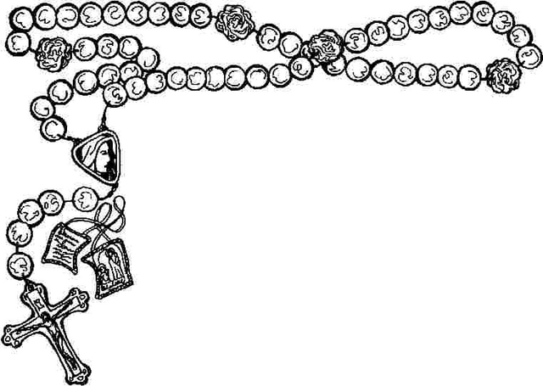

**Rosary**

Praying the rosary traditionally takes on the following form:

* A sign of the cross on the crucifix and then the Apostles’ Creed;
* An “Our Father” on the first large bead;
* A “Hail Mary” on each of the three small beads with the following intentions:
* For the increase of faith
* For the increase of hope
* For the increase of charity
* A “Glory Be” on the next large bead;
* Announce the mystery
* An “Our Father” on the large bead
* A “Hail Mary” on each of the adjacent ten small beads;
* A “Glory Be” on the next large bead;
* Again an “Our Father,” ten “Hail Mary’s,” the “Glory Be,” and the Fatima Prayer for each of the following decades (or groups of ten small beads);
* A “Hail Holy Queen” and a sign of the cross.

**Mysteries of the Rosary**

On Monday and Saturday, meditate on the “Joyful Mysteries”

* First Decade: The Annunciation of Gabriel to Mary (Luke 1:26-38)
* Second Decade: The Visitation of Mary to Elizabeth (Luke 1:39-56)
* Third Decade: The Birth of Our Lord (Luke 2:1-21)
* Fourth Decade: The Presentation of Our Lord (Luke 2:22-38)
* Fifth Decade: The Finding of Our Lord in the Temple (Luke 2:41-52)

On Thursday, meditate on the “Luminous Mysteries”

* First Decade: The Baptism of Our Lord in the River Jordan (Matthew 3:13-16)
* Second Decade: The Wedding at Cana, when Christ manifested Himself (Jn 2:1-11)
* Third Decade: The Proclamation of the Kingdom of God (Mark 1:14-15)
* Fourth Decade: The Transfiguration of Our Lord (Matthew 17:1-8)
* Fifth Decade: The Last Supper, when Our Lord gave us the Holy Eucharist (Mt 26)

On Tuesday and Friday, meditate on the “Sorrowful Mysteries”

* First Decade: The Agony of Our Lord in the Garden (Matthew 26:36-56)
* Second Decade: Our Lord is Scourged at the Pillar (Matthew 27:26)
* Third Decade: Our Lord is Crowned with Thorns (Matthew 27:27-31)
* Fourth Decade: Our Lord Carries the Cross to Calvary (Matthew 27:32)
* Fifth Decade: The Crucifixion of Our Lord (Matthew 27:33-56)

On Wednesday and Sunday, meditate on the “Glorious Mysteries”

* First Decade: The Glorious Resurrection of Our Lord (John 20:1-29)
* Second Decade: The Ascension of Our Lord (Luke 24:36-53)
* Third Decade: The Descent of the Holy Spirit at Pentecost (Acts 2:1-41)
* Fourth Decade: The Assumption of Mary into Heaven
* Fifth Decade: The Coronation of Mary as Queen of Heaven and Earth

**Corporal Works of Mercy**

1. Feed the hungry
2. Give drink to the thirsty
3. Clothe the naked
4. Visit the imprisoned
5. Shelter the homeless
6. Visit the sick
7. Bury the dead

**Spiritual Works of Mercy**

1. Admonish sinners
2. Instruct the ignorant
3. Counsel the doubtful
4. Comfort the sorrowful
5. Bear wrongs patiently
6. Forgive injuries
7. Pray for the living and the dead

**Prayer to St. Michael the Archangel**

*St. Michael, the Archangel, defend us in battle. Be our protection against the wickedness and snares of the devil. May God rebuke him, we humbly pray, and do thou, oh Prince of the Heavenly Host, by the power of God, cast into hell Satan and all evil spirits who prowl about the world seeking the ruin of souls. Amen.*

**Morning Offering**

*O Jesus, through the Immaculate Heart of Mary, I offer You my prayers, works, joys and sufferings of this day for all the intentions of Your Sacred Heart, in union with the Holy Sacrifice of the Mass throughout the world, in reparation for my sins, for the intentions of all my relatives and friends, and in particular for the intentions of the Holy Father. Amen.*

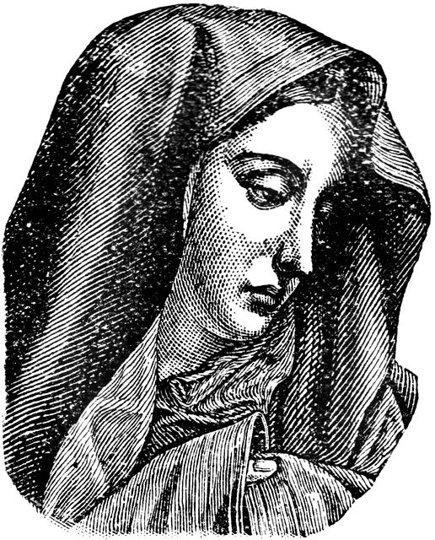**Angelus**

The Angel of the Lord declared unto Mary.

— *And she conceived of the Holy Spirit.*

*Hail Mary...*

Behold the handmaid of the Lord.

— *Be it done unto me according to thy word.*

*Hail Mary...*

And the Word was made Flesh.

— *And dwelt among us.*

*Hail Mary...*

Pray for us, O holy Mother of God.

— *That we may be made worthy of the promises of Christ.*

Let us pray:

*Pour forth we beseech Thee, O Lord, Thy grace into our hearts, that we, to whom the Incarnation of Christ Thy Son was made known by the message of an angel, may by His Passion and Cross be brought to the glory of His Resurrection, through the same Christ Our Lord. Amen*

**Nicene Creed**

*I believe in one God, the Father almighty, maker of heaven and earth, of all things visible and invisible.*

*I believe in one Lord Jesus Christ, the Only Begotten Son of God, born of the Father before all ages. God from God, Light from Light, true God from true God, begotten, not made,  
consubstantial with the Father; through him all things were made. For us men and for our salvation he came down from heaven, and by the Holy Spirit was incarnate of the Virgin Mary, and became man. For our sake he was crucified under Pontius Pilate, he suffered death and was buried, and rose again on the third day in accordance with the Scriptures. He ascended into heaven and is seated at the right hand of the Father. He will come again in glory to judge the living and the dead and his kingdom will have no end.*

*I believe in the Holy Spirit, the Lord, the giver of life, who proceeds from the Father and the Son, who with the Father and the Son is adored and glorified, who has spoken through the prophets.*

*I believe in one, holy, catholic and apostolic Church. I confess one baptism for the forgiveness of sins and I look forward to the resurrection of the dead and the life of the world to come. Amen.*

**Precepts of the Church**

1. You shall attend Mass on Sundays, and holy days of obligation, and rest from servile labor
2. You shall confess your sins at least once a year
3. You shall receive the sacrament of the Eucharist at least once during the Easter season
4. You shall observe the days of fasting and abstinence established by the Church
5. You shall help to provide for the needs of the Church

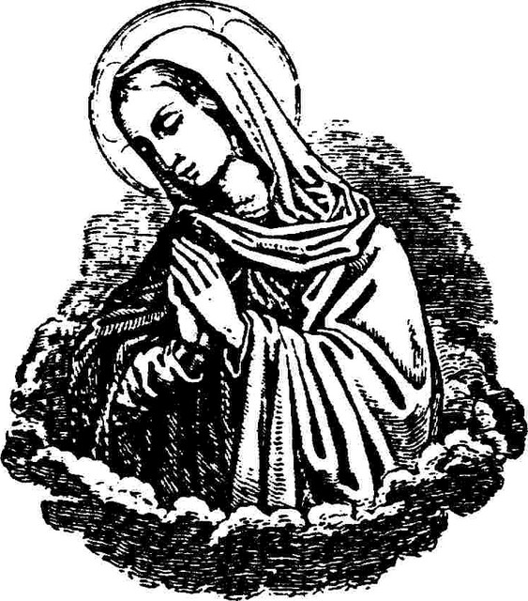**Gifts of the Holy Spirit**

1. wisdom
2. understanding
3. knowledge
4. counsel
5. piety
6. fortitude
7. fear of the Lord

**Fruits of the Holy Spirit**

1. charity 7. kindness
2. joy 8. patience
3. peace 9. self-control
4. faithfulness 10. modesty
5. goodness 11. chastity
6. gentleness 12. generosity

**Prayer to the Holy Spirit**

*Come, Holy Spirit, fill the hearts of your faithful, and enkindle in us the fire of your love. Send forth your spirit and we shall be created, and you shall renew the face of the earth. O God, who by the light of the Holy Spirit did instruct the hearts of the faithful, grant that by the same Holy Spirit we may be truly wise and ever enjoy His consolation, through Christ our Lord. Amen*

**Other Important Information**

**Registration**

All parents with children who do not go to Catholic schools are encouraged to register their children in the Religious Education Program. To do so, you must complete and return the registration forms and pay the required fee. Registration forms can be picked up in the Parish Office, or downloaded from the parish website: [www.blessedmotherchurch.com](http://www.blessedmotherchurch.com)

**Fees**

If you are a member of Blessed Mother parish, the price for one child is $30. The total for two children is $50. The total for three or more children is $75. ***No child will be turned away due to an inability to pay***. If you need financial assistance, please contact the Director of Religious Education.

**Textbooks**

Catechists will teach utilizing the “Into the Deep” Program. Throughout the year, students will utilize age appropriate handouts and studies as needed.

**Attendance**

When it comes to religious education, you only get out what you put in! It is very important for each student to attend every class session and every activity outside of class that is related to his or her religious education (e.g., retreats, practices, service projects, etc.). **If a student is in a grade in which a sacrament is first received (2nd or 8th grade) and misses five or more classes, then this *may* jeopardize the student’s ability to receive the sacraments with the proper disposition**. We understand that illness or exceptional circumstances can prevent perfect attendance. When this is unavoidable, please call the Director of Religious Education in advance.

**Weather**

Sometimes it is necessary to cancel class because of the weather. In such cases, an announcement will be made at all the Masses, and on the Parish Facebook Page. If at all possible, parents will also receive a text or phone call.

**Discipline**

All students are expected to follow the Code of Conduct that came with their registration forms. Normal discipline problems will be handled by the catechist. If the problem persists, the student will be sent to the Director of Religious Education. A child’s parents may be called, and a conference with the parents may also be requested, if the situation requires it.

**Supplies**

We provide the students with pencils, pens, folders, loose-leaf paper, and art supplies.

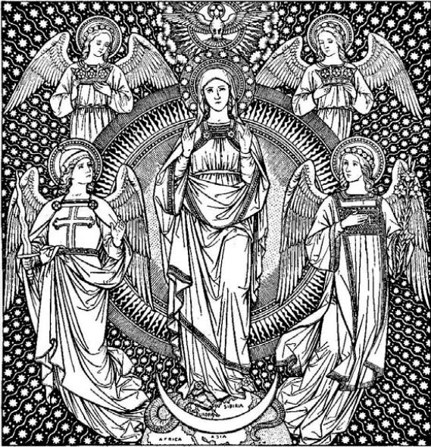**Classrooms**

Classes begin at 8:30 AM and end at 9:30 AM. As we did last year, the Parish Hall may be utilized as classrooms if needed. When class is over at 9:30 AM, please wait in the hallway to pick up your child. This is our best way of ensuring that every child returns home safely. Children are not allowed to walk home.

**Safety**

We are committed to the safety of every student and to upholding his or her dignity as a child of God. All of the catechists and volunteers in the Religious Education Program have received Safe Environment training and have completed the necessary background check. The students will receive instruction as well, so that they know what to do if their personal safety is ever threatened. If you do not wish for your child to receive this instruction, an opt-out form is available for you to sign. All parents will receive this form either upon registration or at the parent meeting. You can also pick up this form in the Parish Office.

For more information on what the Diocese of Owensboro is doing to protect your child, see the website of the *Office for Safe Environment*: <https://owensborodiocese.org/safe/>

You may also contact **Janice Hendricks,** the Coordinator of the *Office for Safe Environment*, by phone (270-852-8338) or by email [janice.hendricks@pastoral.org](mailto:janice.hendricks@pastoral.org)

Finally, you may wish to read the following documents from the United States Conference of Catholic Bishops and the Diocese of Owensboro, KY:

* *Charter for the Protection of Children and Young People*

<http://www.usccb.org/issues-and-action/child-and-youth-protection/upload/Charter-for-the-Protection-of-Children-and-Young-People-2018-final.pdf>

* *Diocese of Owensboro Safe Environment Policy*

<https://owensborodiocese.org/wp-content/uploads/SafeEnvironmentPolicy_2019_English.pdf>



**Final Prayer**

**To Mary, Seat of Wisdom and Mother of Divine Love**

To you, O Mary, are known all the needs of your people and of the whole Church. Mother of Truth and Seat of Wisdom, dissipate the clouds of error which darken our minds. Amend the straying of our hearts and inspire in us love for truth and the desire to do good.

Obtain for all people a holy fear of God so that society may know happiness. Give us lively faith that we may trust in those things which are imperishable. Give us that love which is sealed forever in God. Obtain for families fidelity, harmony, and peace. Stir up and confirm in the hearts of those who govern nations a clear notion of their responsibility, and of their duty to foster religion, morality, and the common good.

And just as your mercy is showered upon souls, O Mary, may it likewise flow over all those ills which afflict this people, and indeed the whole Christian family. Have pity on the poor, on captives, on all who bear persecution for the sake of justice, or are stricken by misfortune. Hail, O Mary, Mother of those who wander here below; you are our life, our sweetness, and our hope.

O Mother of Divine Love, send down your motherly blessing on all who pray to you; send it abundantly and consolingly. Amen.

– Pope Pius XII (1939-1958)

from Judith A. Bauer, Ed., *The Essential Mary Handbook*

(Liguori, MO: Liguori Publications, 1999), 123.

